JAVA SWINGS BASED- STUDENT ASSIGNMENTS TRACKER

## - SQL CONNECTIVITY USING JDBC

*A*

*Report*

*Submitted in partial fulfillment of the Requirements for the award of the Degree of*

BACHELOR OF ENGINEERING

IN

# INFORMATION TECHNOLOGY

By

Vootkuri Swetha <1602-19-737-118>

Under the guidance of Ms B. Leelavathy

Department of Information Technology Vasavi College of Engineering (Autonomous) (Affiliated to Osmania University) Ibrahimbagh, Hyderabad-31

BONAFIDE CERTIFICATE

This is to certify that this project report titled ‘**STUDENT ASSIGNMENTS TRACKER**’ is a project work of Mrs.Vootkuri swetha bearing roll no. 1602-19-737-118 who carried out the project under my supervision in the IV semester for the academic year 2020- 2021.

Signature Signature

Internal Examiner External Examiner

**ABSTRACT:**

**: Vehicle Showroom Management System** Project provides solution for showrooms for organizing data using software application. This software application helps administrator to update data in step by step process while selling vehicle to customer. Using this system management team can update customers information, vehicle information, payment details, Insurance details ,loan details,workers details etc.

payment details, Insurance details ,loan details,workers details etc.

LIST OF TABLES:

* + - SHOWROOM_DETAILS
    - VEHICLE_ DETAILS
    - CUSTOMER_DETAILS
    - EMPLOYEE_DETAILS
    - OREDER_DETAILS
    - LOAN_DETAILS
    - INSURANCE_DETAILS

**List of attributes with their domain types :-**

**Showroom:**

* + - Showroomid : SR_ID -varchar2(20)
    - Showroomaddress:SR_address-varchar(20)
    - No of vehicles:v_ID-NUMBER (20);

**VEHICLES:**

* + - **vehicleID**: V_ID-VARCHAR2(20)
    - vehicle model:v_model-Text
    - vehicle colour:V_colour-varchar2(20)
    - vehicle weight:v_weight-Varchar(20)

**CUSTOMERS:**

* + - **Customer_name**:C_name-varchar(20)
    - Customer contact:C_contact-varchar(20)
    - Customer_mail:C_mail-varchar(50)
    - Customer address-C_address-text
    - Customers vehicle ID:V_ID-varchar(30)

**EMPLOYEES:**

* + - **Employee type:E_type-varchar(20)**
    - **Employee name:E_name-varchar(20)**
    - **Employee salary:E_salary-varchar(20)**
    - **Employee experience:E_contact -varchar(20)**

OREDERS:

* + - Order sno:O_sno-varchar(20)
    - Order vehicle id: V_ID-varchar(20)
    - Customer name:C_name-varchar(20)
    - Customer contact:C_contact-varchar(20)

**LOANS:**

* + - **Sno:L_sno-varchar(10)**
    - **Loan holder name:C_name-varchar(30)**
    - **Loan holder contact:** :C_contact **-varchar (30)**
    - **Loan vehicle Id:V_ID-varchar(20)**
    - **Loan amount:L_amount-varchar(20)**

INSURANCES:

* + - Insurance holder:C_name-varchar(20)
    - Vehicle ID:v_ID-varchar(20)
    - Contact:contact-varchar(20)

AIM AND PRIORITY OF THE PROJECT

To create a Java GUI based Vehicle showroom manaagment system application which takes the vehicles details, customers details, employee details etc.These values are to be updated in the database using JDBC connectivity.

ARCHITECTURE AND TECHNOLOGY

**Software used:** Java Eclipse, Oracle 11g Database, Java SE version 13, SQL*Plus.

**Java SWINGS:**

**Java SWINGS** is an API to develop GUI or window-based applications in java. Java SWING components are platform-independent. It is lightweight. The javax.swing package provides classes for SWING API such as JTextField, JLabel, JTextArea, JRadioButton, JCheckBox, JChoice, JList etc.

**SQL:**

Structure Query Language(SQL) is a database query language used for storing and managing data in Relational DBMS. SQL was the first commercial language introduced for E.F Codd's **Relational** model of database. Today almost all RDBMS (MySql, Oracle, Infomix, Sybase, MS Access) use **SQL** as the standard database query language. SQL is used to perform all types of data operations in RDBMS.

**DESIGN:**

**ER DIAGRAM:**

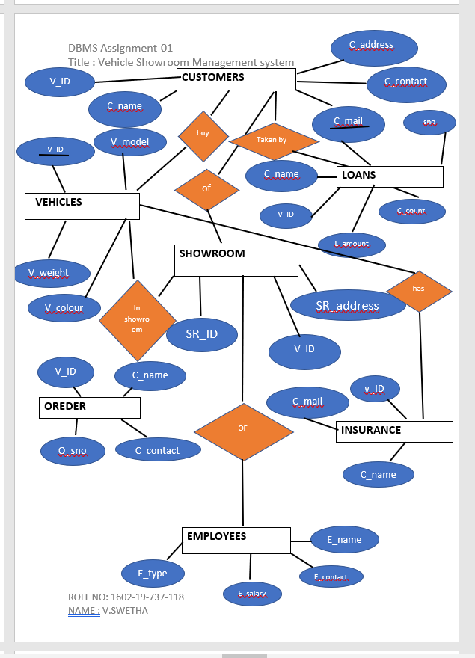

**Mapping Cardinality and participation constraints:**

EMPLOYEES OF SHOWROOM which is many to one participation because many employees can work in a single showroom.

CUSTOMERS BUY VEHICLES is many to many participation because may cutomers buy many vehicles.

Vehicle has insurance is one to one participation because one vehicle can have only one insurance.

Loans taken by customers is many to one participation because many loans can be taken by one customers

**DDL COMMANDS:**

DDL commands

**create table showroom(**

SR_ID varchar(20),

SR_address varchar(20),

V_ID number(20));

**CREATE TABLE Vehicles(**

V_ID number(20),

V_model varchar(100),

V_colour varchar(20),

V_weight number(10),

PRIMARY KEY (V_ID)

);

**CREATE TABLE customers(**

C_name varchar(20),

C_contact number(10),

C_mail varchar(50),

C_address varchar(400),

V_ID number(20)

);

**CREATE TABLE Employee(**

E_ID varchar2(20),

E_type varchar(20),

E_name varchar(50),

E_salary Number(10),

E_contact Number(20),

PRIMARY KEY (E_ID)

);

**CREATE TABLE Loans(**

L_ID number(10),

C_name varchar(20),

C_contact number(20),

V_ID number(20),

L_amount number(30)

);

**CREATE TABLE Insurance (**

C_name varchar(20),

V_ID number(20),

C_contact number(20)

);

**DML commands**

INSERT INTO SHOWROOM VALUES(‘&SR_ID’,’&SR_address’,&v_ID);

INSERT INTO Vehicles

VALUES (&v_ID,’&v_model’,’&v_colour’,&V_weight);

INSERT INTO Customers

VALUES(‘&C_name’,&C_contact,’&C_mail’,’&C_address’,&V_ID);

INSERT INTO Employee

VALUES(‘&E_ID’,’&E_type’,’&E_name’,&E_salary,&E_contact);

INSERT INTO loans

VALUES(&L_ID,’&C_name’,&C_contact,&V_ID,&L_amount);

INSERT INTO insurance

VALUES (‘&c_name’,&V_ID,&C_contact);

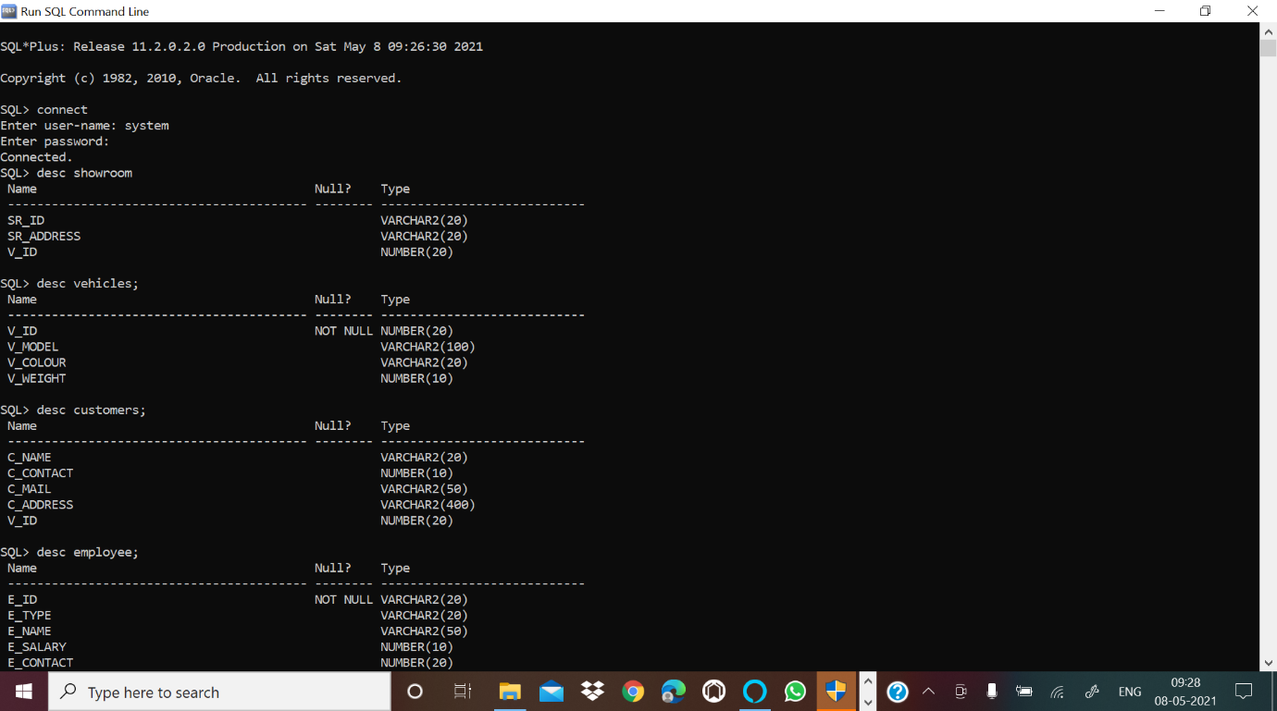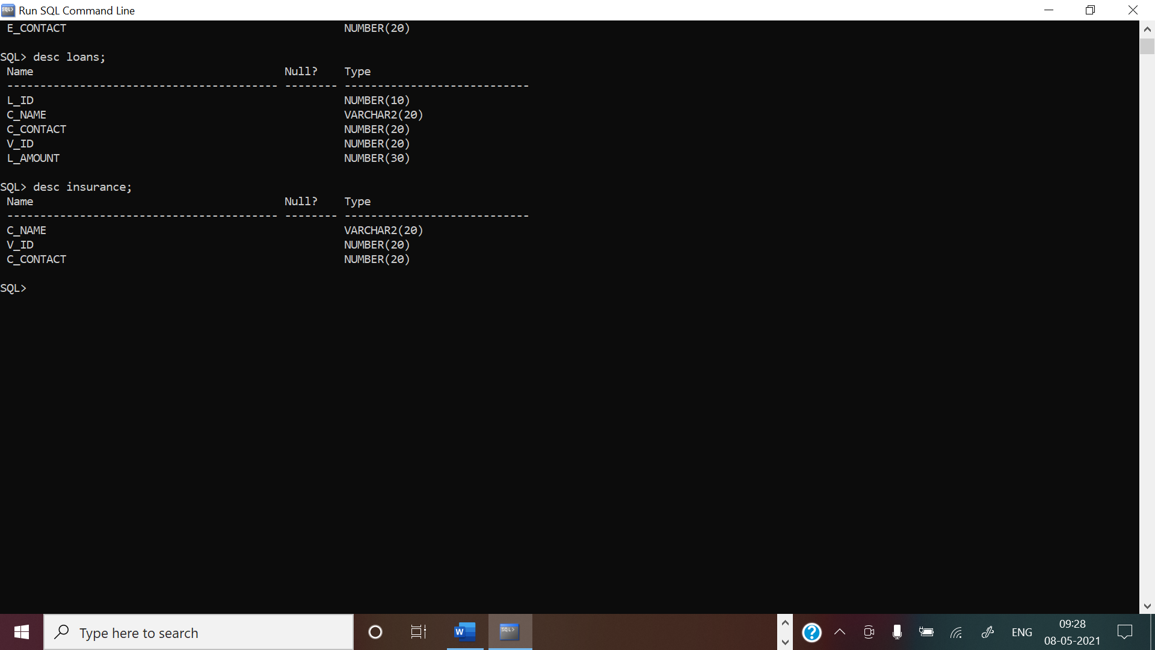

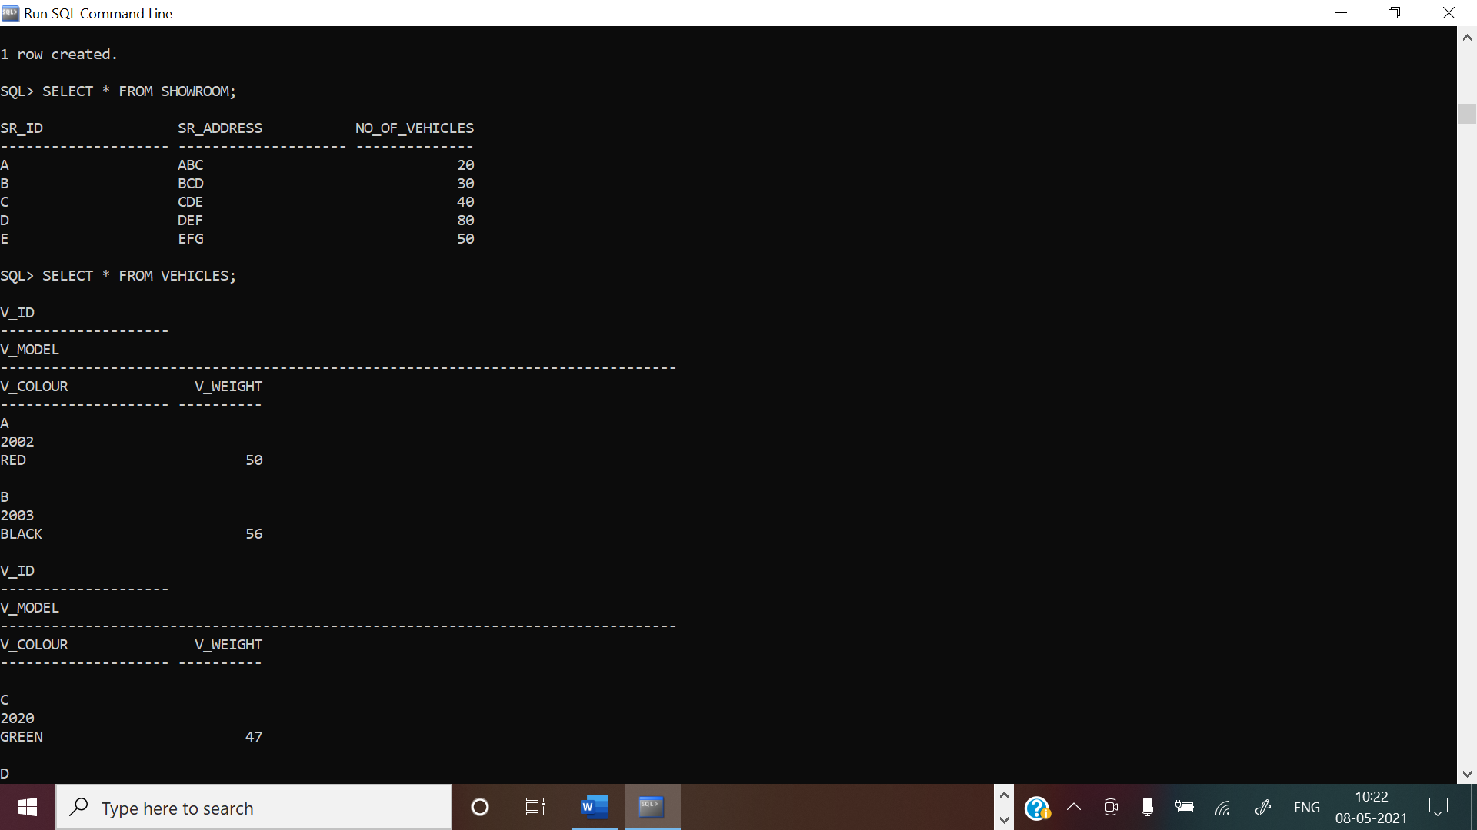

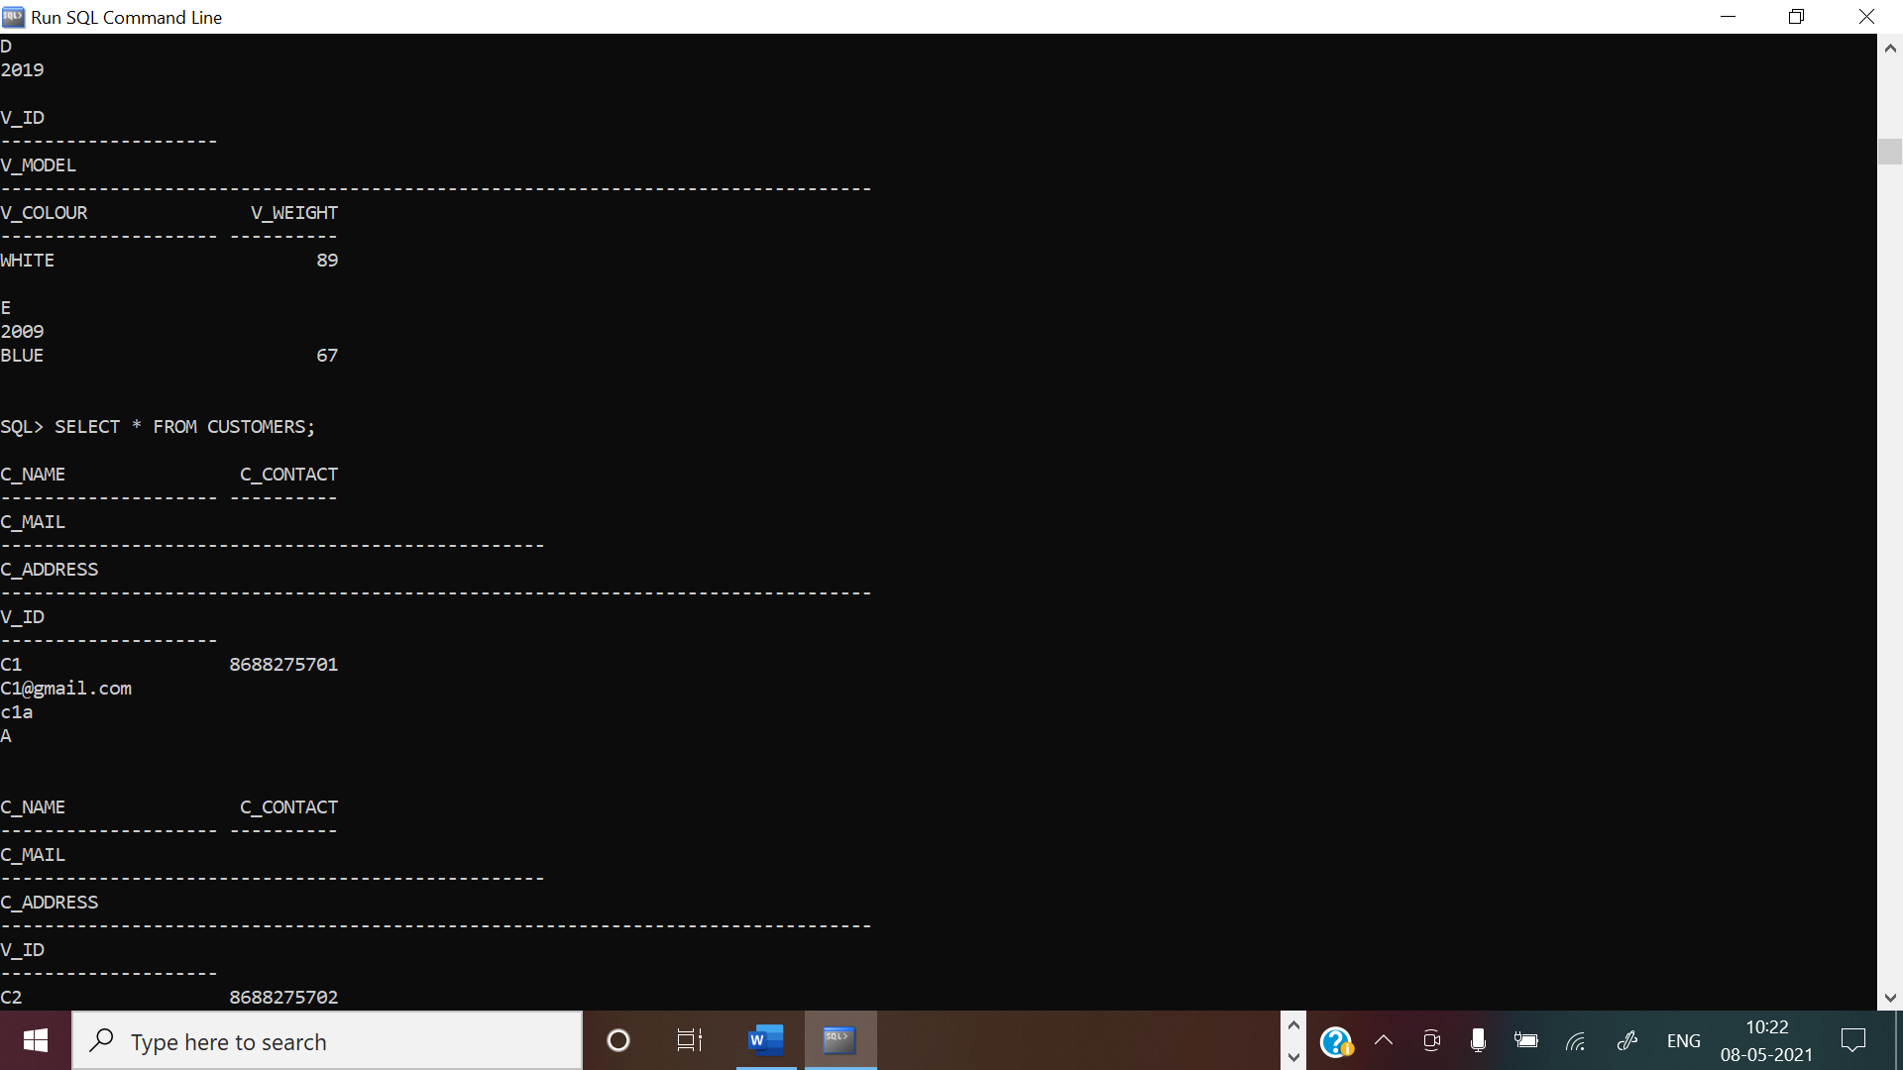

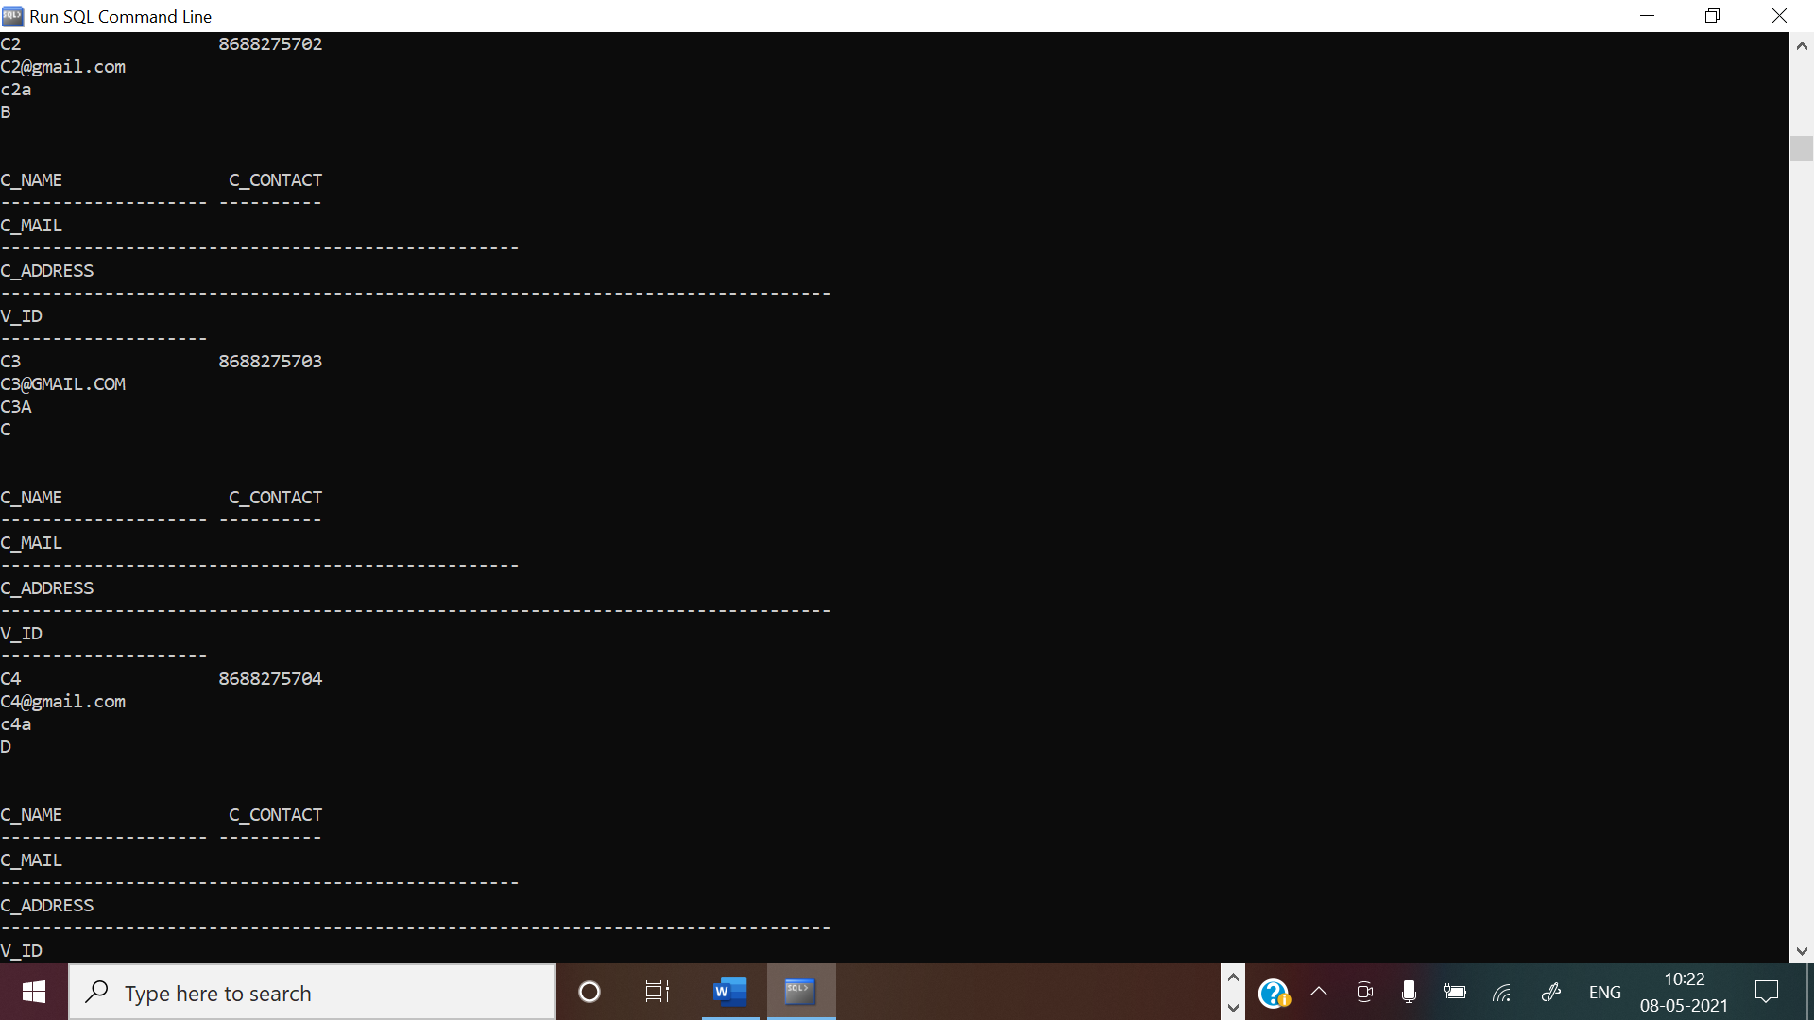

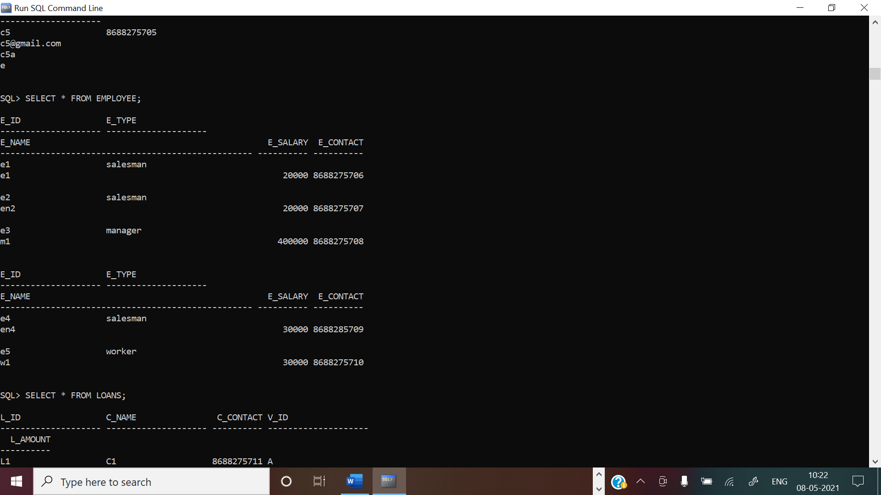

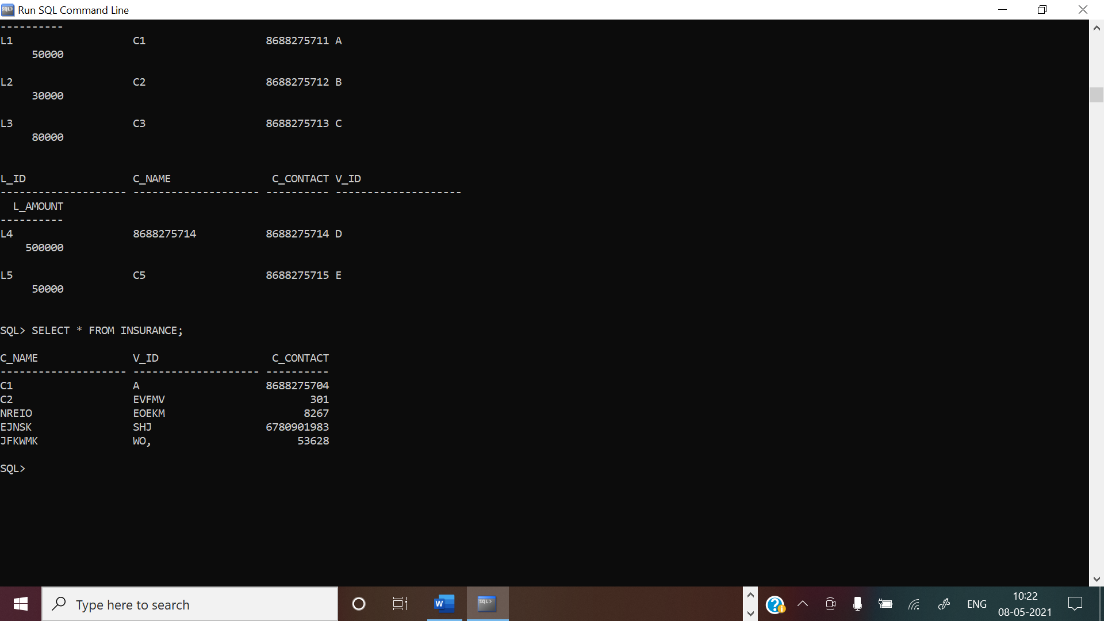

IMPLEMENTATION

**Front end programs and its connectivity**

**Java Database Connectivity** (**JDBC**) is an application programming interface (API) for the programming language Java, which defines how a client may access a database. It is a Java-based data access technology used for Java database connectivity. It is part of the Java Standard Edition platform, from Oracle Corporation. It provides methods to query and update data in a database and is oriented towards relational databases.

The connection to the database can be performed using Java programming (JDBC API) as:

**public void** connectToDB()

{

### try {

Connection con=DriverManager.*getConnection*("jdbc:oracle:thin:@localhost:1521:xe","it19737121","vasavi");

statement=con.createStatement(); statement.executeUpdate("commit");

}

**catch** (SQLException connectException)

{

System.***out***.println(connectException.getMessage()); System.***out***.println(connectException.getSQLState()); System.***out***.println(connectException.getErrorCode()); System.*exit*(1);

}

}

Thus, the connection from Java to Oracle database is performed and therefore, can be used for updating tables in the database directly.

CODE:

//mainframe

package main;

import java.awt.EventQueue;

import javax.swing.JFrame;

import javax.swing.JLabel;

import java.awt.Font;

import javax.swing.JButton;

import java.awt.event.ActionListener;

import java.awt.event.ActionEvent;

import java.awt.Color;

public class FINALMAINFRAME {

private JFrame frame;

/**

* Launch the application.

*/

public static void main(String[] args) {

EventQueue.invokeLater(new Runnable() {

public void run() {

try {

FINALMAINFRAME window = new FINALMAINFRAME();

window.frame.setVisible(true);

} catch (Exception e) {

e.printStackTrace();

}

}

});

}

/**

* Create the application.

*/

public FINALMAINFRAME() {

initialize();

}

/**

* Initialize the contents of the frame.

*/

private void initialize() {

frame = new JFrame();

frame.getContentPane().setBackground(Color.CYAN);

frame.getContentPane().setForeground(new Color(0, 255, 255));

frame.getContentPane().setFont(new Font("Tahoma", Font.PLAIN, 15));

frame.setBounds(100, 100, 1062, 595);

frame.setDefaultCloseOperation(JFrame.EXIT_ON_CLOSE);

frame.getContentPane().setLayout(null);

JLabel lblNewLabel = new JLabel("Vehicle Showroom Management System");

lblNewLabel.setFont(new Font("Tahoma", Font.PLAIN, 30));

lblNewLabel.setBounds(199, 11, 648, 60);

frame.getContentPane().add(lblNewLabel);

JButton btnNewButton = new JButton("SHOWROOM");

btnNewButton.setForeground(Color.BLACK);

btnNewButton.setFont(new Font("Tahoma", Font.BOLD, 15));

btnNewButton.addActionListener(new ActionListener() {

public void actionPerformed(ActionEvent e) {

if (e.getSource() == btnNewButton) {

fSHOWROOM srdetails= new fSHOWROOM();

}

}

});

btnNewButton.setBounds(394, 104, 169, 43);

frame.getContentPane().add(btnNewButton);

JButton btnNewButton_1 = new JButton("CUSTOMERS");

btnNewButton_1.setForeground(Color.BLACK);

btnNewButton_1.setFont(new Font("Tahoma", Font.BOLD, 15));

btnNewButton_1.addActionListener(new ActionListener() {

public void actionPerformed(ActionEvent e) {

if (e.getSource() == btnNewButton_1) {

FCUSTOMER CUST= new FCUSTOMER();

}

}

});

btnNewButton_1.setBounds(394, 185, 169, 43);

frame.getContentPane().add(btnNewButton_1);

JButton btnNewButton_2 = new JButton("EMPLOYEES");

btnNewButton_2.addActionListener(new ActionListener() {

public void actionPerformed(ActionEvent e) {

if (e.getSource() == btnNewButton_2) {

fEMPLOYEE emp=new fEMPLOYEE();

}

}

});

btnNewButton_2.setForeground(Color.BLACK);

btnNewButton_2.setFont(new Font("Tahoma", Font.BOLD, 15));

btnNewButton_2.setBounds(394, 256, 169, 43);

frame.getContentPane().add(btnNewButton_2);

JButton btnNewButton_3 = new JButton("LOANS");

btnNewButton_3.addActionListener(new ActionListener() {

public void actionPerformed(ActionEvent e) {

if(e.getSource()==btnNewButton_3) {

FLOANS l=new FLOANS();

}

}

});

btnNewButton_3.setFont(new Font("Tahoma", Font.BOLD, 15));

btnNewButton_3.setBounds(394, 310, 169, 49);

frame.getContentPane().add(btnNewButton_3);

JButton btnNewButton_4 = new JButton("VEHICLES");

btnNewButton_4.addActionListener(new ActionListener() {

public void actionPerformed(ActionEvent e) {

if(e.getSource()==btnNewButton_4 ) {

fvehicles veh=new fvehicles();

}

}

});

btnNewButton_4.setFont(new Font("Tahoma", Font.BOLD, 15));

btnNewButton_4.setBounds(394, 370, 169, 54);

frame.getContentPane().add(btnNewButton_4);

JButton btnNewButton_5 = new JButton("INSURANCE");

btnNewButton_5.addActionListener(new ActionListener() {

public void actionPerformed(ActionEvent e) {

if(e.getSource()==btnNewButton_5 ) {

fINSURANCE in=new fINSURANCE();

}

}

});

btnNewButton_5.setFont(new Font("Tahoma", Font.BOLD, 15));

btnNewButton_5.setBounds(403, 446, 160, 49);

frame.getContentPane().add(btnNewButton_5);//adhi chusi nak help sare

}

}

//customer

package main;

import java.awt.EventQueue;

import javax.swing.JFrame;

import javax.swing.JLabel;

import javax.swing.JOptionPane;

import java.awt.Font;

import java.awt.Color;

import javax.swing.JPanel;

import javax.swing.JButton;

import java.awt.event.ActionListener;

import java.awt.event.MouseAdapter;

import java.awt.event.MouseEvent;

import java.sql.DriverManager;

import java.sql.PreparedStatement;

import java.sql.ResultSet;

import java.sql.SQLException;

import java.sql.Statement;

import java.awt.event.ActionEvent;

import javax.swing.JTextField;

import javax.swing.border.TitledBorder;

import javax.swing.JTable;

import javax.swing.JScrollPane;

public class FCUSTOMER {

private JFrame frame;

private JTextField nametxt;

private JTextField contacttxt;

private JTextField addresstxt;

private JTextField VIDtxt;

private JTextField mailtxt;

private JTable table;

/**

* Create the application.

*/

public FCUSTOMER() {

initialize();

this.frame.setVisible(true);

Connect();

}

java.sql.Connection con;

Statement stmt;

ResultSet rs;

public void Connect()

{

try

{

Class.forName("oracle.jdbc.driver.OracleDriver");

}

catch (Exception e)

{

System.err.println("Unable to find and load driver");

System.exit(1);

}

try

{

con = DriverManager.getConnection("jdbc:oracle:thin:@localhost:1521:xe","system","Pass#123");

stmt = con.createStatement();

}

catch (SQLException connectException)

{

System.out.println(connectException.getMessage());

System.out.println(connectException.getSQLState());

System.out.println(connectException.getErrorCode());

System.exit(1);

}

}

/**

* Initialize the contents of the frame.

*/

private void initialize() {

frame = new JFrame();

frame.getContentPane().setBackground(Color.PINK);

frame.setBounds(100, 100, 1123, 632);

frame.setDefaultCloseOperation(JFrame.DISPOSE_ON_CLOSE);

frame.getContentPane().setLayout(null);

JLabel lblNewLabel = new JLabel("CUSTOMER");

lblNewLabel.setFont(new Font("Tahoma", Font.BOLD, 30));

lblNewLabel.setBounds(427, -24, 337, 111);

frame.getContentPane().add(lblNewLabel);

JPanel panel = new JPanel();

panel.setBounds(119, 75, 436, 383);

frame.getContentPane().add(panel);

panel.setLayout(null);

JLabel btnNewButton = new JLabel("cname");

btnNewButton.setFont(new Font("Tahoma", Font.BOLD, 20));

btnNewButton.setBounds(38, 55, 127, 38);

panel.add(btnNewButton);

JLabel btnNewButton_1 = new JLabel("VID");

btnNewButton_1.setFont(new Font("Tahoma", Font.BOLD, 20));

btnNewButton_1.setBounds(38, 304, 127, 38);

panel.add(btnNewButton_1);

JLabel btnNewButton_2 = new JLabel("Address");

btnNewButton_2.setFont(new Font("Tahoma", Font.BOLD, 20));

btnNewButton_2.setBounds(38, 155, 127, 38);

panel.add(btnNewButton_2);

btnNewButton_2.setFont(new Font("Tahoma", Font.BOLD, 20));

btnNewButton_2.setBounds(38, 222, 127, 33);

panel.add(btnNewButton_2);

JLabel btnNewButton_3 = new JLabel("Contact");

btnNewButton_3.setFont(new Font("Tahoma", Font.BOLD, 20));

btnNewButton_3.setBounds(38, 143, 127, 33);

panel.add(btnNewButton_3);

nametxt = new JTextField();

nametxt.setBounds(175, 57, 183, 38);

panel.add(nametxt);

nametxt.setColumns(10);

contacttxt = new JTextField();

contacttxt.setColumns(10);

contacttxt.setBounds(175, 147, 183, 33);

panel.add(contacttxt);

addresstxt = new JTextField();

addresstxt.setColumns(10);

addresstxt.setBounds(175, 222, 183, 33);

panel.add(addresstxt);

VIDtxt = new JTextField();

VIDtxt.setColumns(10);

VIDtxt.setBounds(175, 311, 172, 33);

panel.add(VIDtxt);

JPanel panel_1 = new JPanel();

panel_1.setBorder(new TitledBorder(null, "Search", TitledBorder.LEADING, TitledBorder.TOP, null, null));

panel_1.setBounds(148, 510, 383, 60);

frame.getContentPane().add(panel_1);

panel_1.setLayout(null);

JLabel btnNewButton_2_1 = new JLabel("mail");

btnNewButton_2_1.setFont(new Font("Tahoma", Font.BOLD, 20));

btnNewButton_2_1.setBounds(31, 11, 137, 38);

panel_1.add(btnNewButton_2_1);

mailtxt = new JTextField();

mailtxt.addMouseListener(new MouseAdapter() {

@Override

public void mouseReleased(MouseEvent e) {

try {

String name,contact,mail,address,VID;

name=nametxt.getText();

contact=contacttxt.getText();

mail=mailtxt.getText();

address=addresstxt.getText();

VID=VIDtxt.getText();

PreparedStatement pstmt1 = con.prepareStatement("select * from customers where C_MAIL=(?)");

pstmt1.setString(1, mail);

ResultSet rs=pstmt1.executeQuery();

while(rs.next()) {

nametxt.setText(rs.getString(1));

contacttxt.setText(rs.getString(2));

mailtxt.setText(rs.getString(3));

addresstxt.setText(rs.getString(4));

VIDtxt.setText(rs.getString(5));

}

}

catch(Exception E)

{ System.out.println(E);}

}

});

mailtxt.setColumns(10);

mailtxt.setBounds(201, 18, 172, 33);

panel_1.add(mailtxt);

JButton btnNewButton_4 = new JButton("SAVE");

btnNewButton_4.addActionListener(new ActionListener() {

public void actionPerformed(ActionEvent e) {

{

String name,contact,mail,address,VID;

name=nametxt.getText();

contact=contacttxt.getText();

mail=mailtxt.getText();

address=addresstxt.getText();

VID=VIDtxt.getText();

try {

PreparedStatement pstmt = con.prepareStatement("insert into customers values (?,?,?,?,?)");

pstmt.setString(1, name);

pstmt.setString(2,contact);

pstmt.setString(3,mail);

pstmt.setString(4,address);

pstmt.setString(5,VID);

int i=pstmt.executeUpdate();

//txtmsg.append("\nInserted " + i + " rows successfully");

JOptionPane.showMessageDialog(null, "\nInserted " + i + " rows successfully");

}

catch(Exception E)

{ System.out.println(E);}

}

}

});

btnNewButton_4.setFont(new Font("Tahoma", Font.BOLD, 20));

btnNewButton_4.setBounds(730, 127, 111, 55);

frame.getContentPane().add(btnNewButton_4);

JButton btnNewButton_5 = new JButton("VIEW");

btnNewButton_5.addActionListener(new ActionListener() {

public void actionPerformed(ActionEvent e) {

if(e.getSource()==btnNewButton_5) {

fviewcustomers vs=new fviewcustomers();

}

}

});

btnNewButton_5.setFont(new Font("Tahoma", Font.BOLD, 20));

btnNewButton_5.setBounds(743, 428, 135, 45);

frame.getContentPane().add(btnNewButton_5);

JButton btnNewButton_6 = new JButton("UPDATE");

btnNewButton_6.addActionListener(new ActionListener() {

public void actionPerformed(ActionEvent e) {

if(e.getSource()==btnNewButton_6) {

String name,contact,mail,address,VID;

name=nametxt.getText();

contact=contacttxt.getText();

mail=mailtxt.getText();

address=addresstxt.getText();

VID=VIDtxt.getText();

try {

PreparedStatement pstmt = con.prepareStatement("update customers set C_NAME=(?),C_CONTACT=(?),C_MAIL=(?),C_ADDRESS=(?) where V_ID=(?)");

pstmt.setString(5,VID);

pstmt.setString(1,name);

pstmt.setString(2,contact);

pstmt.setString(3,mail);

pstmt.setString(4,address);

int i=pstmt.executeUpdate();

//txtmsg.append("\nInserted " + i + " rows successfully");

JOptionPane.showMessageDialog(null, "\nupdated " + i + " rows successfully");

}

catch(Exception E)

{ System.out.println(E);}

}

}

});

btnNewButton_6.setFont(new Font("Tahoma", Font.BOLD, 20));

btnNewButton_6.setBounds(739, 243, 122, 41);

frame.getContentPane().add(btnNewButton_6);

JButton btnNewButton_6_1 = new JButton("DELETE");

btnNewButton_6_1.addActionListener(new ActionListener() {

public void actionPerformed(ActionEvent e) {

if(e.getSource()==btnNewButton_6_1) {

String name,contact,mail,address,VID;

name=nametxt.getText();

contact=contacttxt.getText();

mail=mailtxt.getText();

address=addresstxt.getText();

VID=VIDtxt.getText();

try {

PreparedStatement pstmt = con.prepareStatement("delete from customers where C_MAIL=(?)");

pstmt.setString(1, mail);

int i=pstmt.executeUpdate();

//txtmsg.append("\nInserted " + i + " rows successfully");

JOptionPane.showMessageDialog(null, "\ndeleted " + i + " rows successfully");

}

catch(Exception E)

{ System.out.println(E);}

}

}

});

btnNewButton_6_1.setFont(new Font("Tahoma", Font.BOLD, 20));

btnNewButton_6_1.setBounds(743, 342, 135, 32);

frame.getContentPane().add(btnNewButton_6_1);

table = new JTable();

table.setBounds(724, 314, 135, -94);

frame.getContentPane().add(table);

}

}

//customerview

package main;

import java.awt.Font;

import java.sql.Connection;

import java.sql.DriverManager;

import java.sql.ResultSet;

import java.sql.SQLException;

import java.sql.Statement;

import javax.swing.JFrame;

import javax.swing.JLabel;

import javax.swing.JTable;

import javax.swing.JTextPane;

import javax.swing.ListSelectionModel;

import javax.swing.table.DefaultTableModel;

class fviewcustomers{

private JFrame frame;

private JTable table;

String[][] tbl=new String[100][100];

Connection con;

Statement stmt;

ResultSet rs;

private JLabel lblNewLabel;

private JLabel lblNewLabel_1;

private JLabel lblNewLabel_3;

private JLabel lblNewLabel_4;

private JLabel lblNewLabel_5;

/**

* Create the application.

*/

fviewcustomers() {

try

{

Class.forName("oracle.jdbc.driver.OracleDriver");

}

catch (Exception e)

{

System.err.println("Unable to find and load driver");

System.exit(1);

}

connectToDB();

initialize();

this.frame.setVisible(true);

}

void connectToDB()

{

try

{

con = DriverManager.getConnection("jdbc:oracle:thin:@localhost:1521:xe","system","Pass#123");

stmt = con.createStatement();

}

catch (SQLException connectException)

{

System.out.println(connectException.getMessage());

System.out.println(connectException.getSQLState());

System.out.println(connectException.getErrorCode());

System.exit(1);

}

}

/**

* Initialize the contents of the frame.

*/

private void initialize() {

frame = new JFrame();

frame.setBounds(100, 100, 797, 503);

frame.setDefaultCloseOperation(JFrame.DISPOSE_ON_CLOSE);

frame.getContentPane().setLayout(null);

JTextPane txtpnOfficerDetails = new JTextPane();

txtpnOfficerDetails.setFont(new Font("Tahoma", Font.BOLD, 21));

txtpnOfficerDetails.setText("employee details");

txtpnOfficerDetails.setBounds(227, 25, 239, 32);

frame.getContentPane().add(txtpnOfficerDetails);

try {

ResultSet rs=stmt.executeQuery("select * from customers");

int i=0;

while(rs.next()) {

tbl[i][0]=rs.getString(1);

tbl[i][1]=rs.getString(2);

tbl[i][2]=rs.getString(3);

tbl[i][3]=rs.getString(4);

tbl[i][4]=rs.getString(5);

i=i+1;

}

table = new JTable();

table.setRowSelectionAllowed(false);

table.setSurrendersFocusOnKeystroke(true);

table.setModel(new DefaultTableModel(

tbl,

new String[] {

"OFFICER ID", "NAME", "PHONENO"," SALARy","CONTACT"

}

));

table.setSelectionMode(ListSelectionModel.SINGLE_SELECTION);

table.setBounds(29, 137, 723, 121);

frame.getContentPane().add(table);

lblNewLabel = new JLabel("NAME");

lblNewLabel.setFont(new Font("Tahoma", Font.BOLD, 17));

lblNewLabel.setBounds(48, 101, 235, 26);

frame.getContentPane().add(lblNewLabel);

lblNewLabel_1 = new JLabel("CONTACT");

lblNewLabel_1.setFont(new Font("Tahoma", Font.BOLD, 17));

lblNewLabel_1.setBounds(200, 92, 199, 45);

frame.getContentPane().add(lblNewLabel_1);

lblNewLabel_3 = new JLabel("MAIL");

lblNewLabel_3.setFont(new Font("Tahoma", Font.BOLD, 17));

lblNewLabel_3.setBounds(350, 101, 164, 26);

frame.getContentPane().add(lblNewLabel_3);

lblNewLabel_4 = new JLabel("ADDRESS");

lblNewLabel_4.setFont(new Font("Tahoma", Font.BOLD, 17));

lblNewLabel_4.setBounds(500, 101, 164, 26);

frame.getContentPane().add(lblNewLabel_4);

lblNewLabel_5 = new JLabel("VID");

lblNewLabel_5.setFont(new Font("Tahoma", Font.BOLD, 17));

lblNewLabel_5.setBounds(600, 101, 164, 26);

frame.getContentPane().add(lblNewLabel_5);

}

catch(Exception E)

{

System.out.println(E);

}

}

}

//showroom

package main;

import java.awt.EventQueue;

import javax.swing.JFrame;

import javax.swing.JLabel;

import javax.swing.JOptionPane;

import java.awt.Font;

import java.sql.DriverManager;

import java.sql.PreparedStatement;

import java.sql.ResultSet;

import java.sql.SQLException;

import java.sql.Statement;

import javax.swing.JPanel;

import javax.swing.border.MatteBorder;

import java.awt.Color;

import javax.swing.JTextField;

import javax.swing.JButton;

import javax.swing.JTable;

import javax.swing.JScrollPane;

import javax.swing.border.TitledBorder;

import com.sun.jdi.connect.spi.Connection;

import java.awt.event.ActionListener;

import java.awt.event.ActionEvent;

import javax.swing.table.DefaultTableModel;

import java.awt.event.MouseAdapter;

import java.awt.event.MouseEvent;

public class fSHOWROOM {

private JFrame frame;

private JTextField txtSRaddress;

private JTextField txtvehicles;

private JTable table;

private JTextField txtSRID;

/**

* Create the application.

*/

public fSHOWROOM() {

initialize();

this.frame.setVisible(true);

Connect();

}

java.sql.Connection con;

Statement stmt;

ResultSet rs;

private JTable table_1;

public void Connect()

{

try

{

Class.forName("oracle.jdbc.driver.OracleDriver");

}

catch (Exception e)

{

System.err.println("Unable to find and load driver");

System.exit(1);

}

try

{

con = DriverManager.getConnection("jdbc:oracle:thin:@localhost:1521:xe","system","Pass#123");

stmt = con.createStatement();

}

catch (SQLException connectException)

{

System.out.println(connectException.getMessage());

System.out.println(connectException.getSQLState());

System.out.println(connectException.getErrorCode());

System.exit(1);

}

}

/**

* Initialize the contents of the frame.

*/

private void initialize() {

frame = new JFrame();

frame.setBounds(100, 100, 1120, 618);

frame.setDefaultCloseOperation(JFrame.DISPOSE_ON_CLOSE);

frame.getContentPane().setLayout(null);

JLabel lblNewLabel = new JLabel("SHOWROOM");

lblNewLabel.setBounds(416, 11, 358, 43);

lblNewLabel.setFont(new Font("Tahoma", Font.BOLD, 30));

frame.getContentPane().add(lblNewLabel);

JPanel panel = new JPanel();

panel.setBorder(new MatteBorder(1, 1, 1, 1, (Color) new Color(0, 0, 0)));

panel.setBounds(80, 64, 408, 312);

frame.getContentPane().add(panel);

panel.setLayout(null);

JLabel lblNewLabel_2 = new JLabel("Showroomaddress");

lblNewLabel_2.setFont(new Font("Tahoma", Font.BOLD, 20));

lblNewLabel_2.setBounds(10, 72, 202, 49);

panel.add(lblNewLabel_2);

JLabel lblNewLabel_3 = new JLabel("noof vehicles");

lblNewLabel_3.setFont(new Font("Tahoma", Font.BOLD, 20));

lblNewLabel_3.setBounds(20, 169, 144, 26);

panel.add(lblNewLabel_3);

txtSRaddress = new JTextField();

txtSRaddress.setBounds(239, 85, 147, 31);

panel.add(txtSRaddress);

txtSRaddress.setColumns(10);

txtvehicles = new JTextField();

txtvehicles.setBounds(226, 171, 147, 31);

panel.add(txtvehicles);

txtvehicles.setColumns(10);

JButton btnNewButton = new JButton("SAVE");

btnNewButton.addActionListener(new ActionListener() {

public void actionPerformed(ActionEvent e) {

{

String SRID,SRaddress,vehicles;

SRID=txtSRID.getText();

SRaddress=txtSRaddress.getText();

vehicles=txtvehicles.getText();

try {

PreparedStatement pstmt = con.prepareStatement("insert into showroom values (?,?,?)");

pstmt.setString(1, SRID);

pstmt.setString(2,SRaddress);

pstmt.setString(3,vehicles);

int i=pstmt.executeUpdate();

//txtmsg.append("\nInserted " + i + " rows successfully");

JOptionPane.showMessageDialog(null, "\nInserted " + i + " rows successfully");

}

catch(Exception E)

{ System.out.println(E);}

}

}

});

btnNewButton.setFont(new Font("Tahoma", Font.BOLD, 20));

btnNewButton.setBounds(104, 388, 175, 54);

frame.getContentPane().add(btnNewButton);

table = new JTable();

table.setBounds(714, 327, 1, 1);

frame.getContentPane().add(table);

JPanel panel_1 = new JPanel();

panel_1.setBorder(new TitledBorder(null, "Search", TitledBorder.LEADING, TitledBorder.TOP, null, null));

panel_1.setBounds(64, 486, 330, 53);

frame.getContentPane().add(panel_1);

panel_1.setLayout(null);

JLabel lblNewLabel_3_1 = new JLabel("SRID");

lblNewLabel_3_1.setFont(new Font("Tahoma", Font.BOLD, 20));

lblNewLabel_3_1.setBounds(10, 11, 144, 26);

panel_1.add(lblNewLabel_3_1);

txtSRID = new JTextField();

txtSRID.addMouseListener(new MouseAdapter() {

@Override

public void mouseReleased(MouseEvent e) {

try {

String SRID,SRaddress,vehicles;

SRID=txtSRID.getText();

SRaddress=txtSRaddress.getText();

vehicles=txtvehicles.getText();

PreparedStatement pstmt1 = con.prepareStatement("select * from showroom where sr_id=(?)");

pstmt1.setString(1, SRID);

ResultSet rs=pstmt1.executeQuery();

while(rs.next()) {

txtSRID.setText(rs.getString(1));

txtSRaddress.setText(rs.getString(2));

txtvehicles.setText(rs.getString(3));

}

}

catch(Exception E)

{ System.out.println(E);}

}

});

txtSRID.setColumns(10);

txtSRID.setBounds(126, 13, 147, 31);

panel_1.add(txtSRID);

JButton btnNewButton_1 = new JButton("UPDATE");

btnNewButton_1.addActionListener(new ActionListener() {

public void actionPerformed(ActionEvent e) {

if(e.getSource()==btnNewButton_1) {

String SRID,SRaddress,vehicles;

SRID=txtSRID.getText();

SRaddress=txtSRaddress.getText();

vehicles=txtvehicles.getText();

try {

PreparedStatement pstmt = con.prepareStatement("update showroom set SR_ADDRESS=(?),NO_OF_VEHICLES=(?) where SR_ID=(?)");

pstmt.setString(3, SRID);

pstmt.setString(1,SRaddress);

pstmt.setString(2,vehicles);

int i=pstmt.executeUpdate();

//txtmsg.append("\nInserted " + i + " rows successfully");

JOptionPane.showMessageDialog(null, "\nupdated " + i + " rows successfully");

}

catch(Exception E)

{ System.out.println(E);}

}

}

});

btnNewButton_1.setFont(new Font("Tahoma", Font.BOLD, 20));

btnNewButton_1.setBounds(616, 83, 175, 57);

frame.getContentPane().add(btnNewButton_1);

JButton btnNewButton_2 = new JButton("DELETE");

btnNewButton_2.addActionListener(new ActionListener() {

public void actionPerformed(ActionEvent e) {

if(e.getSource()==btnNewButton_2) {

String SRID,SRaddress,vehicles;

SRID=txtSRID.getText();

SRaddress=txtSRaddress.getText();

vehicles=txtvehicles.getText();

try {

PreparedStatement pstmt = con.prepareStatement("delete from showroom where SR_ID=(?)");

pstmt.setString(1, SRID);

int i=pstmt.executeUpdate();

//txtmsg.append("\nInserted " + i + " rows successfully");

JOptionPane.showMessageDialog(null, "\ndeleted " + i + " rows successfully");

}

catch(Exception E)

{ System.out.println(E);}

}

}

});

btnNewButton_2.setFont(new Font("Tahoma", Font.BOLD, 20));

btnNewButton_2.setBounds(628, 198, 146, 54);

frame.getContentPane().add(btnNewButton_2);

JButton btnNewButton_3 = new JButton("view");

btnNewButton_3.addActionListener(new ActionListener() {

public void actionPerformed(ActionEvent e) {

if(e.getSource()==btnNewButton_3) {

fviewshowroom vs=new fviewshowroom();

}

}

});

btnNewButton_3.setFont(new Font("Tahoma", Font.BOLD, 18));

btnNewButton_3.setBounds(638, 327, 136, 49);

frame.getContentPane().add(btnNewButton_3);

}

}

//viewshowroom

package main;

import java.awt.Font;

import java.sql.Connection;

import java.sql.DriverManager;

import java.sql.ResultSet;

import java.sql.SQLException;

import java.sql.Statement;

import javax.swing.JFrame;

import javax.swing.JLabel;

import javax.swing.JTable;

import javax.swing.JTextPane;

import javax.swing.ListSelectionModel;

import javax.swing.table.DefaultTableModel;

class fviewshowroom {

private JFrame frame;

private JTable table;

String[][] tbl=new String[100][100];

Connection con;

Statement stmt;

ResultSet rs;

private JLabel lblNewLabel;

private JLabel lblNewLabel_1;

private JLabel lblNewLabel_3;

/**

* Create the application.

*/

fviewshowroom() {

try

{

Class.forName("oracle.jdbc.driver.OracleDriver");

}

catch (Exception e)

{

System.err.println("Unable to find and load driver");

System.exit(1);

}

connectToDB();

initialize();

this.frame.setVisible(true);

}

void connectToDB()

{

try

{

con = DriverManager.getConnection("jdbc:oracle:thin:@localhost:1521:xe","system","Pass#123");

stmt = con.createStatement();

}

catch (SQLException connectException)

{

System.out.println(connectException.getMessage());

System.out.println(connectException.getSQLState());

System.out.println(connectException.getErrorCode());

System.exit(1);

}

}

/**

* Initialize the contents of the frame.

*/

private void initialize() {

frame = new JFrame();

frame.setBounds(100, 100, 797, 503);

frame.setDefaultCloseOperation(JFrame.DISPOSE_ON_CLOSE);

frame.getContentPane().setLayout(null);

JTextPane txtpnOfficerDetails = new JTextPane();

txtpnOfficerDetails.setFont(new Font("Tahoma", Font.BOLD, 21));

txtpnOfficerDetails.setText("showroom details");

txtpnOfficerDetails.setBounds(227, 25, 239, 32);

frame.getContentPane().add(txtpnOfficerDetails);

try {

ResultSet rs=stmt.executeQuery("select * from showroom");

int i=0;

while(rs.next()) {

tbl[i][0]=rs.getString(1);

tbl[i][1]=rs.getString(2);

tbl[i][2]=rs.getString(3);

i=i+1;

}

table = new JTable();

table.setRowSelectionAllowed(false);

table.setSurrendersFocusOnKeystroke(true);

table.setModel(new DefaultTableModel(

tbl,

new String[] {

"OFFICER ID", "NAME", "PHONENO"

}

));

table.setSelectionMode(ListSelectionModel.SINGLE_SELECTION);

table.setBounds(29, 137, 723, 121);

frame.getContentPane().add(table);

lblNewLabel = new JLabel(" ID");

lblNewLabel.setFont(new Font("Tahoma", Font.BOLD, 17));

lblNewLabel.setBounds(48, 101, 235, 26);

frame.getContentPane().add(lblNewLabel);

lblNewLabel_1 = new JLabel("adress");

lblNewLabel_1.setFont(new Font("Tahoma", Font.BOLD, 17));

lblNewLabel_1.setBounds(311, 92, 199, 45);

frame.getContentPane().add(lblNewLabel_1);

lblNewLabel_3 = new JLabel("no of vechiles");

lblNewLabel_3.setFont(new Font("Tahoma", Font.BOLD, 17));

lblNewLabel_3.setBounds(541, 101, 164, 26);

frame.getContentPane().add(lblNewLabel_3);

}

catch(Exception E)

{

System.out.println(E);

}

}

}

//employee

package main;

import java.awt.EventQueue;

import javax.swing.JFrame;

import javax.swing.JLabel;

import javax.swing.JOptionPane;

import java.awt.Font;

import java.awt.Color;

import javax.swing.JPanel;

import javax.swing.JButton;

import java.awt.event.ActionListener;

import java.awt.event.MouseAdapter;

import java.awt.event.MouseEvent;

import java.sql.DriverManager;

import java.sql.PreparedStatement;

import java.sql.ResultSet;

import java.sql.SQLException;

import java.sql.Statement;

import java.awt.event.ActionEvent;

import javax.swing.JTextField;

import javax.swing.border.TitledBorder;

import javax.swing.JTable;

import javax.swing.JScrollPane;

public class fEMPLOYEE {

private JFrame frame;

private JTextField nametxt;

private JTextField typetxt;

private JTextField salarytxt;

private JTextField contacttxt;

private JTextField EIDtxt;

java.sql.Connection con;

Statement stmt;

ResultSet rs;

private JTable table_1;

public void Connect()

{

try

{

Class.forName("oracle.jdbc.driver.OracleDriver");

}

catch (Exception e)

{

System.err.println("Unable to find and load driver");

System.exit(1);

}

try

{

con = DriverManager.getConnection("jdbc:oracle:thin:@localhost:1521:xe","system","Pass#123");

stmt = con.createStatement();

}

catch (SQLException connectException)

{

System.out.println(connectException.getMessage());

System.out.println(connectException.getSQLState());

System.out.println(connectException.getErrorCode());

System.exit(1);

}

}

/**

* Create the application.

*/

public fEMPLOYEE() {

initialize();

this.frame.setVisible(true);

Connect();

}

/**

* Initialize the contents of the frame.

*/

private void initialize() {

frame = new JFrame();

frame.getContentPane().setBackground(Color.PINK);

frame.setBounds(100, 100, 1123, 632);

frame.setDefaultCloseOperation(JFrame.DISPOSE_ON_CLOSE);

frame.getContentPane().setLayout(null);

JLabel lblNewLabel = new JLabel("EMPLOYEE");

lblNewLabel.setFont(new Font("Tahoma", Font.BOLD, 30));

lblNewLabel.setBounds(427, -24, 337, 111);

frame.getContentPane().add(lblNewLabel);

JPanel panel = new JPanel();

panel.setBounds(119, 75, 436, 383);

frame.getContentPane().add(panel);

panel.setLayout(null);

JLabel btnNewButton = new JLabel("Ename");

btnNewButton.setFont(new Font("Tahoma", Font.BOLD, 20));

btnNewButton.setBounds(38, 55, 127, 38);

panel.add(btnNewButton);

JLabel btnNewButton_1 = new JLabel("etype");

btnNewButton_1.setFont(new Font("Tahoma", Font.BOLD, 20));

btnNewButton_1.setBounds(38, 140, 127, 38);

panel.add(btnNewButton_1);

JLabel btnNewButton_2 = new JLabel("Esalary");

btnNewButton_2.setFont(new Font("Tahoma", Font.BOLD, 20));

btnNewButton_2.setBounds(38, 155, 127, 38);

panel.add(btnNewButton_2);

btnNewButton_2.setFont(new Font("Tahoma", Font.BOLD, 20));

btnNewButton_2.setBounds(38, 222, 127, 33);

panel.add(btnNewButton_2);

JLabel btnNewButton_3 = new JLabel("Econtact");

btnNewButton_3.setFont(new Font("Tahoma", Font.BOLD, 20));

btnNewButton_3.setBounds(38, 311, 127, 33);

panel.add(btnNewButton_3);

nametxt = new JTextField();

nametxt.setBounds(175, 57, 183, 38);

panel.add(nametxt);

nametxt.setColumns(10);

typetxt = new JTextField();

typetxt.setColumns(10);

typetxt.setBounds(175, 147, 183, 33);

panel.add(typetxt);

salarytxt = new JTextField();

salarytxt.setColumns(10);

salarytxt.setBounds(175, 222, 183, 33);

panel.add(salarytxt);

contacttxt = new JTextField();

contacttxt.setColumns(10);

contacttxt.setBounds(175, 311, 172, 33);

panel.add(contacttxt);

JPanel panel_1 = new JPanel();

panel_1.setBorder(new TitledBorder(null, "Search", TitledBorder.LEADING, TitledBorder.TOP, null, null));

panel_1.setBounds(148, 510, 383, 60);

frame.getContentPane().add(panel_1);

panel_1.setLayout(null);

JLabel btnNewButton_2_1 = new JLabel("EID");

btnNewButton_2_1.setFont(new Font("Tahoma", Font.BOLD, 20));

btnNewButton_2_1.setBounds(31, 11, 137, 38);

panel_1.add(btnNewButton_2_1);

EIDtxt = new JTextField();

EIDtxt.addMouseListener(new MouseAdapter() {

@Override

public void mouseReleased(MouseEvent e) {

try {

String EID,ename,etype,esalary,econtact;

EID=EIDtxt.getText();

ename=nametxt.getText();

etype=typetxt.getText();

esalary=salarytxt.getText();

econtact=contacttxt.getText();

PreparedStatement pstmt1 = con.prepareStatement("select * from employee where E_ID=(?)");

pstmt1.setString(1, EID);

ResultSet rs=pstmt1.executeQuery();

while(rs.next()) {

EIDtxt.setText(rs.getString(1));

nametxt.setText(rs.getString(2));

typetxt.setText(rs.getString(3));

salarytxt.setText(rs.getString(4));

contacttxt.setText(rs.getString(5));

}

}

catch(Exception E)

{ System.out.println(E);}

}

});

EIDtxt.setColumns(10);

EIDtxt.setBounds(201, 18, 172, 33);

panel_1.add(EIDtxt);

JButton btnNewButton_4 = new JButton("SAVE");

btnNewButton_4.addActionListener(new ActionListener() {

public void actionPerformed(ActionEvent e) {

{

String EID,ename,etype,esalary,econtact;

EID=EIDtxt.getText();

ename=nametxt.getText();

etype=typetxt.getText();

esalary=salarytxt.getText();

econtact=contacttxt.getText();

try {

PreparedStatement pstmt = con.prepareStatement("insert into employee values(?,?,?,?,?)");

pstmt.setString(1, EID);

pstmt.setString(2,etype);

pstmt.setString(3,ename);

pstmt.setString(4,esalary);

pstmt.setString(5,econtact);

int i=pstmt.executeUpdate();

//txtmsg.append("\nInserted " + i + " rows successfully");

JOptionPane.showMessageDialog(null, "\nInserted " + i + " rows successfully");

}

catch(Exception E)

{ System.out.println(E);}

}

}

});

btnNewButton_4.setFont(new Font("Tahoma", Font.BOLD, 20));

btnNewButton_4.setBounds(730, 127, 111, 55);

frame.getContentPane().add(btnNewButton_4);

JButton btnNewButton_5 = new JButton("VIEW");

btnNewButton_5.addActionListener(new ActionListener() {

public void actionPerformed(ActionEvent e) {

if(e.getSource()==btnNewButton_5) {

fviewemployee vs=new fviewemployee();

}

}

});

btnNewButton_5.setFont(new Font("Tahoma", Font.BOLD, 20));

btnNewButton_5.setBounds(743, 428, 135, 45);

frame.getContentPane().add(btnNewButton_5);

JButton btnNewButton_6 = new JButton("UPDATE");

btnNewButton_6.addActionListener(new ActionListener() {

public void actionPerformed(ActionEvent e) {

if(e.getSource()==btnNewButton_6) {

String EID,ename,etype,esalary,econtact;

EID=EIDtxt.getText();

ename=nametxt.getText();

etype=typetxt.getText();

esalary=salarytxt.getText();

econtact=contacttxt.getText();

try {

PreparedStatement pstmt = con.prepareStatement("update employee set E_TYPE=(?),E_NAME=(?),E_SALARY=(?),E_CONTACT=(?) where E_ID=(?)");

pstmt.setString(5, EID);

pstmt.setString(1,etype);

pstmt.setString(2,ename);

pstmt.setString(3,esalary);

pstmt.setString(4,econtact);

int i=pstmt.executeUpdate();

//txtmsg.append("\nInserted " + i + " rows successfully");

JOptionPane.showMessageDialog(null, "\nupdated " + i + " rows successfully");

}

catch(Exception E)

{ System.out.println(E);}

}

}

});

btnNewButton_6.setFont(new Font("Tahoma", Font.BOLD, 20));

btnNewButton_6.setBounds(739, 243, 122, 41);

frame.getContentPane().add(btnNewButton_6);

JButton btnNewButton_6_1 = new JButton("DELETE");

btnNewButton_6_1.addActionListener(new ActionListener() {

public void actionPerformed(ActionEvent e) {

if(e.getSource()==btnNewButton_6_1) {

String EID,ename,etype,esalary,econtact;

EID=EIDtxt.getText();

ename=nametxt.getText();

etype=typetxt.getText();

esalary=salarytxt.getText();

econtact=contacttxt.getText();

try {

PreparedStatement pstmt = con.prepareStatement("delete from employee where E_ID=(?)");

pstmt.setString(1, EID);

int i=pstmt.executeUpdate();

//txtmsg.append("\nInserted " + i + " rows successfully");

JOptionPane.showMessageDialog(null, "\ndeleted " + i + " rows successfully");

}

catch(Exception E)

{ System.out.println(E);}

}

}

});

btnNewButton_6_1.setFont(new Font("Tahoma", Font.BOLD, 20));

btnNewButton_6_1.setBounds(743, 342, 135, 32);

frame.getContentPane().add(btnNewButton_6_1);

}

}

//viewemployee

package main;

import java.awt.Font;

import java.sql.Connection;

import java.sql.DriverManager;

import java.sql.ResultSet;

import java.sql.SQLException;

import java.sql.Statement;

import javax.swing.JFrame;

import javax.swing.JLabel;

import javax.swing.JTable;

import javax.swing.JTextPane;

import javax.swing.ListSelectionModel;

import javax.swing.table.DefaultTableModel;

class fviewemployee{

private JFrame frame;

private JTable table;

String[][] tbl=new String[100][100];

Connection con;

Statement stmt;

ResultSet rs;

private JLabel lblNewLabel;

private JLabel lblNewLabel_1;

private JLabel lblNewLabel_3;

private JLabel lblNewLabel_4;

private JLabel lblNewLabel_5;

/**

* Create the application.

*/

fviewemployee() {

try

{

Class.forName("oracle.jdbc.driver.OracleDriver");

}

catch (Exception e)

{

System.err.println("Unable to find and load driver");

System.exit(1);

}

connectToDB();

initialize();

this.frame.setVisible(true);

}

void connectToDB()

{

try

{

con = DriverManager.getConnection("jdbc:oracle:thin:@localhost:1521:xe","system","Pass#123");

stmt = con.createStatement();

}

catch (SQLException connectException)

{

System.out.println(connectException.getMessage());

System.out.println(connectException.getSQLState());

System.out.println(connectException.getErrorCode());

System.exit(1);

}

}

/**

* Initialize the contents of the frame.

*/

private void initialize() {

frame = new JFrame();

frame.setBounds(100, 100, 797, 503);

frame.setDefaultCloseOperation(JFrame.DISPOSE_ON_CLOSE);

frame.getContentPane().setLayout(null);

JTextPane txtpnOfficerDetails = new JTextPane();

txtpnOfficerDetails.setFont(new Font("Tahoma", Font.BOLD, 21));

txtpnOfficerDetails.setText("employee details");

txtpnOfficerDetails.setBounds(227, 25, 239, 32);

frame.getContentPane().add(txtpnOfficerDetails);

try {

ResultSet rs=stmt.executeQuery("select * from employee");

int i=0;

while(rs.next()) {

tbl[i][0]=rs.getString(1);

tbl[i][1]=rs.getString(2);

tbl[i][2]=rs.getString(3);

tbl[i][3]=rs.getString(4);

tbl[i][4]=rs.getString(5);

i=i+1;

}

table = new JTable();

table.setRowSelectionAllowed(false);

table.setSurrendersFocusOnKeystroke(true);

table.setModel(new DefaultTableModel(

tbl,

new String[] {

"OFFICER ID", "NAME", "PHONENO"," SALARy","CONTACT"

}

));

table.setSelectionMode(ListSelectionModel.SINGLE_SELECTION);

table.setBounds(29, 137, 723, 121);

frame.getContentPane().add(table);

lblNewLabel = new JLabel(" EID");

lblNewLabel.setFont(new Font("Tahoma", Font.BOLD, 17));

lblNewLabel.setBounds(48, 101, 235, 26);

frame.getContentPane().add(lblNewLabel);

lblNewLabel_1 = new JLabel("EType");

lblNewLabel_1.setFont(new Font("Tahoma", Font.BOLD, 17));

lblNewLabel_1.setBounds(200, 92, 199, 45);

frame.getContentPane().add(lblNewLabel_1);

lblNewLabel_3 = new JLabel("Ename");

lblNewLabel_3.setFont(new Font("Tahoma", Font.BOLD, 17));

lblNewLabel_3.setBounds(350, 101, 164, 26);

frame.getContentPane().add(lblNewLabel_3);

lblNewLabel_4 = new JLabel("Esalary");

lblNewLabel_4.setFont(new Font("Tahoma", Font.BOLD, 17));

lblNewLabel_4.setBounds(500, 101, 164, 26);

frame.getContentPane().add(lblNewLabel_4);

lblNewLabel_5 = new JLabel("Econtact");

lblNewLabel_5.setFont(new Font("Tahoma", Font.BOLD, 17));

lblNewLabel_5.setBounds(600, 101, 164, 26);

frame.getContentPane().add(lblNewLabel_5);

}

catch(Exception E)

{

System.out.println(E);

}

}

}

//vehicles

package main;

import java.awt.EventQueue;

import javax.swing.JFrame;

import javax.swing.JLabel;

import javax.swing.JOptionPane;

import javax.swing.JPanel;

import javax.swing.JTable;

import java.awt.Font;

import java.awt.event.ActionEvent;

import java.awt.event.ActionListener;

import java.awt.event.MouseAdapter;

import java.awt.event.MouseEvent;

import java.sql.DriverManager;

import java.sql.PreparedStatement;

import java.sql.ResultSet;

import java.sql.SQLException;

import java.sql.Statement;

import javax.swing.JTextArea;

import javax.swing.border.TitledBorder;

import javax.swing.JButton;

import javax.swing.JScrollPane;

import java.awt.Color;

public class fvehicles {

private JFrame frame;

/**

* Create the application.

*/

public fvehicles() {

initialize();

this.frame.setVisible(true);

Connect();

}

java.sql.Connection con;

Statement stmt;

ResultSet rs;

private JTable table_1;

public void Connect()

{

try

{

Class.forName("oracle.jdbc.driver.OracleDriver");

}

catch (Exception e)

{

System.err.println("Unable to find and load driver");

System.exit(1);

}

try

{

con = DriverManager.getConnection("jdbc:oracle:thin:@localhost:1521:xe","system","Pass#123");

stmt = con.createStatement();

}

catch (SQLException connectException)

{

System.out.println(connectException.getMessage());

System.out.println(connectException.getSQLState());

System.out.println(connectException.getErrorCode());

System.exit(1);

}

}

/**

* Initialize the contents of the frame.

*/

private void initialize() {

frame = new JFrame();

frame.getContentPane().setBackground(Color.LIGHT_GRAY);

frame.setBounds(100, 100, 1128, 627);

frame.setDefaultCloseOperation(JFrame.DISPOSE_ON_CLOSE);

frame.getContentPane().setLayout(null);

JLabel lblNewLabel = new JLabel("VEHICLES");

lblNewLabel.setFont(new Font("Tahoma", Font.BOLD, 30));

lblNewLabel.setBounds(447, 11, 192, 46);

frame.getContentPane().add(lblNewLabel);

JPanel panel = new JPanel();

panel.setBounds(204, 80, 387, 316);

frame.getContentPane().add(panel);

panel.setLayout(null);

JLabel lblNewLabel_1 = new JLabel("Model");

lblNewLabel_1.setFont(new Font("Tahoma", Font.BOLD, 20));

lblNewLabel_1.setBounds(22, 60, 102, 41);

panel.add(lblNewLabel_1);

JLabel lblNewLabel_1_1 = new JLabel("Colour");

lblNewLabel_1_1.setFont(new Font("Tahoma", Font.BOLD, 20));

lblNewLabel_1_1.setBounds(22, 129, 102, 41);

panel.add(lblNewLabel_1_1);

JLabel lblNewLabel_1_1_1 = new JLabel("Weight");

lblNewLabel_1_1_1.setFont(new Font("Tahoma", Font.BOLD, 20));

lblNewLabel_1_1_1.setBounds(22, 217, 102, 41);

panel.add(lblNewLabel_1_1_1);

JTextArea txtmodel = new JTextArea();

txtmodel.setBounds(122, 60, 160, 34);

panel.add(txtmodel);

JTextArea txtcolour = new JTextArea();

txtcolour.setBounds(122, 129, 160, 34);

panel.add(txtcolour);

JTextArea txtweight = new JTextArea();

txtweight.setBounds(122, 217, 160, 34);

panel.add(txtweight);

JPanel panel_1 = new JPanel();

panel_1.setBorder(new TitledBorder(null, "Search", TitledBorder.LEADING, TitledBorder.TOP, null, null));

panel_1.setBounds(204, 497, 387, 82);

frame.getContentPane().add(panel_1);

panel_1.setLayout(null);

JLabel lblNewLabel_1_1_1_1 = new JLabel("ID");

lblNewLabel_1_1_1_1.setFont(new Font("Tahoma", Font.BOLD, 20));

lblNewLabel_1_1_1_1.setBounds(35, 30, 102, 41);

panel_1.add(lblNewLabel_1_1_1_1);

JTextArea txtID = new JTextArea();

txtID.addMouseListener(new MouseAdapter() {

@Override

public void mouseReleased(MouseEvent e) {

try {

String VID,Vcolour,Vweight,Vmodel;

VID=txtID.getText();

Vcolour=txtcolour.getText();

Vweight=txtweight.getText();

Vmodel=txtmodel.getText();

PreparedStatement pstmt1 = con.prepareStatement("select * from vehicles where V_ID=(?)");

pstmt1.setString(1, VID);

ResultSet rs=pstmt1.executeQuery();

while(rs.next()) {

txtID.setText(rs.getString(1));

txtmodel.setText(rs.getString(2));

txtcolour.setText(rs.getString(3));

txtweight.setText(rs.getString(4));

}

}

catch(Exception E)

{ System.out.println(E);}

}

});

txtID.setBounds(106, 23, 181, 48);

panel_1.add(txtID);

JButton btnNewButton = new JButton("UPDATE");

btnNewButton.addActionListener(new ActionListener() {

public void actionPerformed(ActionEvent e) {

if(e.getSource()==btnNewButton) {

String VID,Vcolour,Vweight,Vmodel;

VID=txtID.getText();

Vcolour=txtcolour.getText();

Vweight=txtweight.getText();

Vmodel=txtmodel.getText();

try {

PreparedStatement pstmt = con.prepareStatement("update vehicles set V_MODEL=(?),V_COLOUR=(?),V_WEIGHT=(?) where V_ID=(?)");

pstmt.setString(4, VID);

pstmt.setString(1,Vmodel);

pstmt.setString(2,Vcolour);

pstmt.setString(3,Vweight);

int i=pstmt.executeUpdate();

//txtmsg.append("\nInserted " + i + " rows successfully");

JOptionPane.showMessageDialog(null, "\nupdated " + i + " rows successfully");

}

catch(Exception E)

{ System.out.println(E);}

}

}

});

btnNewButton.setFont(new Font("Tahoma", Font.BOLD, 20));

btnNewButton.setBounds(803, 301, 142, 53);

frame.getContentPane().add(btnNewButton);

JButton btnExit = new JButton("VIEW");

btnExit.addActionListener(new ActionListener() {

public void actionPerformed(ActionEvent e) {

if(e.getSource()==btnExit) {

fviewvehicles vs=new fviewvehicles();

}

}

});

btnExit.setFont(new Font("Tahoma", Font.BOLD, 20));

btnExit.setBounds(819, 418, 110, 53);

frame.getContentPane().add(btnExit);

JButton btnSave = new JButton("SAVE");

btnSave.addActionListener(new ActionListener() {

public void actionPerformed(ActionEvent e) {

{

String VID,Vcolour,Vweight,Vmodel;

VID=txtID.getText();

Vcolour=txtcolour.getText();

Vweight=txtweight.getText();

Vmodel=txtmodel.getText();

try {

PreparedStatement pstmt = con.prepareStatement("insert into vehicles values (?,?,?,?)");

pstmt.setString(1, VID);

pstmt.setString(2,Vmodel);

pstmt.setString(3,Vcolour);

pstmt.setString(4,Vweight);

int i=pstmt.executeUpdate();

//txtmsg.append("\nInserted " + i + " rows successfully");

JOptionPane.showMessageDialog(null, "\nInserted " + i + " rows successfully");

}

catch(Exception E)

{ System.out.println(E);}

}

}

});

btnSave.setFont(new Font("Tahoma", Font.BOLD, 20));

btnSave.setBounds(803, 77, 110, 46);

frame.getContentPane().add(btnSave);

JButton btnDelete = new JButton("DELETE");

btnDelete.addActionListener(new ActionListener() {

public void actionPerformed(ActionEvent e) {

if(e.getSource()== btnDelete) {

String VID,Vcolour,Vweight,Vmodel;

VID=txtID.getText();

Vcolour=txtcolour.getText();

Vweight=txtweight.getText();

Vmodel=txtmodel.getText();

try {

PreparedStatement pstmt = con.prepareStatement("delete from vehicles where V_ID=(?)");

pstmt.setString(1,VID);

int i=pstmt.executeUpdate();

//txtmsg.append("\nInserted " + i + " rows successfully");

JOptionPane.showMessageDialog(null, "\ndeleted " + i + " rows successfully");

}

catch(Exception E)

{ System.out.println(E);}

}

}

});

btnDelete.setFont(new Font("Tahoma", Font.BOLD, 20));

btnDelete.setBounds(801, 177, 128, 53);

frame.getContentPane().add(btnDelete);

}

}

//viewvehicles

package main;

import java.awt.Font;

import java.sql.Connection;

import java.sql.DriverManager;

import java.sql.ResultSet;

import java.sql.SQLException;

import java.sql.Statement;

import javax.swing.JFrame;

import javax.swing.JLabel;

import javax.swing.JTable;

import javax.swing.JTextPane;

import javax.swing.ListSelectionModel;

import javax.swing.table.DefaultTableModel;

class fviewvehicles {

private JFrame frame;

private JTable table;

String[][] tbl=new String[100][100];

Connection con;

Statement stmt;

ResultSet rs;

private JLabel lblNewLabel;

private JLabel lblNewLabel_1;

private JLabel lblNewLabel_3;

private JLabel lblNewLabel_4;

/**

* Create the application.

*/

fviewvehicles() {

try

{

Class.forName("oracle.jdbc.driver.OracleDriver");

}

catch (Exception e)

{

System.err.println("Unable to find and load driver");

System.exit(1);

}

connectToDB();

initialize();

this.frame.setVisible(true);

}

void connectToDB()

{

try

{

con = DriverManager.getConnection("jdbc:oracle:thin:@localhost:1521:xe","system","Pass#123");

stmt = con.createStatement();

}

catch (SQLException connectException)

{

System.out.println(connectException.getMessage());

System.out.println(connectException.getSQLState());

System.out.println(connectException.getErrorCode());

System.exit(1);

}

}

/**

* Initialize the contents of the frame.

*/

private void initialize() {

frame = new JFrame();

frame.setBounds(100, 100, 797, 503);

frame.setDefaultCloseOperation(JFrame.DISPOSE_ON_CLOSE);

frame.getContentPane().setLayout(null);

JTextPane txtpnOfficerDetails = new JTextPane();

txtpnOfficerDetails.setFont(new Font("Tahoma", Font.BOLD, 21));

txtpnOfficerDetails.setText("showroom details");

txtpnOfficerDetails.setBounds(227, 25, 239, 32);

frame.getContentPane().add(txtpnOfficerDetails);

try {

ResultSet rs=stmt.executeQuery("select * from vehicles");

int i=0;

while(rs.next()) {

tbl[i][0]=rs.getString(1);

tbl[i][1]=rs.getString(2);

tbl[i][2]=rs.getString(3);

tbl[i][3]=rs.getString(4);

i=i+1;

}

table = new JTable();

table.setRowSelectionAllowed(false);

table.setSurrendersFocusOnKeystroke(true);

table.setModel(new DefaultTableModel(

tbl,

new String[] {

"OFFICER ID", "NAME", "PHONENO"," WEIGHT"

}

));

table.setSelectionMode(ListSelectionModel.SINGLE_SELECTION);

table.setBounds(29, 137, 723, 121);

frame.getContentPane().add(table);

lblNewLabel = new JLabel(" ID");

lblNewLabel.setFont(new Font("Tahoma", Font.BOLD, 17));

lblNewLabel.setBounds(48, 101, 235, 26);

frame.getContentPane().add(lblNewLabel);

lblNewLabel_1 = new JLabel("MODEL");

lblNewLabel_1.setFont(new Font("Tahoma", Font.BOLD, 17));

lblNewLabel_1.setBounds(211, 92, 199, 45);

frame.getContentPane().add(lblNewLabel_1);

lblNewLabel_3 = new JLabel("COLOUR");

lblNewLabel_3.setFont(new Font("Tahoma", Font.BOLD, 17));

lblNewLabel_3.setBounds(390, 101, 164, 26);

frame.getContentPane().add(lblNewLabel_3);

lblNewLabel_4 = new JLabel("WEIGHT");

lblNewLabel_4.setFont(new Font("Tahoma", Font.BOLD, 17));

lblNewLabel_4.setBounds(580, 101, 164, 26);

frame.getContentPane().add(lblNewLabel_4);

}

catch(Exception E)

{

System.out.println(E);

}

}

}

//loans

package main;

import java.awt.EventQueue;

import javax.swing.JFrame;

import javax.swing.JLabel;

import javax.swing.JOptionPane;

import javax.swing.JPanel;

import javax.swing.JTextField;

import javax.swing.JButton;

import javax.swing.JTable;

import javax.swing.JScrollPane;

import java.awt.Font;

import java.awt.event.ActionEvent;

import java.awt.event.ActionListener;

import java.awt.event.MouseAdapter;

import java.awt.event.MouseEvent;

import java.sql.DriverManager;

import java.sql.PreparedStatement;

import java.sql.ResultSet;

import java.sql.SQLException;

import java.sql.Statement;

import java.awt.Color;

public class FLOANS {

private JFrame frame;

private JTextField txtname;

private JTextField txtcontact;

private JTextField txtvehicleID;

private JTextField txtloanID;

private JTextField txtamount;

/**

* Create the application.

*/

public FLOANS() {

initialize();

this.frame.setVisible(true);

Connect();

}

java.sql.Connection con;

Statement stmt;

ResultSet rs;

public void Connect()

{

try

{

Class.forName("oracle.jdbc.driver.OracleDriver");

}

catch (Exception e)

{

System.err.println("Unable to find and load driver");

System.exit(1);

}

try

{

con = DriverManager.getConnection("jdbc:oracle:thin:@localhost:1521:xe","system","Pass#123");

stmt = con.createStatement();

}

catch (SQLException connectException)

{

System.out.println(connectException.getMessage());

System.out.println(connectException.getSQLState());

System.out.println(connectException.getErrorCode());

System.exit(1);

}

}

/**

* Initialize the contents of the frame.

*/

private void initialize() {

frame = new JFrame();

frame.getContentPane().setBackground(Color.ORANGE);

frame.getContentPane().setFont(new Font("Tahoma", Font.BOLD, 20));

frame.setBounds(100, 100, 1161, 618);

frame.setDefaultCloseOperation(JFrame.DISPOSE_ON_CLOSE);

frame.getContentPane().setLayout(null);

JLabel lblNewLabel = new JLabel("LOANS");

lblNewLabel.setFont(new Font("Tahoma", Font.BOLD, 20));

lblNewLabel.setBounds(483, 22, 149, 29);

frame.getContentPane().add(lblNewLabel);

JPanel panel = new JPanel();

panel.setBounds(31, 44, 442, 326);

frame.getContentPane().add(panel);

panel.setLayout(null);

JLabel lblNewLabel_1 = new JLabel("Name");

lblNewLabel_1.setFont(new Font("Tahoma", Font.BOLD, 20));

lblNewLabel_1.setBounds(34, 30, 82, 24);

panel.add(lblNewLabel_1);

JLabel lblNewLabel_1_1 = new JLabel("contact");

lblNewLabel_1_1.setFont(new Font("Tahoma", Font.BOLD, 20));

lblNewLabel_1_1.setBounds(23, 118, 108, 24);

panel.add(lblNewLabel_1_1);

JLabel lblNewLabel_1_2 = new JLabel("vehicleID");

lblNewLabel_1_2.setFont(new Font("Tahoma", Font.BOLD, 20));

lblNewLabel_1_2.setBounds(23, 200, 108, 24);

panel.add(lblNewLabel_1_2);

txtname = new JTextField();

txtname.setBounds(172, 23, 195, 46);

panel.add(txtname);

txtname.setColumns(10);

txtcontact = new JTextField();

txtcontact.setColumns(10);

txtcontact.setBounds(172, 104, 195, 36);

panel.add(txtcontact);

txtvehicleID = new JTextField();

txtvehicleID.setColumns(10);

txtvehicleID.setBounds(172, 198, 195, 36);

panel.add(txtvehicleID);

JLabel lblNewLabel_1_1_2 = new JLabel("Amount");

lblNewLabel_1_1_2.setFont(new Font("Tahoma", Font.BOLD, 20));

lblNewLabel_1_1_2.setBounds(23, 274, 82, 24);

panel.add(lblNewLabel_1_1_2);

txtamount = new JTextField();

txtamount.setColumns(10);

txtamount.setBounds(172, 267, 195, 47);

panel.add(txtamount);

JPanel panel_1 = new JPanel();

panel_1.setBounds(46, 509, 388, 61);

frame.getContentPane().add(panel_1);

panel_1.setLayout(null);

JLabel lblNewLabel_1_3 = new JLabel("LOAN ID");

lblNewLabel_1_3.setFont(new Font("Tahoma", Font.BOLD, 20));

lblNewLabel_1_3.setBounds(10, 22, 111, 24);

panel_1.add(lblNewLabel_1_3);

txtloanID = new JTextField();

txtloanID.addMouseListener(new MouseAdapter() {

@Override

public void mouseReleased(MouseEvent e) {

try {

String LID,name,contact,VID,amount;

LID=txtloanID.getText();

name=txtname.getText();

contact=txtcontact.getText();

VID=txtvehicleID.getText();

amount=txtamount.getText();

PreparedStatement pstmt1 = con.prepareStatement("select * from loans where l_ID=(?)");

pstmt1.setString(1, LID);

ResultSet rs=pstmt1.executeQuery();

while(rs.next()) {

txtloanID.setText(rs.getString(1));

txtname.setText(rs.getString(2));

txtcontact.setText(rs.getString(3));

txtvehicleID.setText(rs.getString(4));

txtamount.setText(rs.getString(5));

}

}

catch(Exception E)

{ System.out.println(E);}

}

});

txtloanID.setColumns(10);

txtloanID.setBounds(143, 20, 164, 37);

panel_1.add(txtloanID);

JButton btnNewButton = new JButton("SAVE");

btnNewButton.addActionListener(new ActionListener() {

public void actionPerformed(ActionEvent e) {

{

String LID,name,contact,VID,amount;

LID=txtloanID.getText();

name=txtname.getText();

contact=txtcontact.getText();

VID=txtvehicleID.getText();

amount=txtamount.getText();

try {

PreparedStatement pstmt = con.prepareStatement("insert into loans values (?,?,?,?,?)");

pstmt.setString(1, LID);

pstmt.setString(2,name);

pstmt.setString(3,contact);

pstmt.setString(4,VID);

pstmt.setString(5,amount);

int i=pstmt.executeUpdate();

//txtmsg.append("\nInserted " + i + " rows successfully");

JOptionPane.showMessageDialog(null, "\nInserted " + i + " rows successfully");

}

catch(Exception E)

{ System.out.println(E);}

}

}

});

btnNewButton.setFont(new Font("Tahoma", Font.BOLD, 20));

btnNewButton.setBounds(721, 177, 109, 41);

frame.getContentPane().add(btnNewButton);

JButton btnExit = new JButton("VIEW");

btnExit.addActionListener(new ActionListener() {

public void actionPerformed(ActionEvent e) {

if(e.getSource()==btnExit) {

fviewloans vs=new fviewloans();

}

}

});

btnExit.setFont(new Font("Tahoma", Font.BOLD, 20));

btnExit.setBounds(721, 91, 109, 47);

frame.getContentPane().add(btnExit);

JButton btnDelete = new JButton("DELETE");

btnDelete.addActionListener(new ActionListener() {

public void actionPerformed(ActionEvent e) {

if(e.getSource()==btnDelete) {

try {

String LID,name,contact,VID,amount;

LID=txtloanID.getText();

name=txtname.getText();

contact=txtcontact.getText();

VID=txtvehicleID.getText();

amount=txtamount.getText();

PreparedStatement pstmt = con.prepareStatement("delete from loans where L_ID=(?)");

pstmt.setString(1, LID);

int i=pstmt.executeUpdate();

//txtmsg.append("\nInserted " + i + " rows successfully");

JOptionPane.showMessageDialog(null, "\ndeleted " + i + " rows successfully");

}

catch(Exception E)

{ System.out.println(E);}

}

}

});

btnDelete.setFont(new Font("Tahoma", Font.BOLD, 20));

btnDelete.setBounds(724, 280, 135, 48);

frame.getContentPane().add(btnDelete);

JButton btnUpdate = new JButton("UPDATE");

btnUpdate.addActionListener(new ActionListener() {

public void actionPerformed(ActionEvent e) {

if(e.getSource()==btnUpdate) {

String LID,name,contact,VID,amount;

LID=txtloanID.getText();

name=txtname.getText();

contact=txtcontact.getText();

VID=txtvehicleID.getText();

amount=txtamount.getText();

try {

PreparedStatement pstmt = con.prepareStatement("update loans set C_NAME=(?),C_CONTACT=(?),V_ID=(?),L_AMOUNT=(?) where L_ID=(?)");

pstmt.setString(5, LID);

pstmt.setString(1,name);

pstmt.setString(2,contact);

pstmt.setString(3,VID);

pstmt.setString(4,amount);

int i=pstmt.executeUpdate();

//txtmsg.append("\nInserted " + i + " rows successfully");

JOptionPane.showMessageDialog(null, "\nupdated " + i + " rows successfully");

}

catch(Exception E)

{ System.out.println(E);}

}

}

});

btnUpdate.setFont(new Font("Tahoma", Font.BOLD, 20));

btnUpdate.setBounds(743, 412, 135, 48);

frame.getContentPane().add(btnUpdate);

}

}

//viewloans

package main;

import java.awt.Font;

import java.sql.Connection;

import java.sql.DriverManager;

import java.sql.ResultSet;

import java.sql.SQLException;

import java.sql.Statement;

import javax.swing.JFrame;

import javax.swing.JLabel;

import javax.swing.JTable;

import javax.swing.JTextPane;

import javax.swing.ListSelectionModel;

import javax.swing.table.DefaultTableModel;

class fviewloans {

private JFrame frame;

private JTable table;

String[][] tbl=new String[100][100];

Connection con;

Statement stmt;

ResultSet rs;

private JLabel loanIDtxt;

private JLabel nametxt;

private JLabel contacttxt;

private JLabel VIdtxt;

private JLabel amounttxt;

/**

* Create the application.

*/

fviewloans() {

try

{

Class.forName("oracle.jdbc.driver.OracleDriver");

}

catch (Exception e)

{

System.err.println("Unable to find and load driver");

System.exit(1);

}

connectToDB();

initialize();

this.frame.setVisible(true);

}

void connectToDB()

{

try

{

con = DriverManager.getConnection("jdbc:oracle:thin:@localhost:1521:xe","system","Pass#123");

stmt = con.createStatement();

}

catch (SQLException connectException)

{

System.out.println(connectException.getMessage());

System.out.println(connectException.getSQLState());

System.out.println(connectException.getErrorCode());

System.exit(1);

}

}

/**

* Initialize the contents of the frame.

*/

private void initialize() {

frame = new JFrame();

frame.setBounds(100, 100, 797, 503);

frame.setDefaultCloseOperation(JFrame.DISPOSE_ON_CLOSE);

frame.getContentPane().setLayout(null);

JTextPane txtpnOfficerDetails = new JTextPane();

txtpnOfficerDetails.setFont(new Font("Tahoma", Font.BOLD, 21));

txtpnOfficerDetails.setText("vehicle detatils");

txtpnOfficerDetails.setBounds(227, 25, 239, 32);

frame.getContentPane().add(txtpnOfficerDetails);

try {

ResultSet rs=stmt.executeQuery("select * from loans");

int i=0;

while(rs.next()) {

tbl[i][0]=rs.getString(1);

tbl[i][1]=rs.getString(2);

tbl[i][2]=rs.getString(3);

tbl[i][3]=rs.getString(4);

tbl[i][4]=rs.getString(5);

i=i+1;

}

table = new JTable();

table.setRowSelectionAllowed(false);

table.setSurrendersFocusOnKeystroke(true);

table.setModel(new DefaultTableModel(

tbl,

new String[] {

"OFFICER ID", "NAME", "PHONENO"," ",""

}

));

table.setSelectionMode(ListSelectionModel.SINGLE_SELECTION);

table.setBounds(29, 137, 723, 121);

frame.getContentPane().add(table);

loanIDtxt = new JLabel("CID");

loanIDtxt.setFont(new Font("Tahoma", Font.BOLD, 17));

loanIDtxt.setBounds(48, 101, 235, 26);

frame.getContentPane().add(loanIDtxt);

nametxt = new JLabel("name");

nametxt.setFont(new Font("Tahoma", Font.BOLD, 17));

nametxt.setBounds(211, 92, 199, 45);

frame.getContentPane().add(nametxt);

contacttxt = new JLabel("contact");

contacttxt.setFont(new Font("Tahoma", Font.BOLD, 17));

contacttxt.setBounds(341, 101, 164, 26);

frame.getContentPane().add(contacttxt);

VIdtxt = new JLabel("VID");

VIdtxt.setFont(new Font("Tahoma", Font.BOLD, 17));

VIdtxt.setBounds(500, 101, 164, 26);

frame.getContentPane().add(VIdtxt);

amounttxt = new JLabel("amount");

amounttxt.setFont(new Font("Tahoma", Font.BOLD, 17));

amounttxt.setBounds(641, 101, 164, 26);

frame.getContentPane().add(amounttxt);

}

catch(Exception E)

{

System.out.println(E);

}

}

}

//insurance

package main;

import java.awt.EventQueue;

import javax.swing.JFrame;

import javax.swing.JLabel;

import javax.swing.JOptionPane;

import javax.swing.JPanel;

import javax.swing.JTextField;

import javax.swing.JButton;

import javax.swing.JTable;

import javax.swing.JScrollPane;

import java.awt.Font;

import java.awt.event.ActionEvent;

import java.awt.event.ActionListener;

import java.awt.event.MouseAdapter;

import java.awt.event.MouseEvent;

import java.sql.DriverManager;

import java.sql.PreparedStatement;

import java.sql.ResultSet;

import java.sql.SQLException;

import java.sql.Statement;

import java.awt.Color;

public class fINSURANCE {

private JFrame frame;

private JTextField nametxt;

private JTextField contacttxt;

private JTextField IDtxt;

/**

* Create the application.

*/

public fINSURANCE() {

initialize();

this.frame.setVisible(true);

Connect();

}

java.sql.Connection con;

Statement stmt;

ResultSet rs;

public void Connect()

{

try

{

Class.forName("oracle.jdbc.driver.OracleDriver");

}

catch (Exception e)

{

System.err.println("Unable to find and load driver");

System.exit(1);

}

try

{

con = DriverManager.getConnection("jdbc:oracle:thin:@localhost:1521:xe","system","Pass#123");

stmt = con.createStatement();

}

catch (SQLException connectException)

{

System.out.println(connectException.getMessage());

System.out.println(connectException.getSQLState());

System.out.println(connectException.getErrorCode());

System.exit(1);

}

}

/**

* Initialize the contents of the frame.

*/

private void initialize() {

frame = new JFrame();

frame.getContentPane().setBackground(Color.CYAN);

frame.setBounds(100, 100, 1119, 606);

frame.setDefaultCloseOperation(JFrame.DISPOSE_ON_CLOSE);

frame.getContentPane().setLayout(null);

JLabel lblNewLabel = new JLabel("INSURANCE");

lblNewLabel.setFont(new Font("Tahoma", Font.BOLD, 20));

lblNewLabel.setBounds(452, 11, 153, 37);

frame.getContentPane().add(lblNewLabel);

JPanel panel = new JPanel();

panel.setBounds(208, 116, 338, 258);

frame.getContentPane().add(panel);

panel.setLayout(null);

JLabel lblNewLabel_1 = new JLabel("Name");

lblNewLabel_1.setFont(new Font("Tahoma", Font.BOLD, 20));

lblNewLabel_1.setBounds(20, 39, 84, 38);

panel.add(lblNewLabel_1);

JLabel lblNewLabel_1_1 = new JLabel("Contact");

lblNewLabel_1_1.setFont(new Font("Tahoma", Font.BOLD, 20));

lblNewLabel_1_1.setBounds(20, 170, 84, 38);

panel.add(lblNewLabel_1_1);

nametxt = new JTextField();

nametxt.setBounds(114, 39, 163, 38);

panel.add(nametxt);

nametxt.setColumns(10);

contacttxt = new JTextField();

contacttxt.setColumns(10);

contacttxt.setBounds(114, 179, 163, 38);

panel.add(contacttxt);

JPanel panel_1 = new JPanel();

panel_1.setBounds(226, 496, 312, 62);

frame.getContentPane().add(panel_1);

panel_1.setLayout(null);

JLabel lblNewLabel_1_2 = new JLabel("VID");

lblNewLabel_1_2.setFont(new Font("Tahoma", Font.BOLD, 20));

lblNewLabel_1_2.setBounds(10, 11, 84, 38);

panel_1.add(lblNewLabel_1_2);

IDtxt = new JTextField();

IDtxt.addMouseListener(new MouseAdapter() {

@Override

public void mouseReleased(MouseEvent e) {

try {

String name,contact,ID;

name=nametxt.getText();

contact=contacttxt.getText();

ID=IDtxt.getText();

PreparedStatement pstmt1 = con.prepareStatement("select * from insurance where V_ID=(?)");

pstmt1.setString(1, ID);

ResultSet rs=pstmt1.executeQuery();

while(rs.next()) {

IDtxt.setText(rs.getString(2));

nametxt.setText(rs.getString(1));

contacttxt.setText(rs.getString(3));

}

}

catch(Exception E)

{ System.out.println(E);}

}

});

IDtxt.setColumns(10);

IDtxt.setBounds(113, 20, 163, 38);

panel_1.add(IDtxt);

JButton btnNewButton = new JButton("SAVE");

btnNewButton.addActionListener(new ActionListener() {

public void actionPerformed(ActionEvent e) {

{

String name,contact,ID;

name=nametxt.getText();

contact=contacttxt.getText();

ID=IDtxt.getText();

try {

PreparedStatement pstmt = con.prepareStatement("insert into insurance values (?,?,?)");

pstmt.setString(1, name);

pstmt.setString(2,ID);

pstmt.setString(3,contact);

int i=pstmt.executeUpdate();

//txtmsg.append("\nInserted " + i + " rows successfully");

JOptionPane.showMessageDialog(null, "\nInserted " + i + " rows successfully");

}

catch(Exception E)

{ System.out.println(E);}

}

}

});

btnNewButton.setFont(new Font("Tahoma", Font.BOLD, 20));

btnNewButton.setBounds(771, 134, 137, 37);

frame.getContentPane().add(btnNewButton);

JButton btnExit = new JButton("VIEW");

btnExit.addActionListener(new ActionListener() {

public void actionPerformed(ActionEvent e) {

if(e.getSource()==btnExit) {

fviewinsurance emp=new fviewinsurance();

}

}

});

btnExit.setFont(new Font("Tahoma", Font.BOLD, 20));

btnExit.setBounds(781, 452, 137, 37);

frame.getContentPane().add(btnExit);

JButton btnUpdate = new JButton("UPDATE");

btnUpdate.addActionListener(new ActionListener() {

public void actionPerformed(ActionEvent e) {

if(e.getSource()==btnUpdate) {

String name,contact,ID;

name=nametxt.getText();

contact=contacttxt.getText();

ID=IDtxt.getText();

try {

PreparedStatement pstmt = con.prepareStatement("update insurance set C_NAME=(?),C_CONTACT=(?) where V_ID=(?)");

pstmt.setString(3,ID);

pstmt.setString(1,name);

pstmt.setString(2,contact);

int i=pstmt.executeUpdate();

//txtmsg.append("\nInserted " + i + " rows successfully");

JOptionPane.showMessageDialog(null, "\nupdated " + i + " rows successfully");

}

catch(Exception E)

{ System.out.println(E);}

}

}

});

btnUpdate.setFont(new Font("Tahoma", Font.BOLD, 20));

btnUpdate.setBounds(781, 247, 137, 37);

frame.getContentPane().add(btnUpdate);

JButton btnDelete = new JButton("DELETE");

btnDelete.addActionListener(new ActionListener() {

public void actionPerformed(ActionEvent e) {

if(e.getSource()==btnDelete) {

String name,contact,ID;

name=nametxt.getText();

contact=contacttxt.getText();

ID=IDtxt.getText();

try {

PreparedStatement pstmt = con.prepareStatement("delete from insurance where V_ID=(?)");

pstmt.setString(1, ID);

int i=pstmt.executeUpdate();

//txtmsg.append("\nInserted " + i + " rows successfully");

JOptionPane.showMessageDialog(null, "\ndeleted " + i + " rows successfully");

}

catch(Exception E)

{ System.out.println(E);}

}

}

});

btnDelete.setFont(new Font("Tahoma", Font.BOLD, 20));

btnDelete.setBounds(781, 352, 137, 37);

frame.getContentPane().add(btnDelete);

}

}

//viewinsurance

package main;

import java.awt.Font;

import java.sql.Connection;

import java.sql.DriverManager;

import java.sql.ResultSet;

import java.sql.SQLException;

import java.sql.Statement;

import javax.swing.JFrame;

import javax.swing.JLabel;

import javax.swing.JTable;

import javax.swing.JTextPane;

import javax.swing.ListSelectionModel;

import javax.swing.table.DefaultTableModel;

class fviewinsurance {

private JFrame frame;

private JTable table;

String[][] tbl=new String[100][100];

Connection con;

Statement stmt;

ResultSet rs;

private JLabel lblNewLabel;

private JLabel lblNewLabel_1;

private JLabel lblNewLabel_3;

/**

* Create the application.

*/

fviewinsurance() {

try

{

Class.forName("oracle.jdbc.driver.OracleDriver");

}

catch (Exception e)

{

System.err.println("Unable to find and load driver");

System.exit(1);

}

connectToDB();

initialize();

this.frame.setVisible(true);

}

void connectToDB()

{

try

{

con = DriverManager.getConnection("jdbc:oracle:thin:@localhost:1521:xe","system","Pass#123");

stmt = con.createStatement();

}

catch (SQLException connectException)

{

System.out.println(connectException.getMessage());

System.out.println(connectException.getSQLState());

System.out.println(connectException.getErrorCode());

System.exit(1);

}

}

/**

* Initialize the contents of the frame.

*/

private void initialize() {

frame = new JFrame();

frame.setBounds(100, 100, 797, 503);

frame.setDefaultCloseOperation(JFrame.DISPOSE_ON_CLOSE);

frame.getContentPane().setLayout(null);

JTextPane txtpnOfficerDetails = new JTextPane();

txtpnOfficerDetails.setFont(new Font("Tahoma", Font.BOLD, 21));

txtpnOfficerDetails.setText("showroom details");

txtpnOfficerDetails.setBounds(227, 25, 239, 32);

frame.getContentPane().add(txtpnOfficerDetails);

try {

ResultSet rs=stmt.executeQuery("select * from insurance");

int i=0;

while(rs.next()) {

tbl[i][0]=rs.getString(1);

tbl[i][1]=rs.getString(2);

tbl[i][2]=rs.getString(3);

i=i+1;

}

table = new JTable();

table.setRowSelectionAllowed(false);

table.setSurrendersFocusOnKeystroke(true);

table.setModel(new DefaultTableModel(

tbl,

new String[] {

"OFFICER ID", "NAME", "PHONENO"

}

));

table.setSelectionMode(ListSelectionModel.SINGLE_SELECTION);

table.setBounds(29, 137, 723, 121);

frame.getContentPane().add(table);

lblNewLabel = new JLabel(" NAME");

lblNewLabel.setFont(new Font("Tahoma", Font.BOLD, 17));

lblNewLabel.setBounds(48, 101, 235, 26);

frame.getContentPane().add(lblNewLabel);

lblNewLabel_1 = new JLabel("ID");

lblNewLabel_1.setFont(new Font("Tahoma", Font.BOLD, 17));

lblNewLabel_1.setBounds(311, 92, 199, 45);

frame.getContentPane().add(lblNewLabel_1);

lblNewLabel_3 = new JLabel("CONTACT");

lblNewLabel_3.setFont(new Font("Tahoma", Font.BOLD, 17));

lblNewLabel_3.setBounds(541, 101, 164, 26);

frame.getContentPane().add(lblNewLabel_3);

}

catch(Exception E)

{

System.out.println(E);

}

}

}

Output:

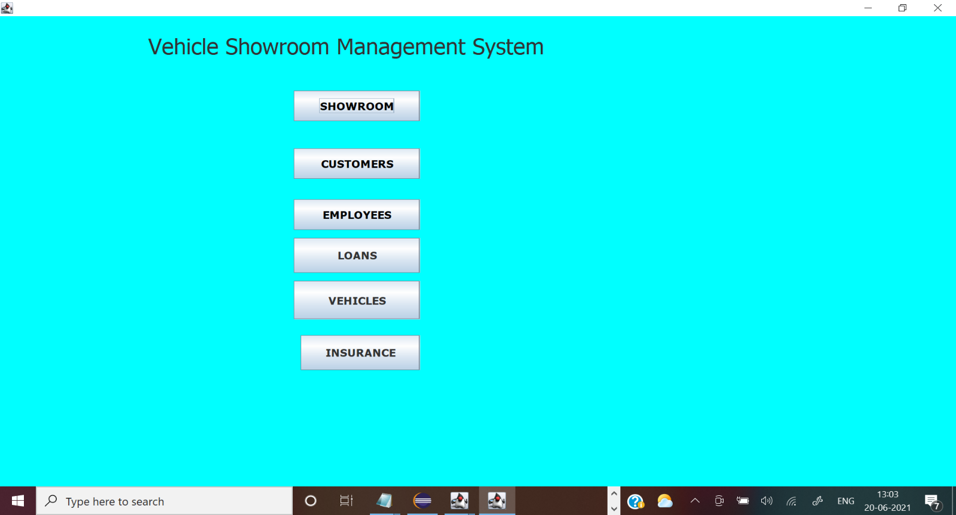

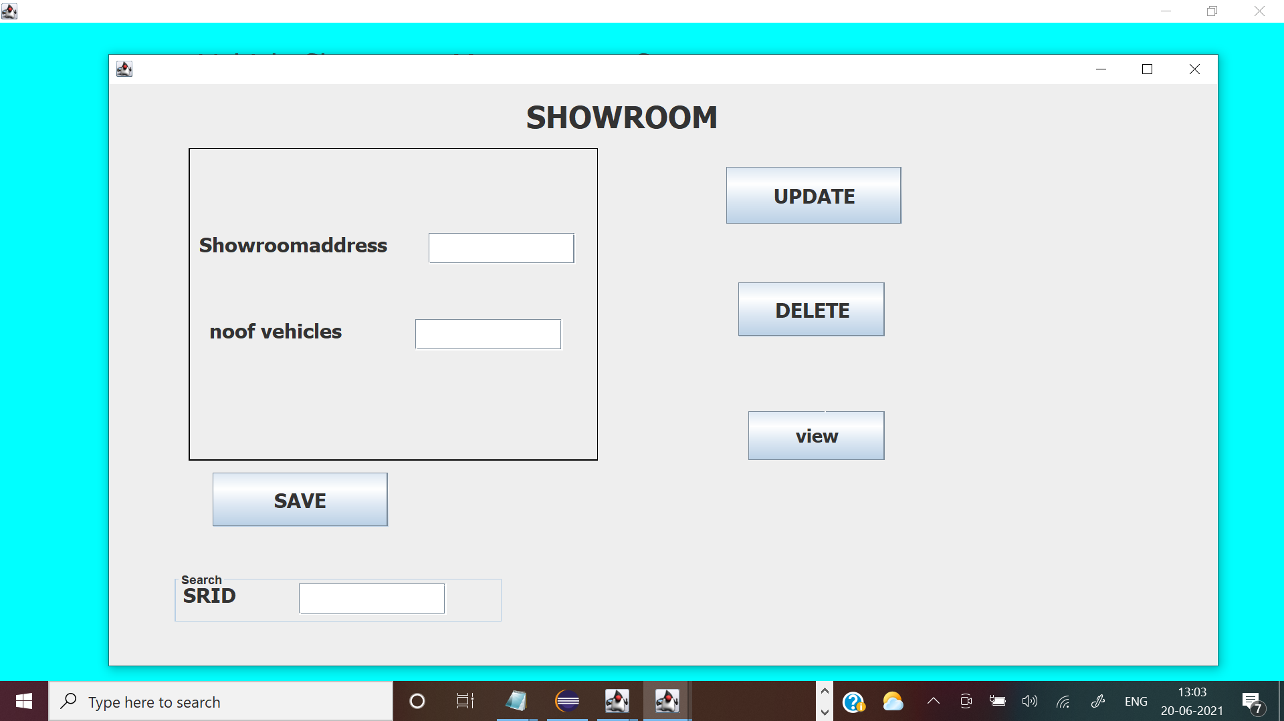

//showroom database

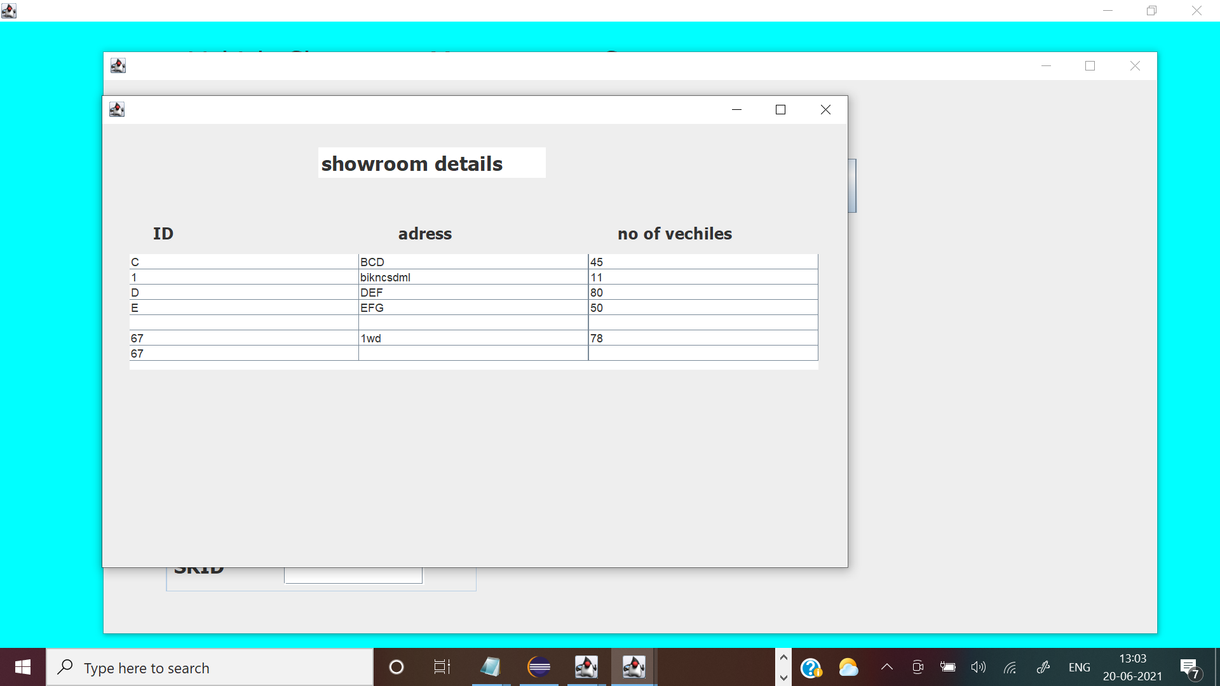

//fetching values from SRID

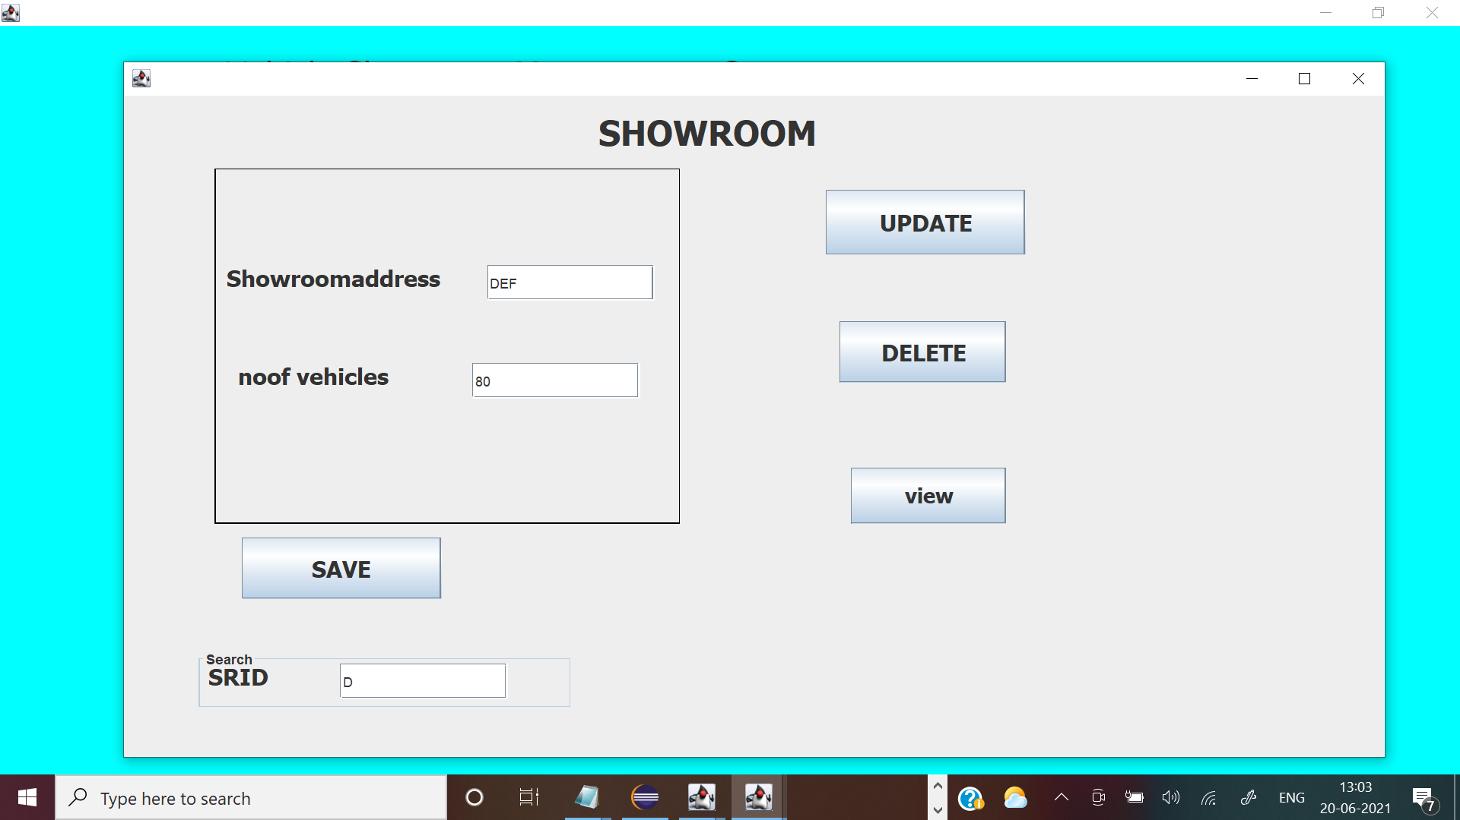

//adding details

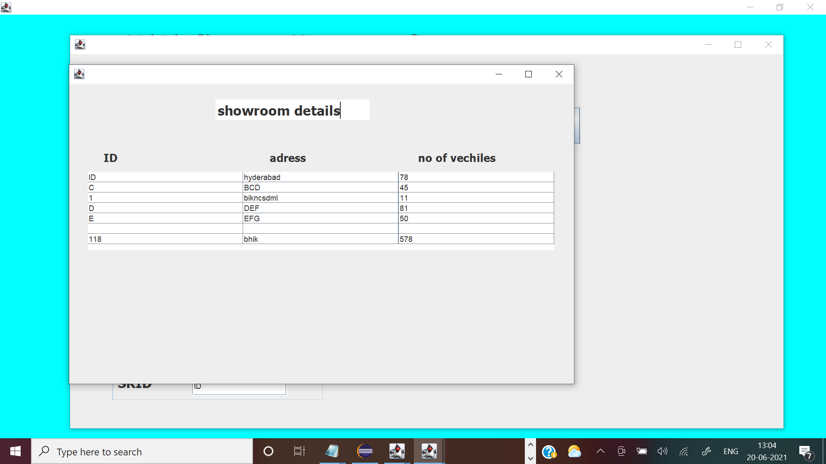

//customers databse

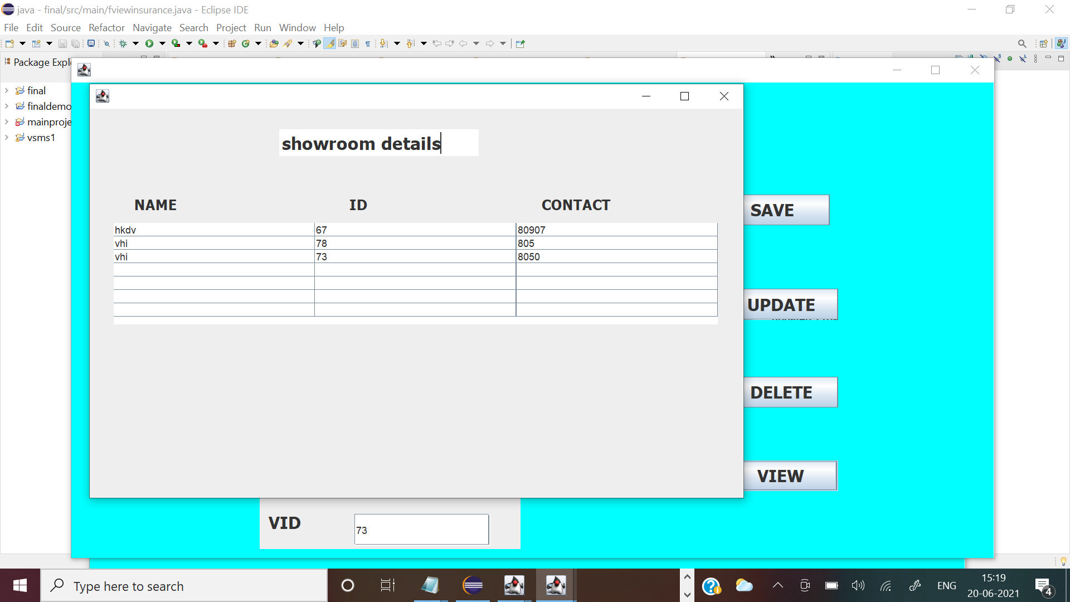

//insurance

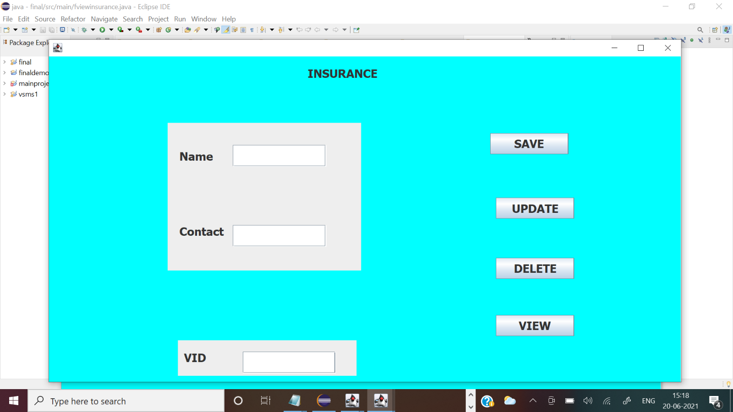

//database

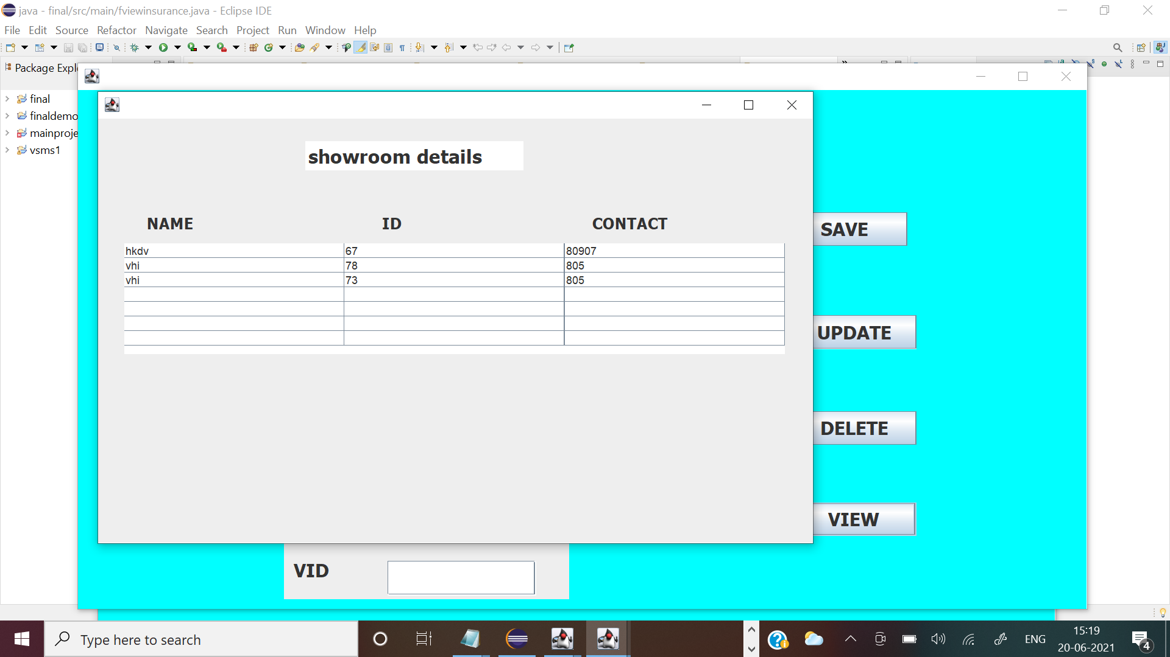

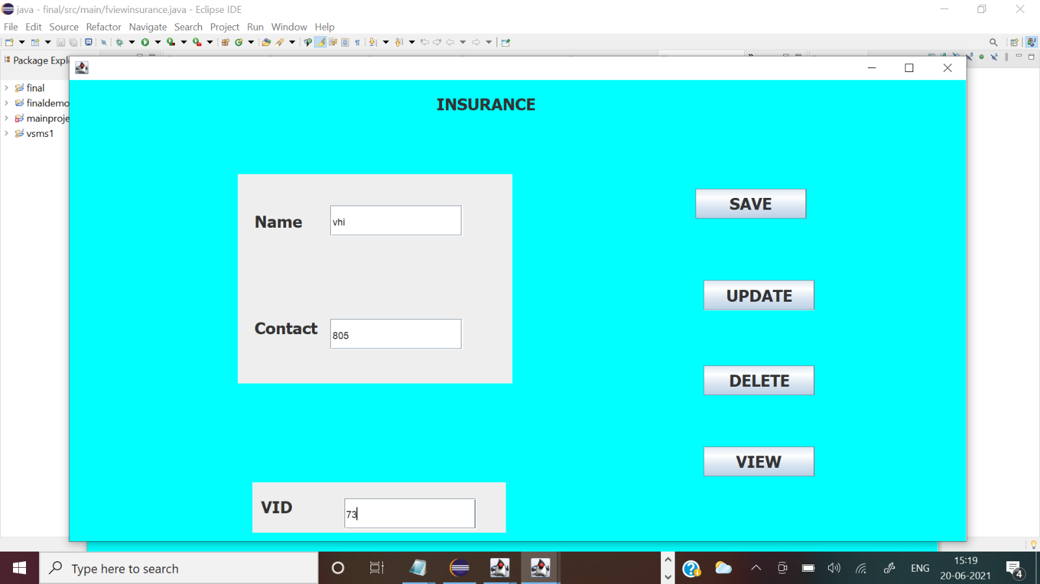

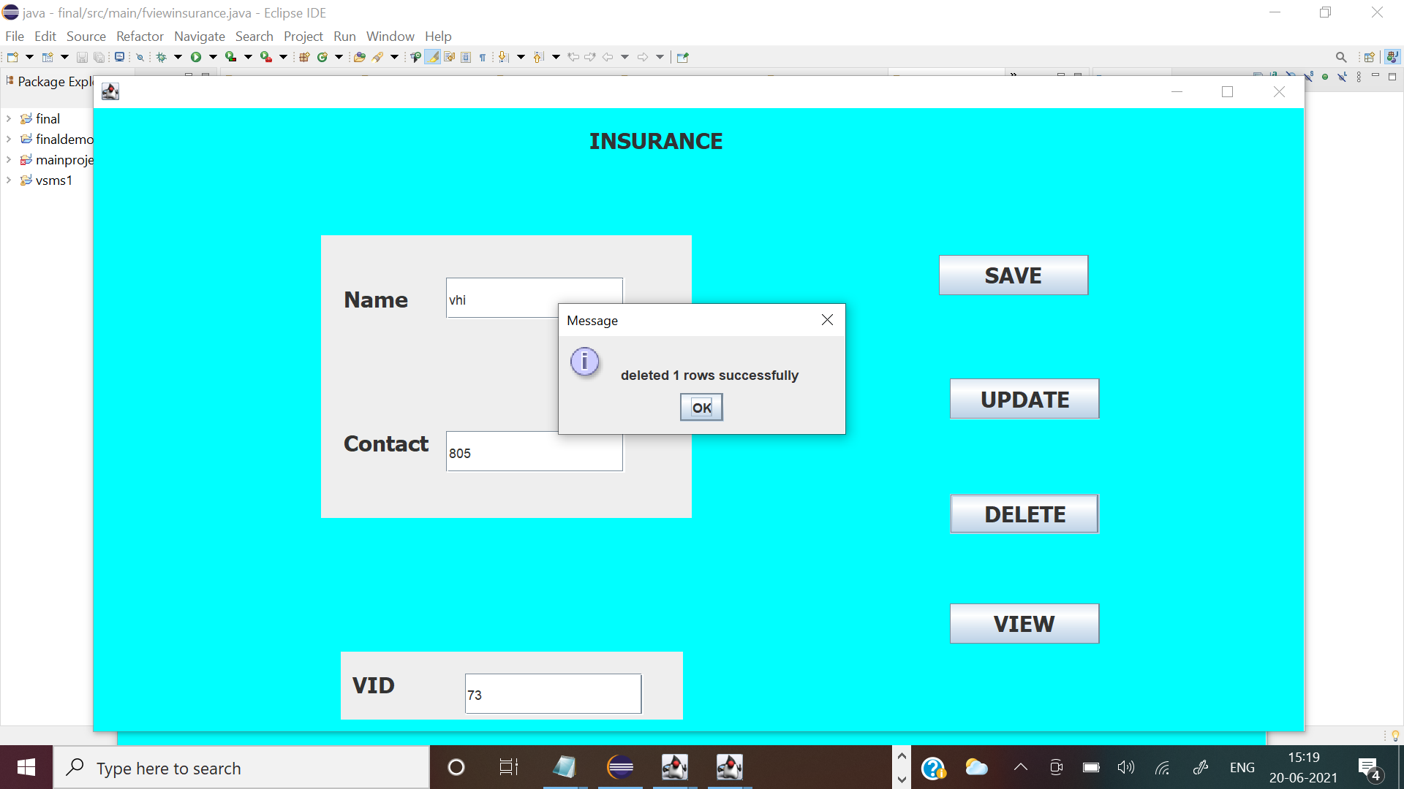

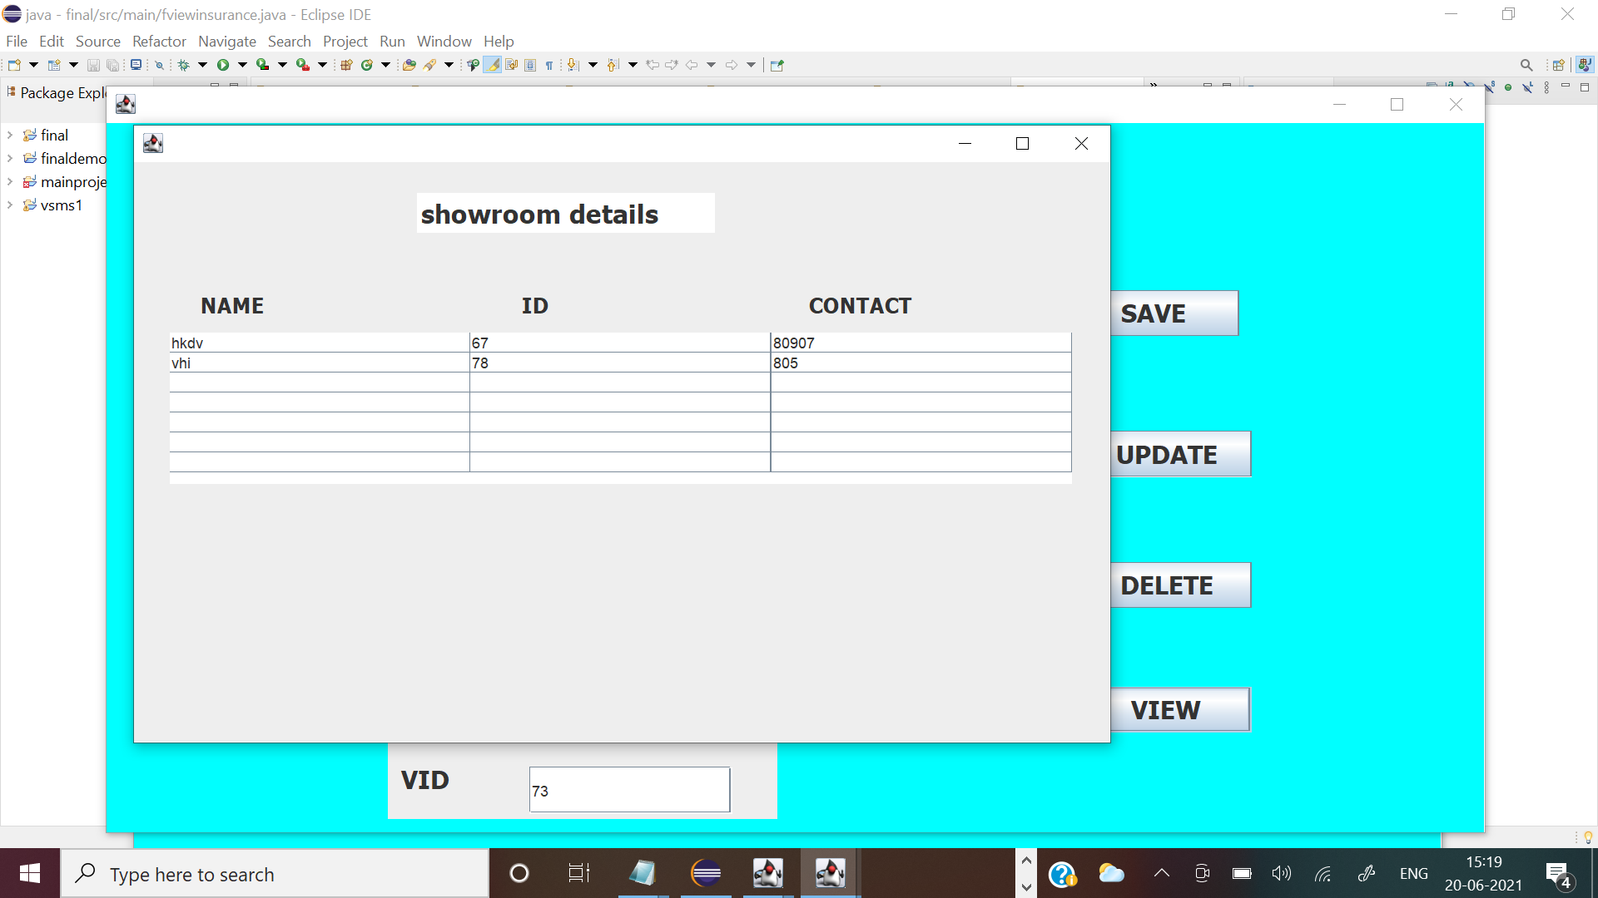

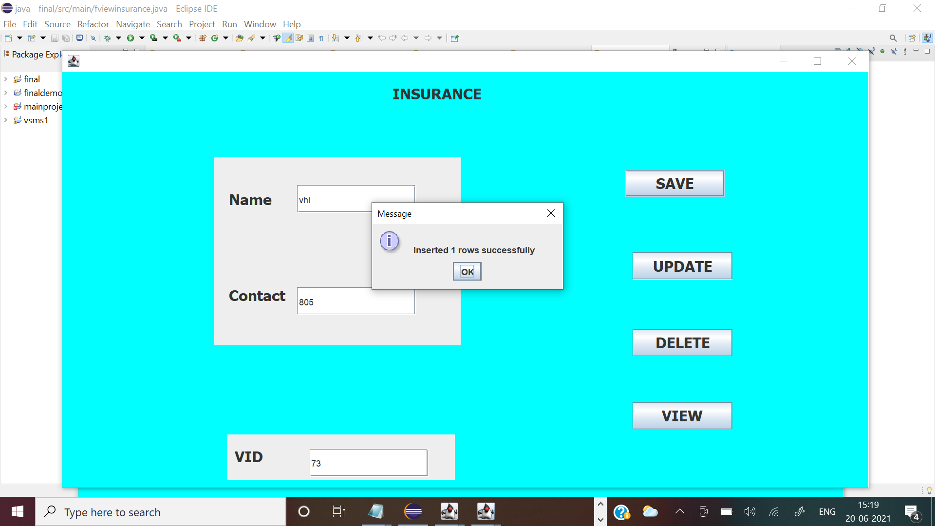

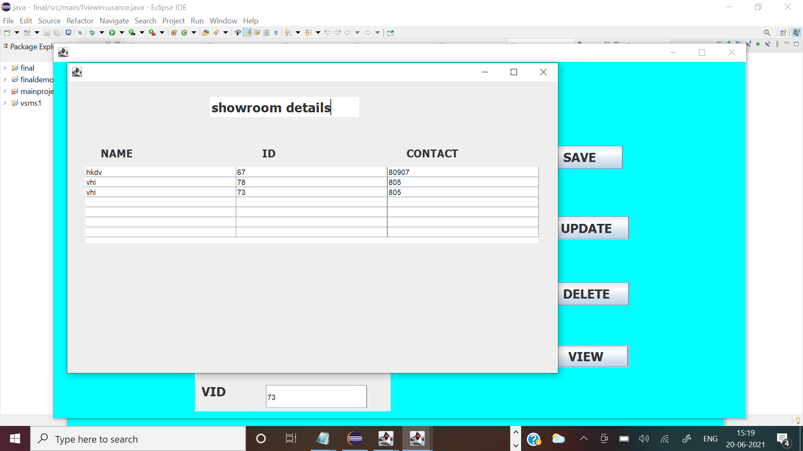

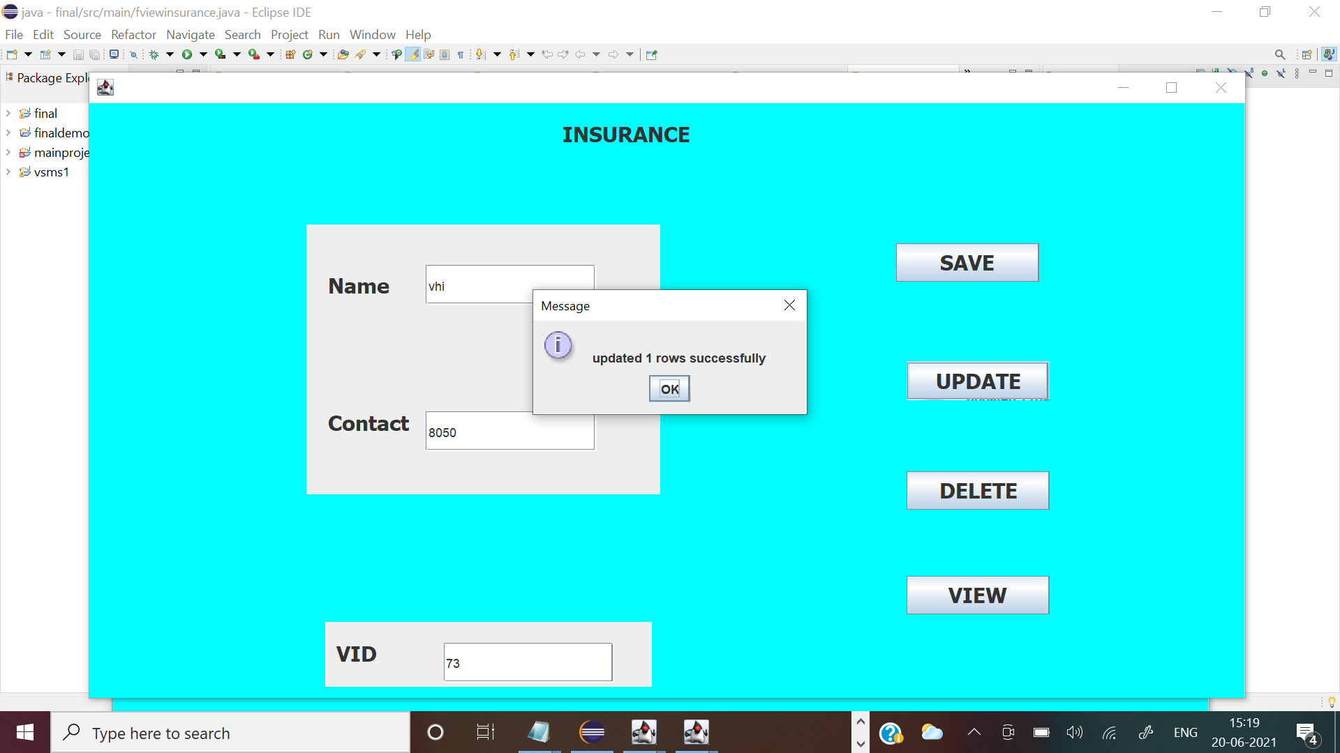

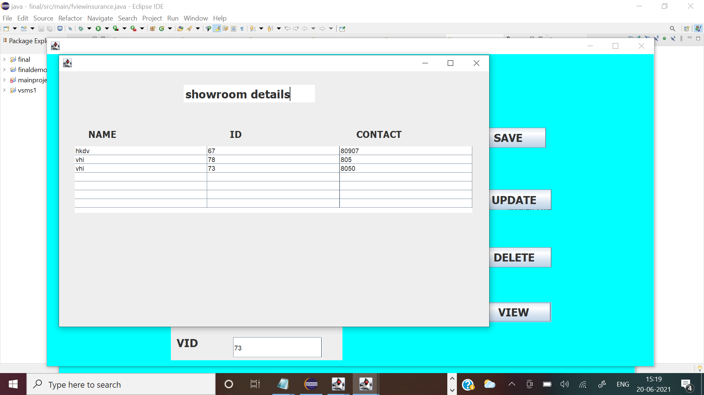

//fetching customers details with mail

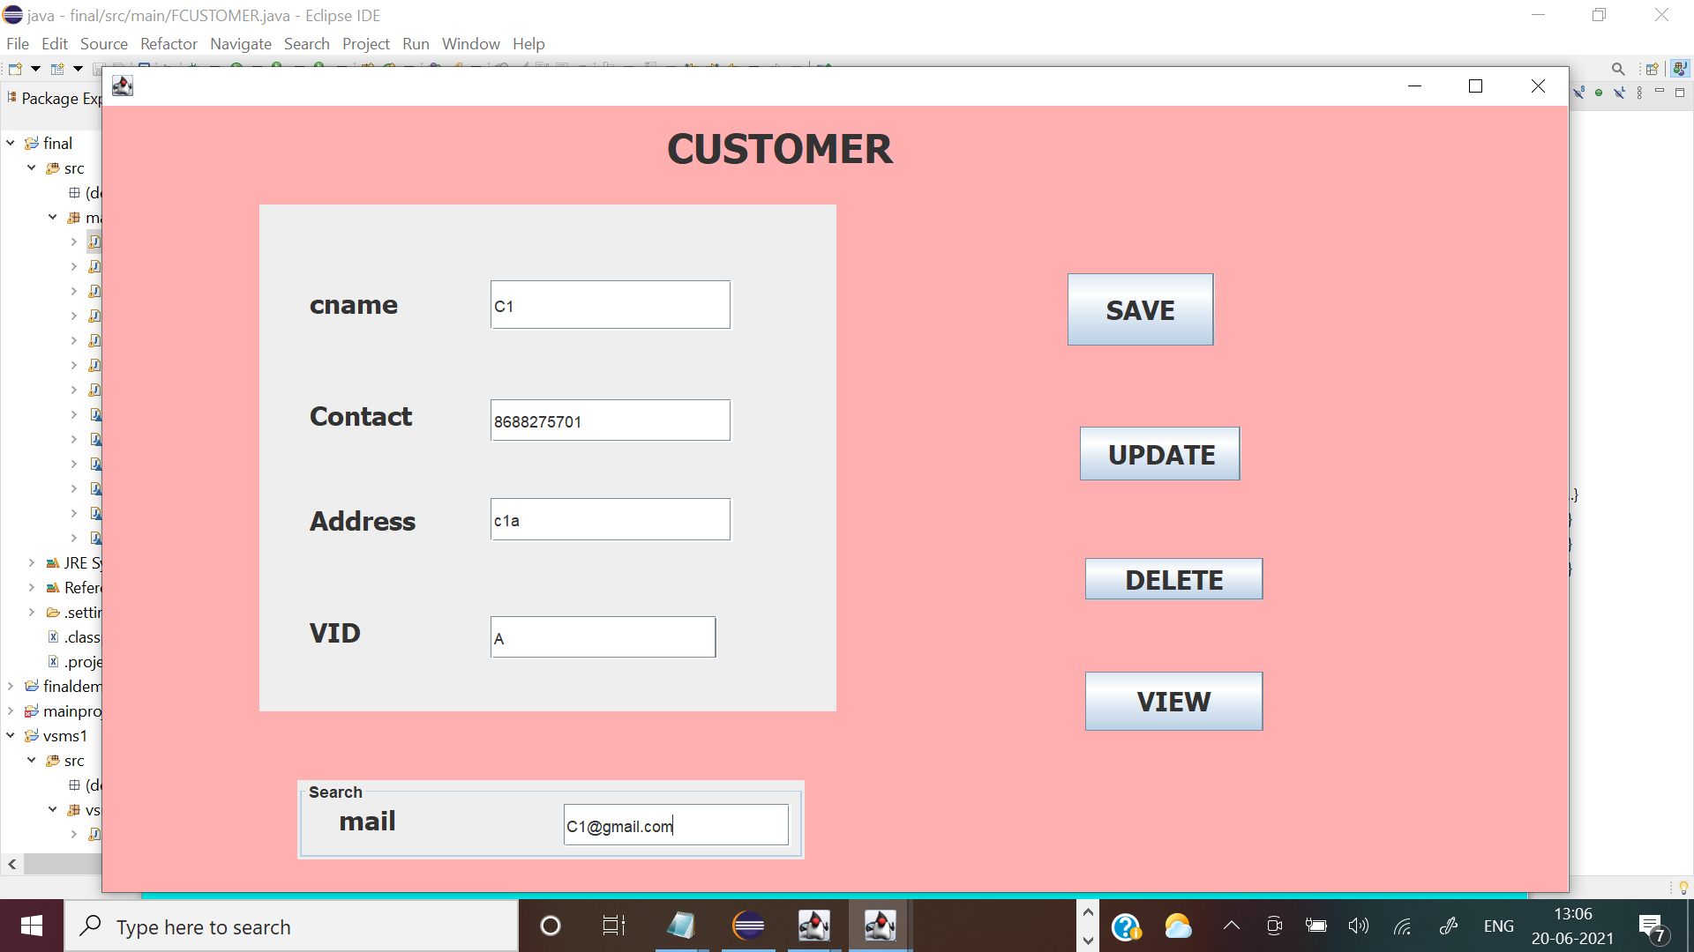

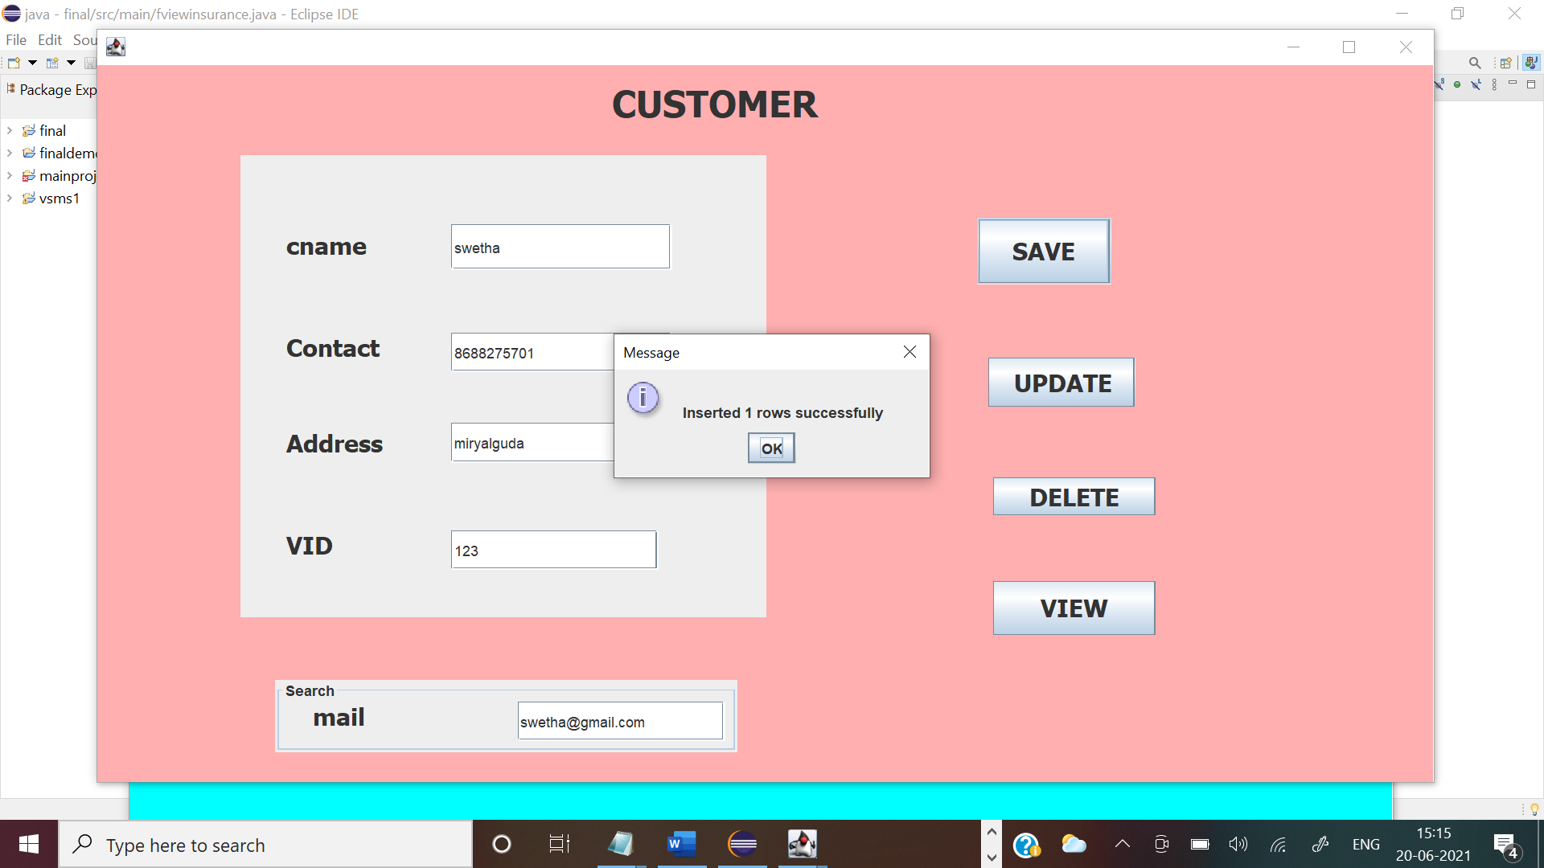

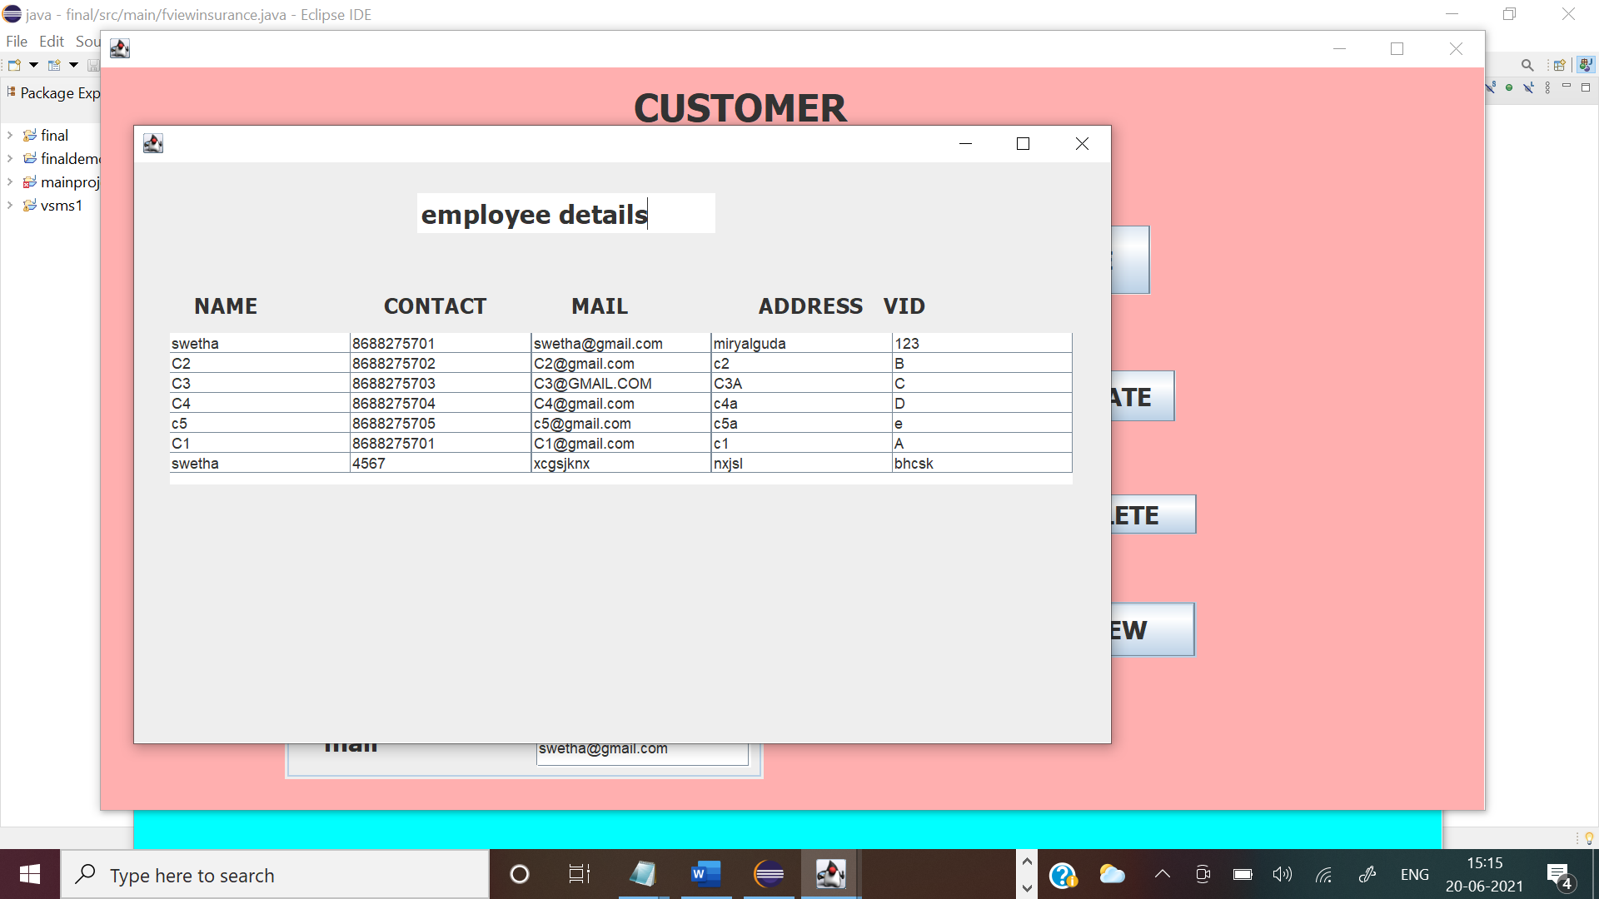

//vehicles

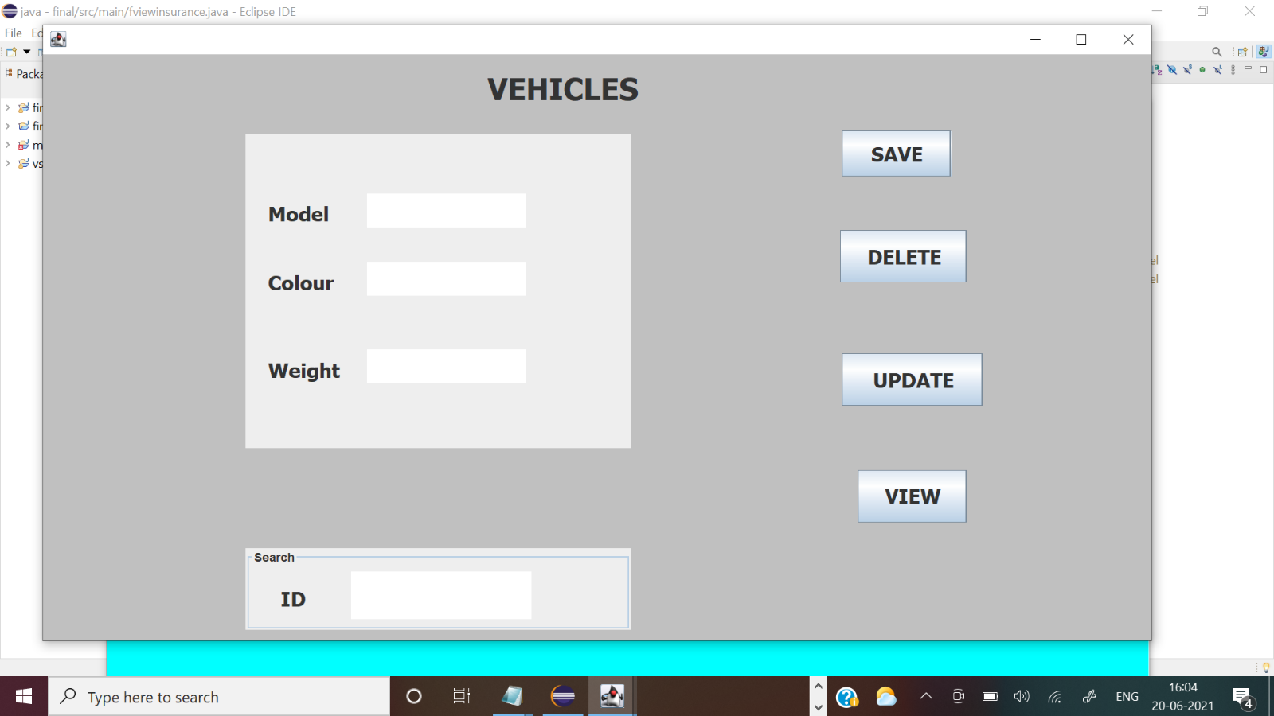

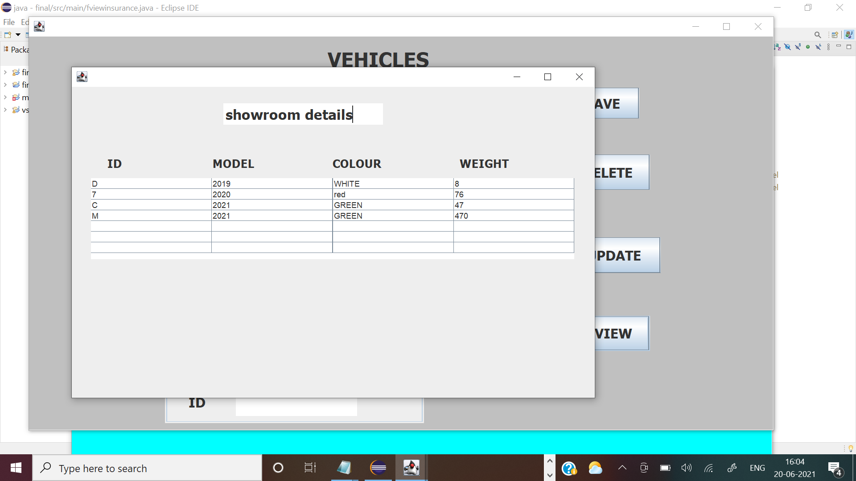

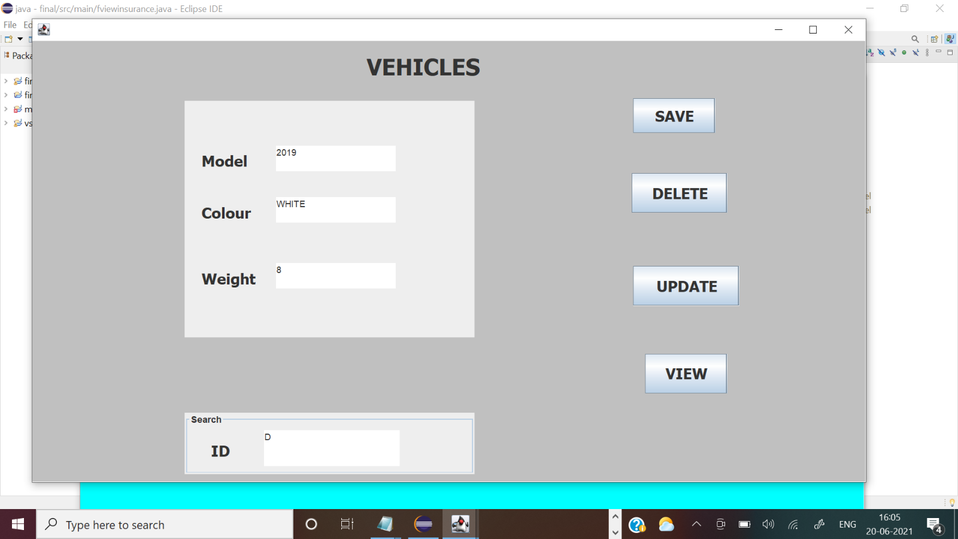

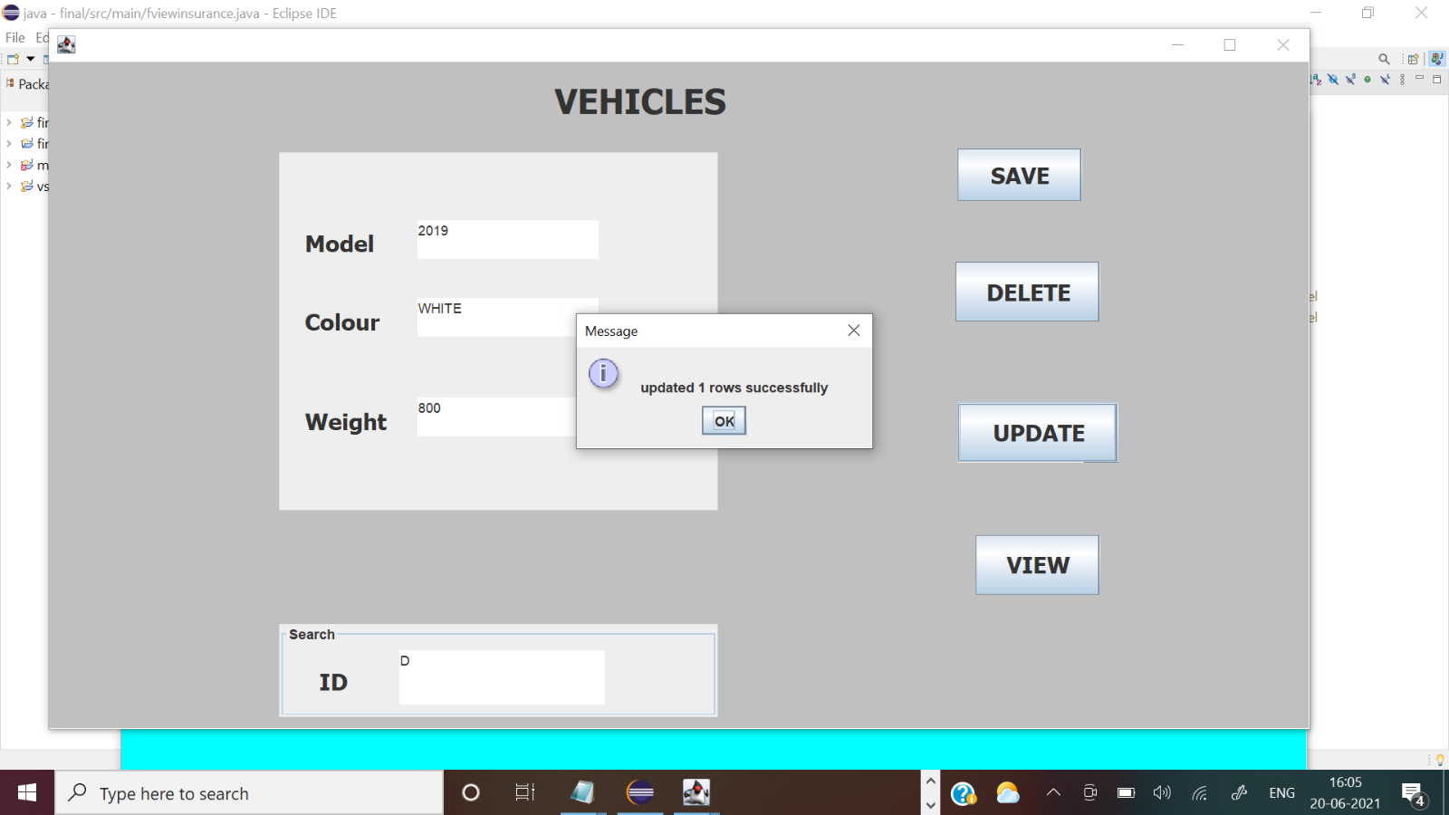

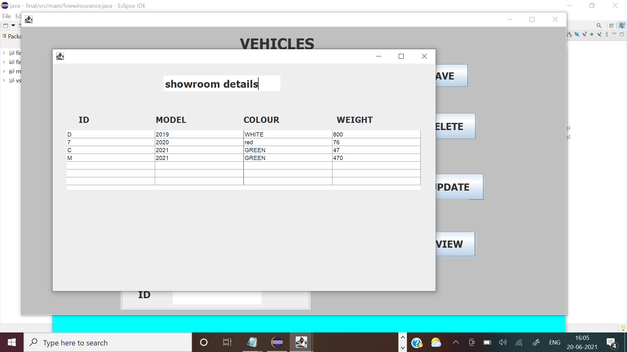

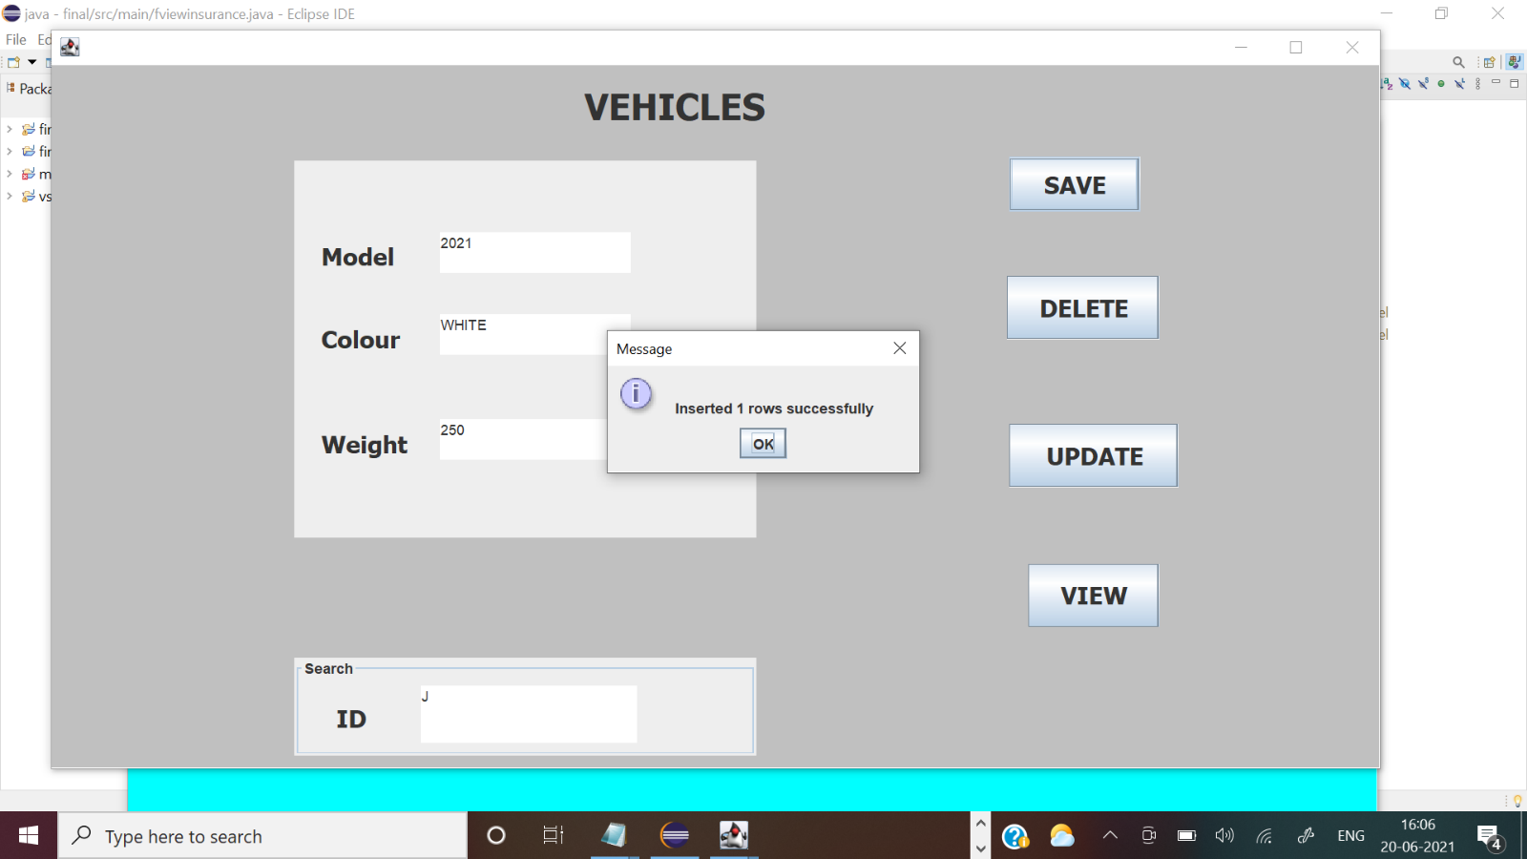

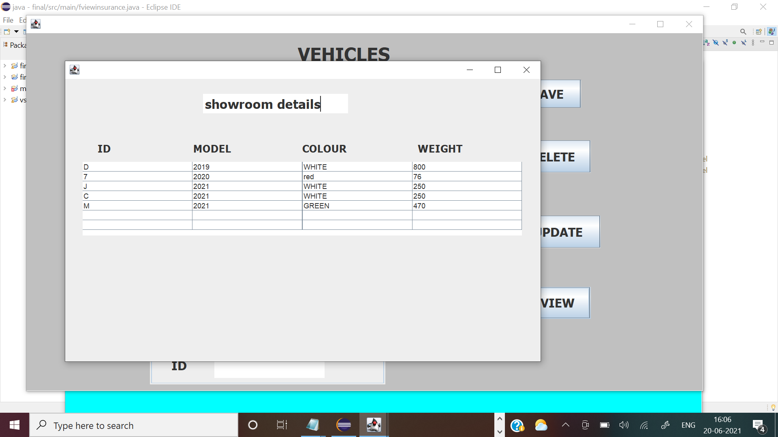

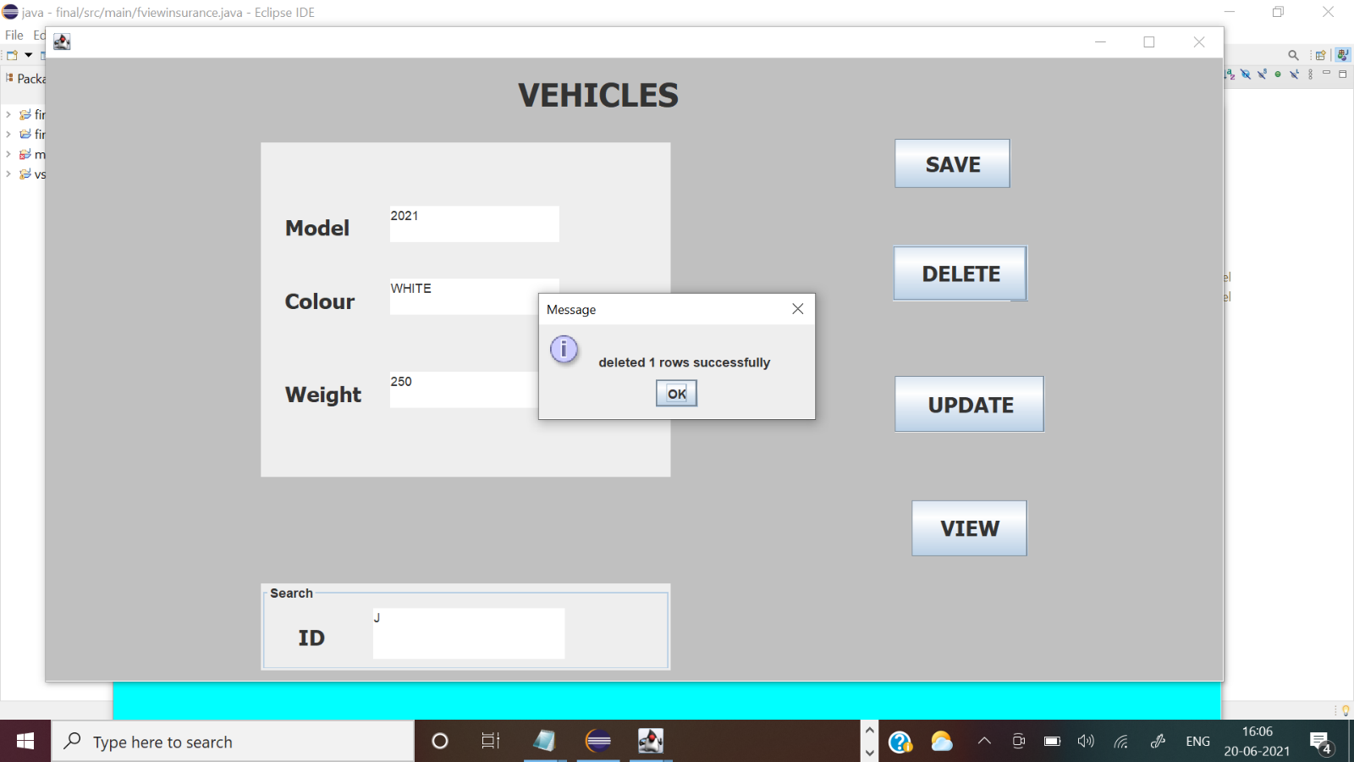

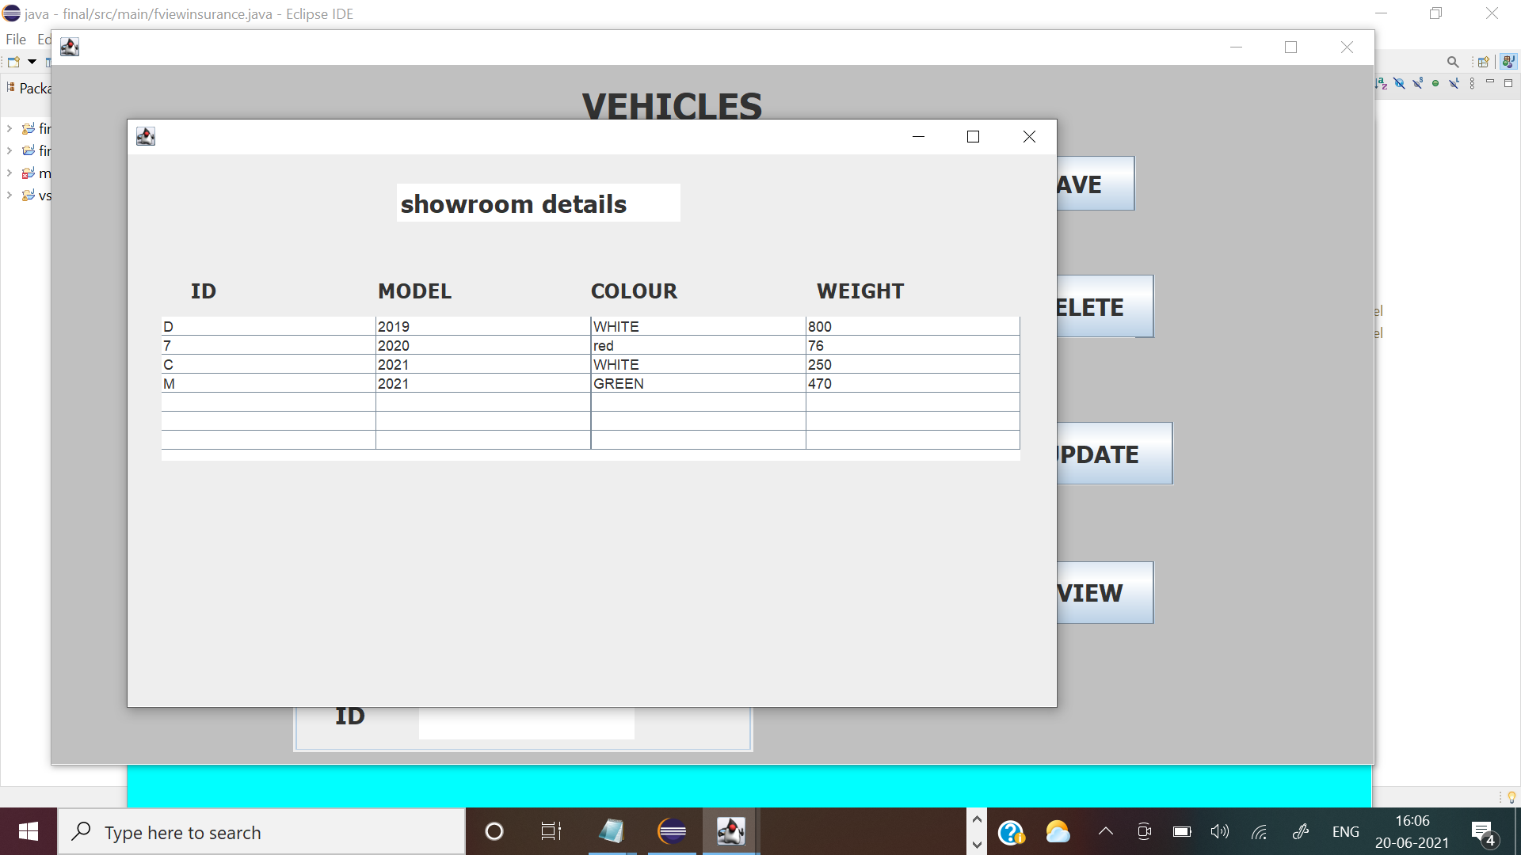

//loans

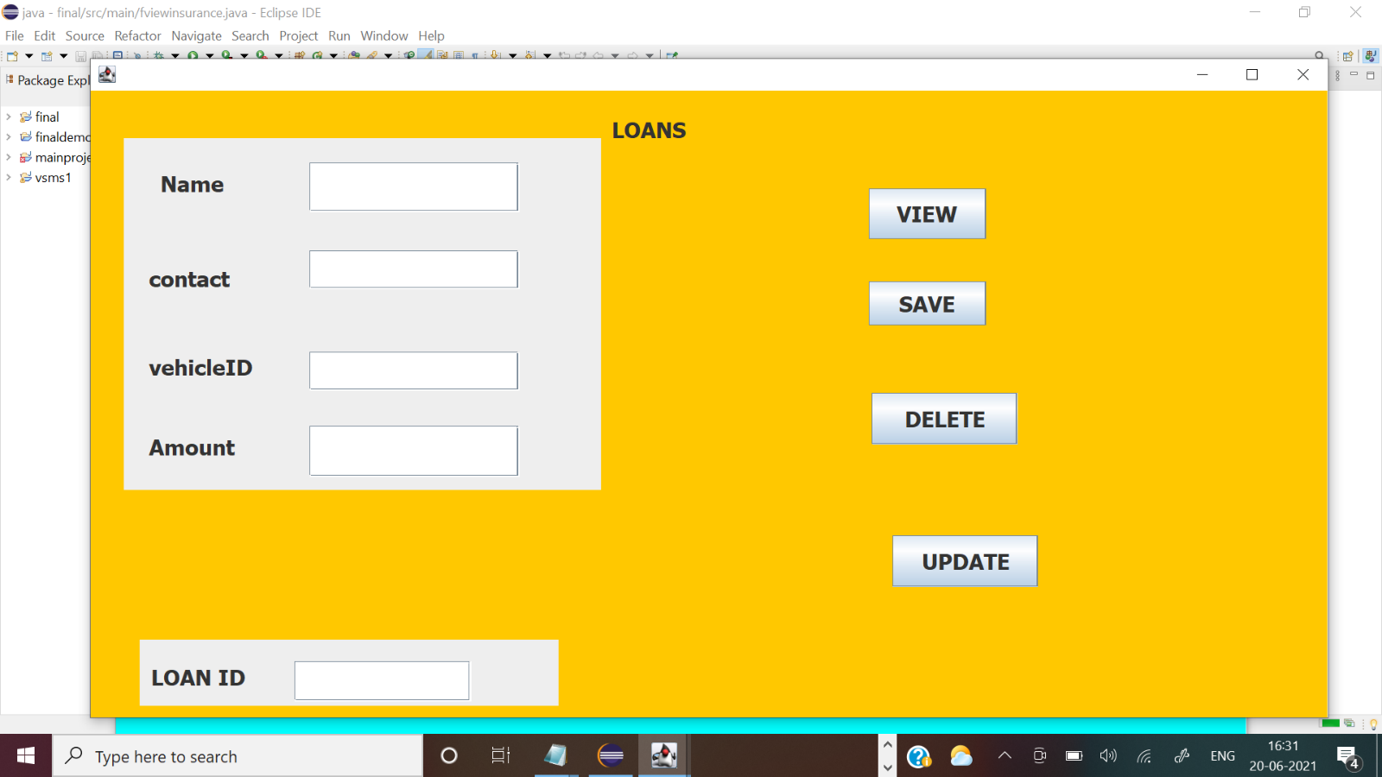

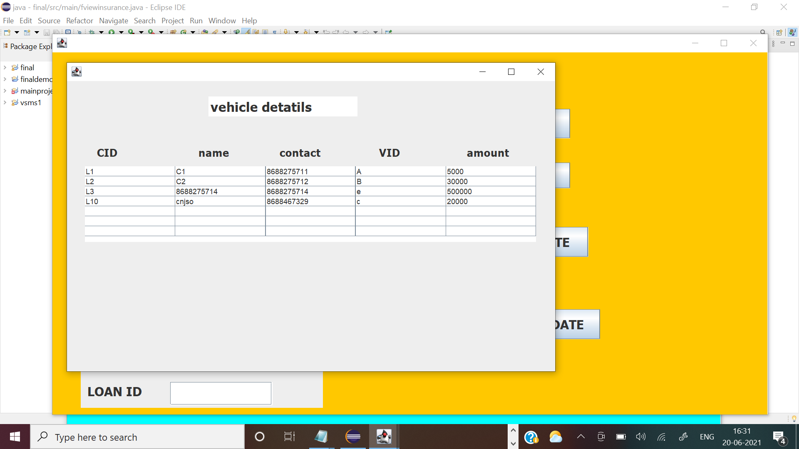

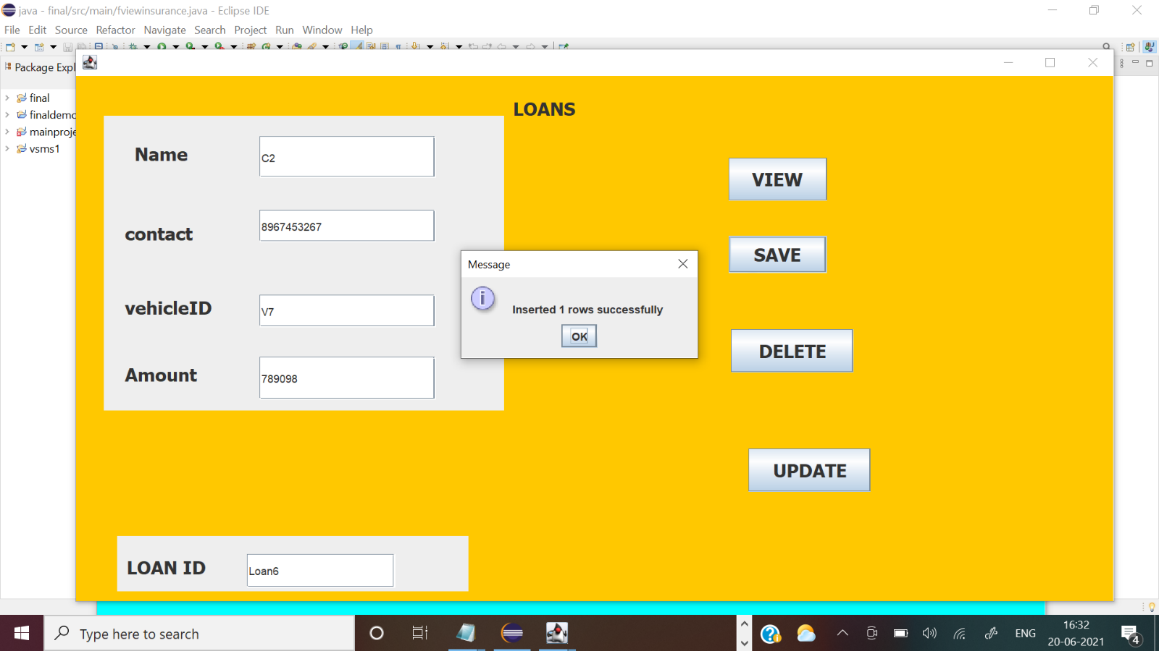

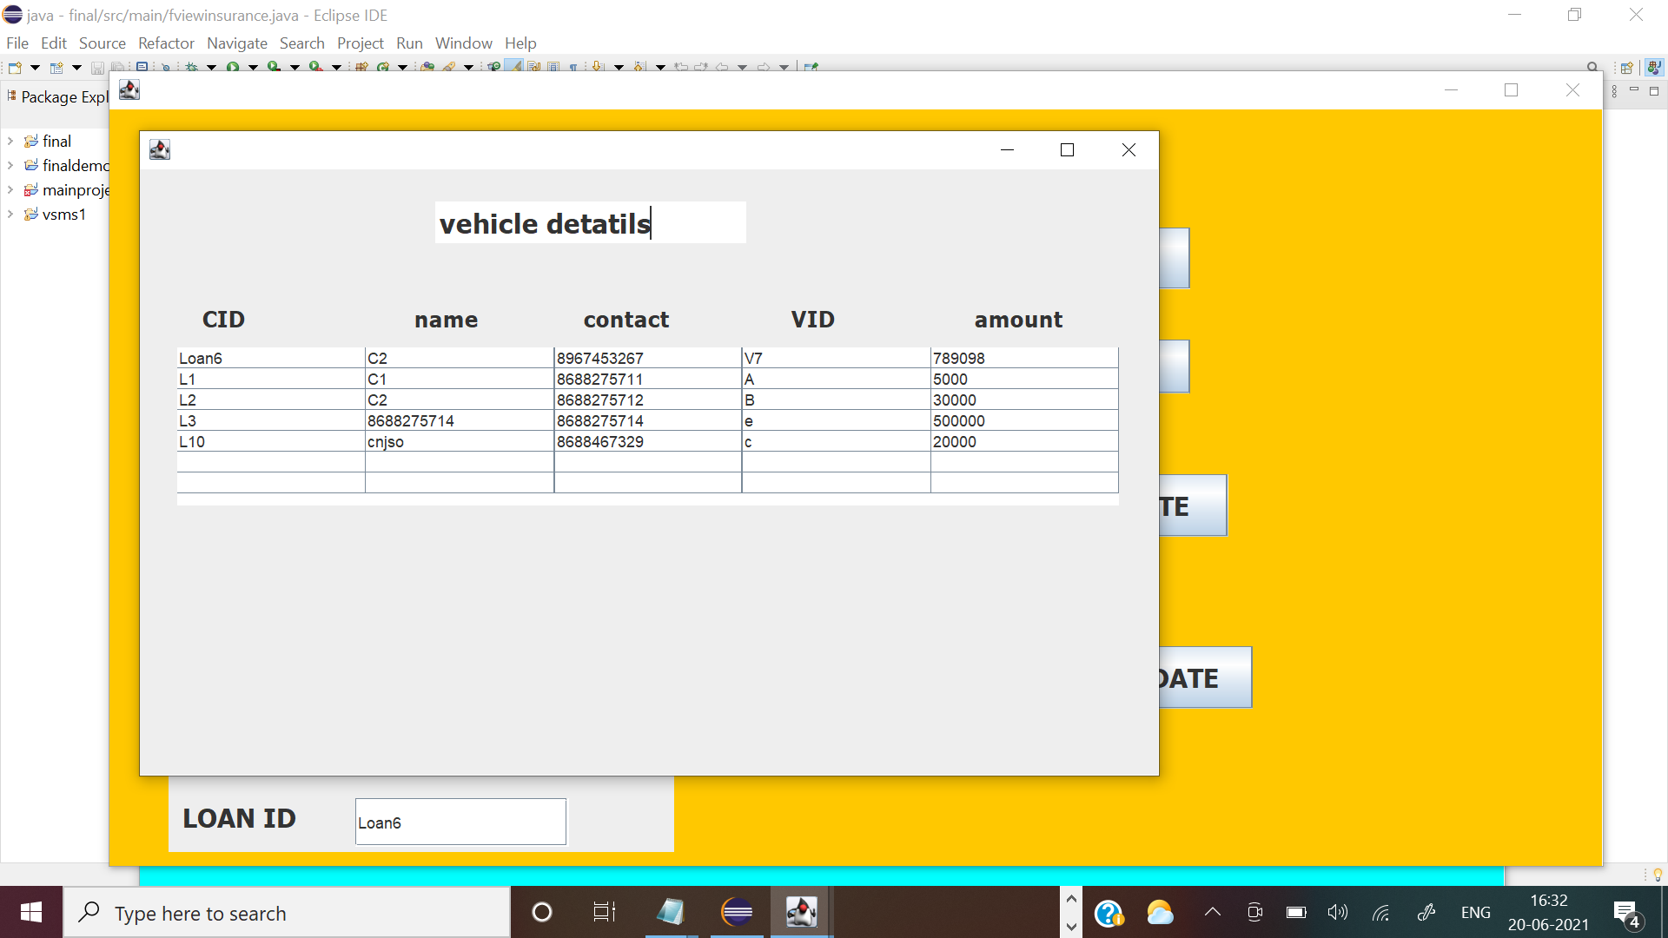

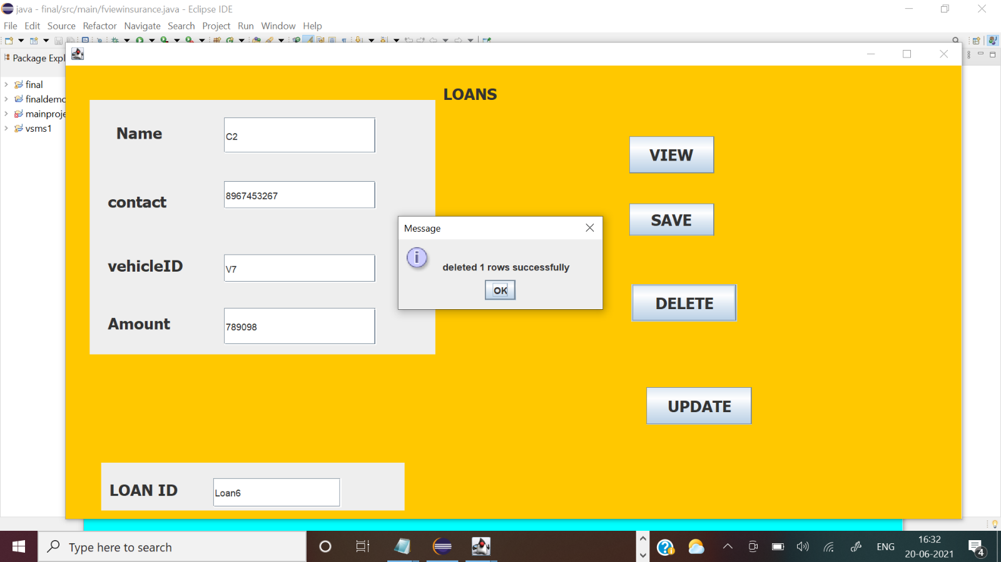

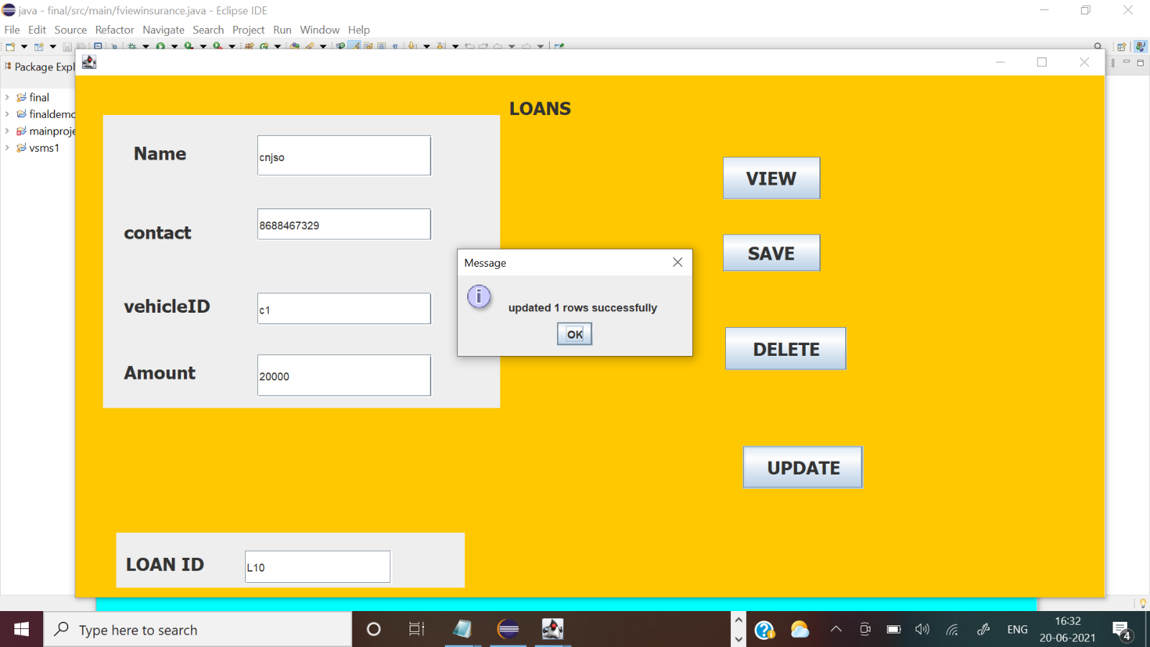

//employee

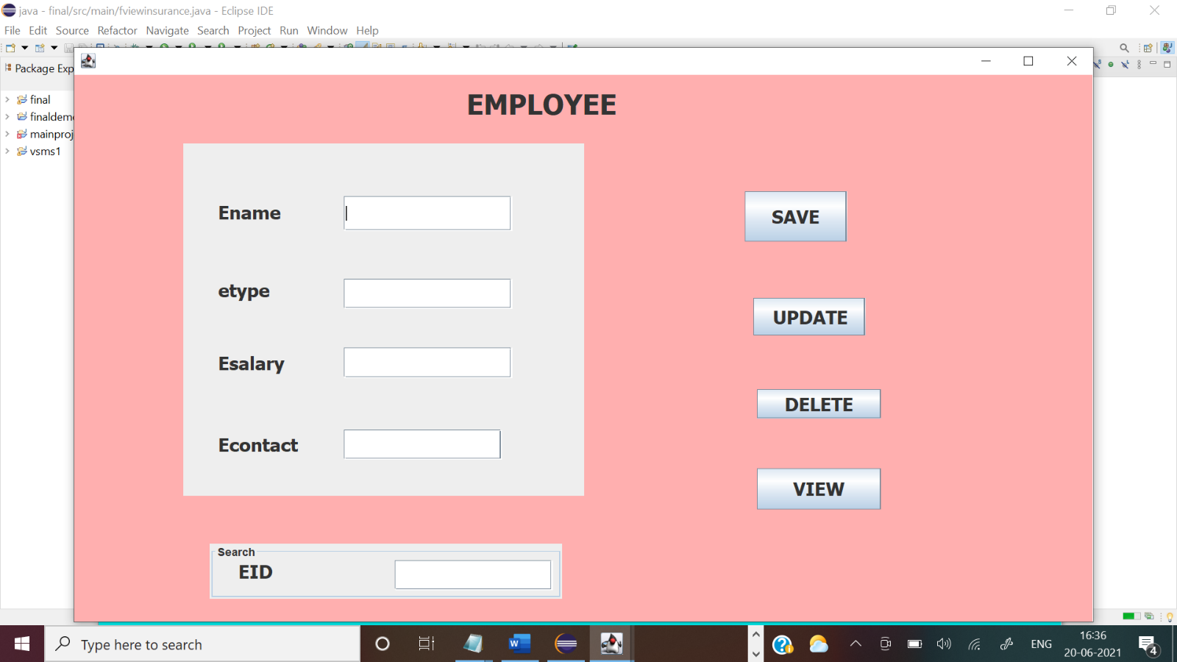

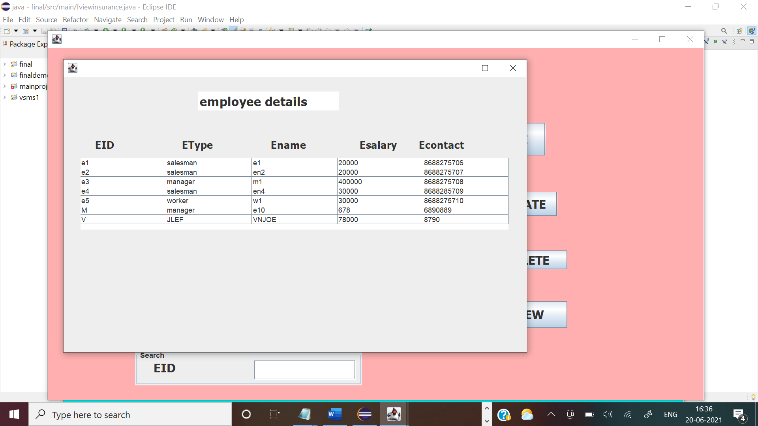

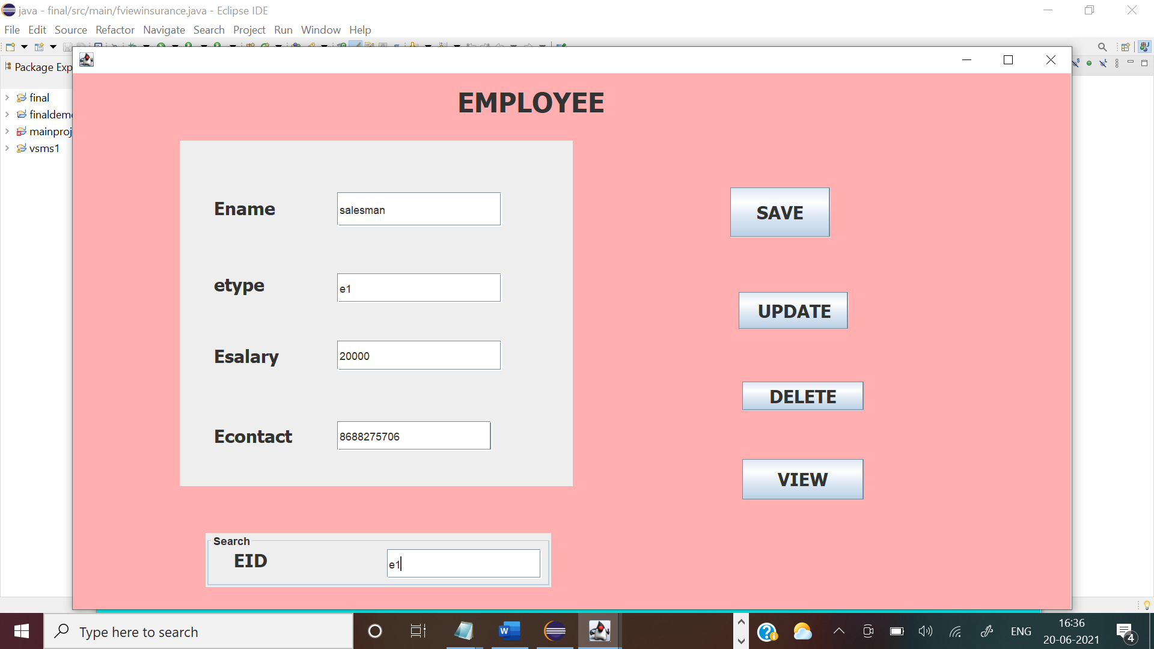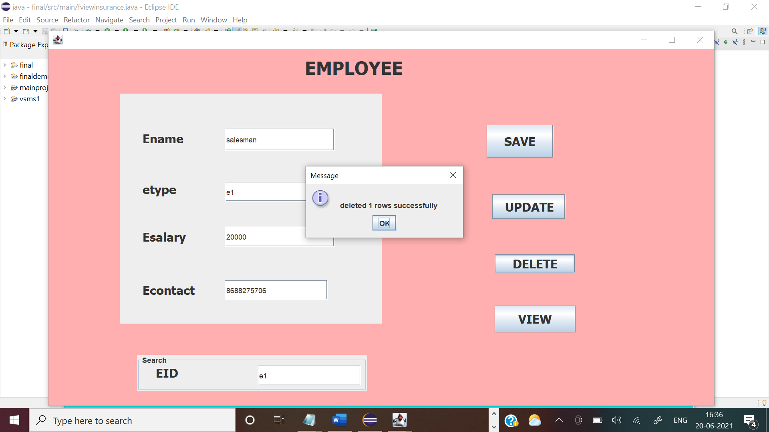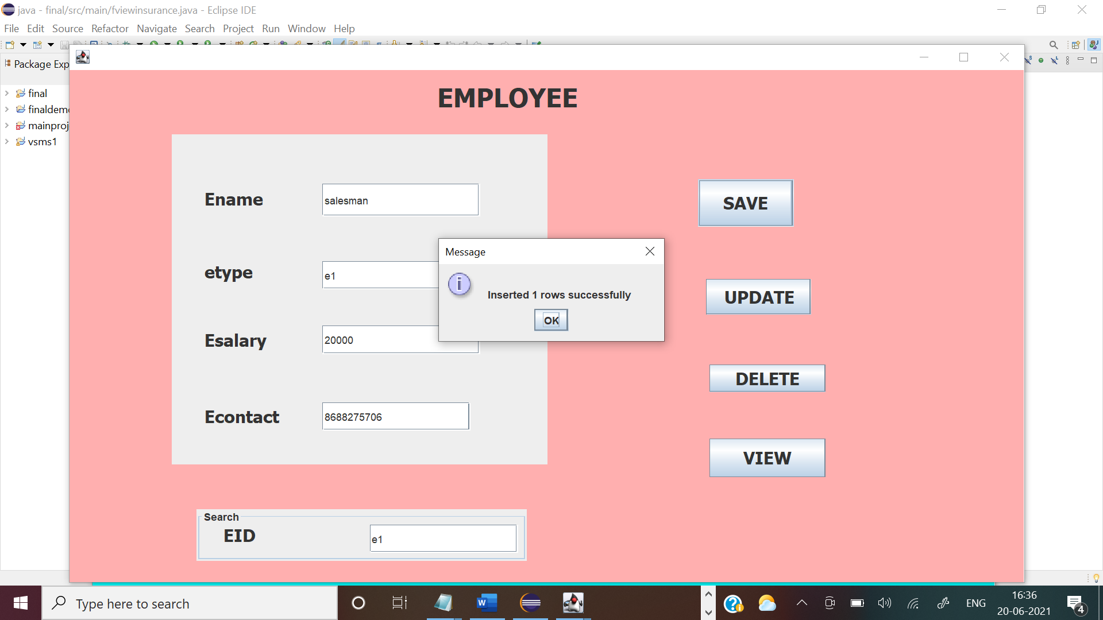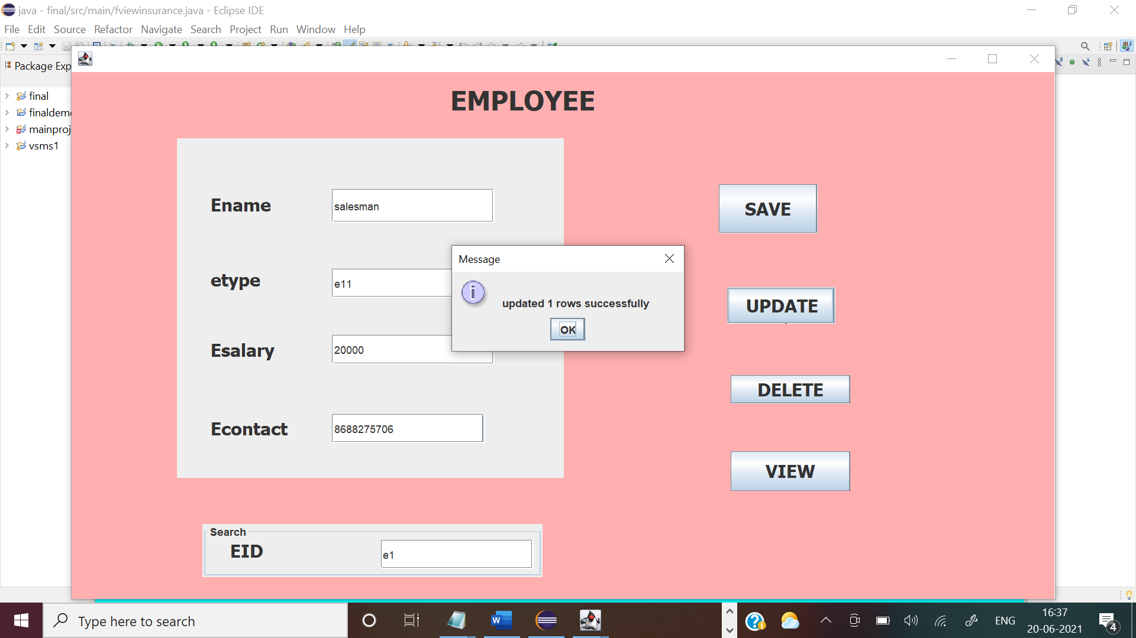

DATABASE OUTPUTS:

BEFORE:

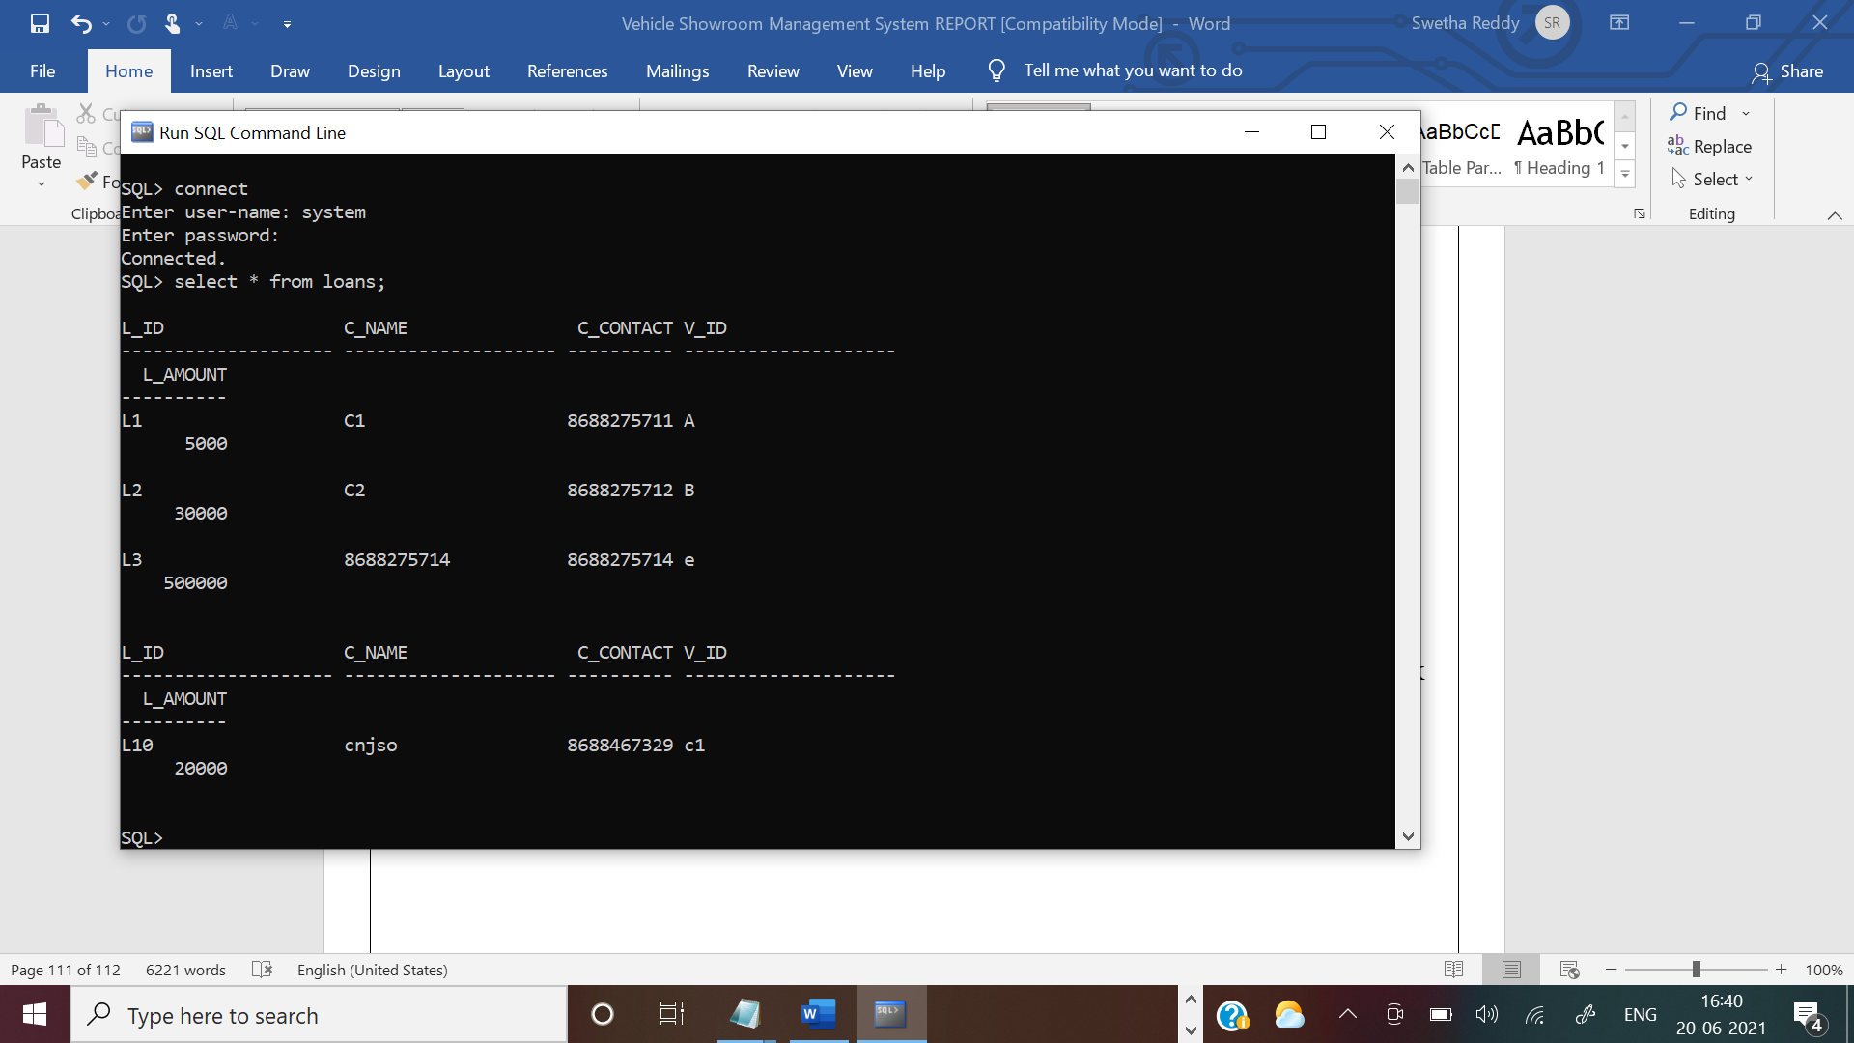

AFTER:

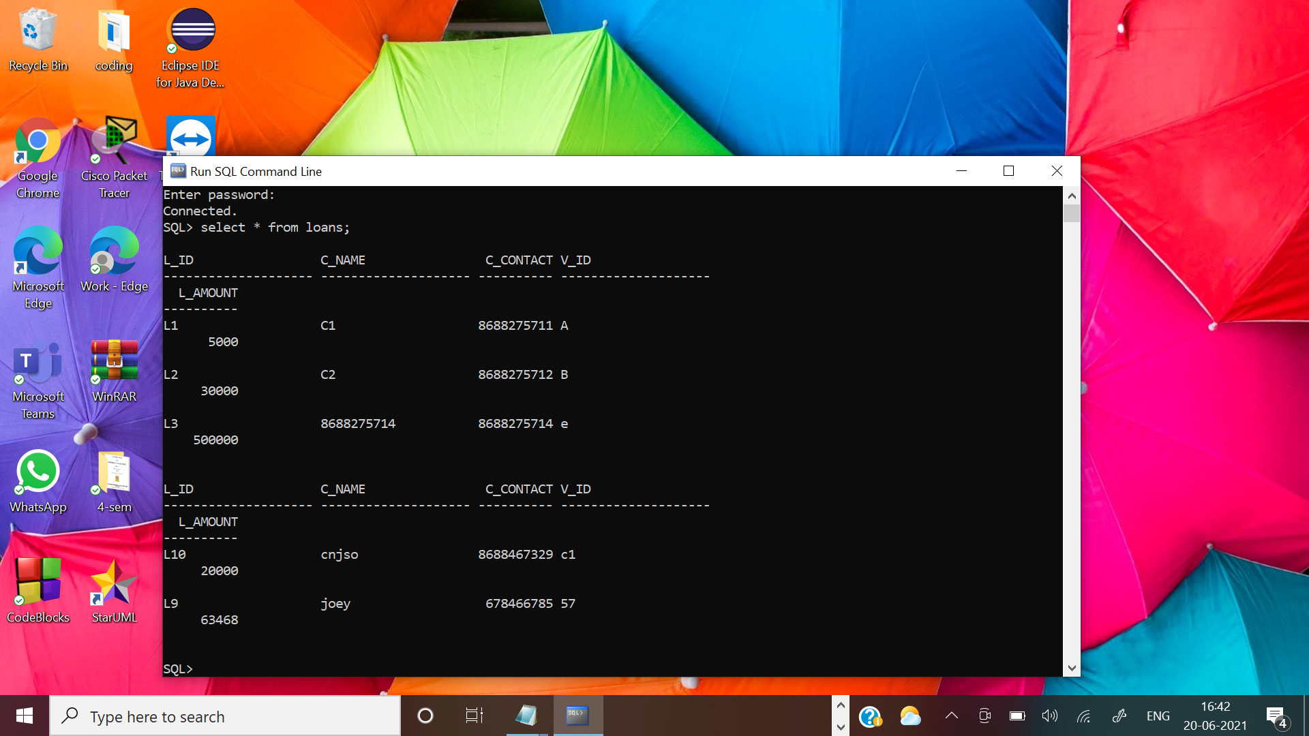

REFERENCES:

Abraham Silberschatz, Henry F Korth, S. Sudarshan, Database System Concepts, 6th Edition, McGraw-Hill International Edition, 2010.

1. [https://docs.oracle.com/cd/E11882_01/server.112/e40540/intro.htm#CNCPT001](https://docs.oracle.com/cd/E11882_01/server.112/e40540/intro.htm)

GitHub link and folder structures:

